R2-Which name do you prefer for the following method?

1.

Please read through the following code snippet where the original method name is marked by "\*\*\*". If necessary, you can refer to the enclosing class of the method at [this link](https://r.wjx.com/redirect.aspx?url=https%3A%2F%2Fgithub.com%2Fjiangyanjie%2FsurveyData%2Fblob%2Fmain%2FSecondRound%2F1%2F1.java&activity=267595662" \t "_blank). Among the names provided below, please indicate your preference for the method name.

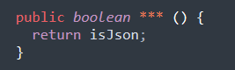 \*

|  |
| --- |
| isJson |
| isJavaScriptObjectNotation |

Please kindly explain why the selected option should be preferred.

\*

|  |
| --- |
| □Use of widely recognized abbreviations that do not hinder the understanding of the source code |
| □Excessively lengthy method names significantly impact code readability |
| □Consistency with the naming conventions of identifiers within the method body |
| □Less common abbreviation influences the understanding of the source code |
| □Method name with full terms are not excessively long and full terms tend to be more readable |
| □Others \_\_\_\_\_\_\_\_\_\_\_\_\_\_\_\_\_ |

2.

Please read through the following code snippet where the original method name is marked by "\*\*\*". If necessary, you can refer to the enclosing class of the method at [this link](https://r.wjx.com/redirect.aspx?url=https%3A%2F%2Fgithub.com%2Fjiangyanjie%2FsurveyData%2Fblob%2Fmain%2FSecondRound%2F2%2F2.java&activity=267595662" \t "_blank). Among the names provided below, please indicate your preference for the method name.

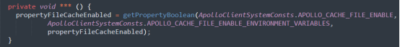

\*

|  |
| --- |
| initPropertyFileCacheEnabled |
| initializePropertyFileCacheEnabled |

Please kindly explain why the selected option should be preferred.

\*

|  |
| --- |
| □Use of widely recognized abbreviations that do not hinder the understanding of the source code |
| □Excessively lengthy method names significantly impact code readability |
| □Consistency with the naming conventions of identifiers within the method body |
| □Less common abbreviation influences the understanding of the source code |
| □Method name with full terms are not excessively long and full terms tend to be more readable |
| □Others \_\_\_\_\_\_\_\_\_\_\_\_\_\_\_\_\_ |

3.

Please read through the following code snippet where the original method name is marked by "\*\*\*". If necessary, you can refer to the enclosing class of the method at [this link](https://r.wjx.com/redirect.aspx?url=https%3A%2F%2Fgithub.com%2Fjiangyanjie%2FsurveyData%2Fblob%2Fmain%2FSecondRound%2F3%2F3.java&activity=267595662" \t "_blank). Among the names provided below, please indicate your preference for the method name.

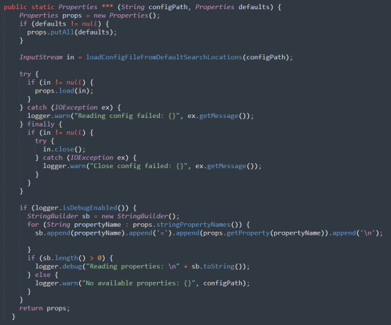

\*

|  |
| --- |
| readConfigFile |
| readConfigurationFile |

Please kindly explain why the selected option should be preferred.

\*

|  |
| --- |
| □Use of widely recognized abbreviations that do not hinder the understanding of the source code |
| □Excessively lengthy method names significantly impact code readability |
| □Consistency with the naming conventions of identifiers within the method body |
| □Less common abbreviation influences the understanding of the source code |
| □Method name with full terms are not excessively long and full terms tend to be more readable |
| □Others \_\_\_\_\_\_\_\_\_\_\_\_\_\_\_\_\_ |

4.

Please read through the following code snippet where the original method name is marked by "\*\*\*". If necessary, you can refer to the enclosing class of the method at [this link](https://r.wjx.com/redirect.aspx?url=https%3A%2F%2Fgithub.com%2Fjiangyanjie%2FsurveyData%2Fblob%2Fmain%2FSecondRound%2F4%2F4.java&activity=267595662" \t "_blank). Among the names provided below, please indicate your preference for the method name.

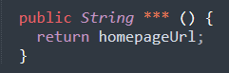 \*

|  |
| --- |
| getHomepageUrl |
| getHomepageUniformResourceLocator |

Please kindly explain why the selected option should be preferred.

\*

|  |
| --- |
| □Use of widely recognized abbreviations that do not hinder the understanding of the source code |
| □Excessively lengthy method names significantly impact code readability |
| □Consistency with the naming conventions of identifiers within the method body |
| □Less common abbreviation influences the understanding of the source code |
| □Method name with full terms are not excessively long and full terms tend to be more readable |
| □Others \_\_\_\_\_\_\_\_\_\_\_\_\_\_\_\_\_ |

5. Please read through the following code snippet where the original method name is marked by "\*\*\*". If necessary, you can refer to the enclosing class of the method at [this link](https://r.wjx.com/redirect.aspx?url=https%3A%2F%2Fgithub.com%2Fjiangyanjie%2FsurveyData%2Fblob%2Fmain%2FSecondRound%2F5%2F5.java&activity=267595662" \t "_blank). Among the names provided below, please indicate your preference for the method name.

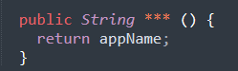

\*

|  |
| --- |
| getAppName |
| getApplicationName |

Please kindly explain why the selected option should be preferred.

\*

|  |
| --- |
| □Use of widely recognized abbreviations that do not hinder the understanding of the source code |
| □Excessively lengthy method names significantly impact code readability |
| □Consistency with the naming conventions of identifiers within the method body |
| □Less common abbreviation influences the understanding of the source code |
| □Method name with full terms are not excessively long and full terms tend to be more readable |
| □Others \_\_\_\_\_\_\_\_\_\_\_\_\_\_\_\_\_ |

6. Please read through the following code snippet where the original method name is marked by "\*\*\*". If necessary, you can refer to the enclosing class of the method at [this link](https://r.wjx.com/redirect.aspx?url=https%3A%2F%2Fgithub.com%2Fjiangyanjie%2FsurveyData%2Fblob%2Fmain%2FSecondRound%2F6%2F6.java&activity=267595662" \t "_blank). Among the names provided below, please indicate your preference for the method name.

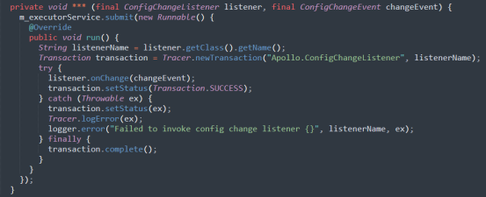

\*

|  |
| --- |
| notifyAsync |
| notifyAsynchrony |

Please kindly explain why the selected option should be preferred.

\*

|  |
| --- |
| □Use of widely recognized abbreviations that do not hinder the understanding of the source code |
| □Excessively lengthy method names significantly impact code readability |
| □Consistency with the naming conventions of identifiers within the method body |
| □Less common abbreviation influences the understanding of the source code |
| □Method name with full terms are not excessively long and full terms tend to be more readable |
| □Others \_\_\_\_\_\_\_\_\_\_\_\_\_\_\_\_\_ |

7. Please read through the following code snippet where the original method name is marked by "\*\*\*". If necessary, you can refer to the enclosing class of the method at[this link](https://r.wjx.com/redirect.aspx?url=https%3A%2F%2Fgithub.com%2Fjiangyanjie%2FsurveyData%2Fblob%2Fmain%2FSecondRound%2F7%2F7.java&activity=267595662" \t "_blank). Among the names provided below, please indicate your preference for the method name.

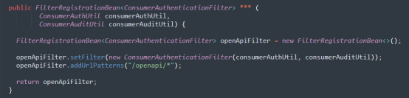

\*

|  |
| --- |
| openApiAuthenticationFilter |
| openApplicationProgramInterfaceAuthenticationFilter |

Please kindly explain why the selected option should be preferred.

\*

|  |
| --- |
| □Use of widely recognized abbreviations that do not hinder the understanding of the source code |
| □Excessively lengthy method names significantly impact code readability |
| □Consistency with the naming conventions of identifiers within the method body |
| □Less common abbreviation influences the understanding of the source code |
| □Method name with full terms are not excessively long and full terms tend to be more readable |
| □Others \_\_\_\_\_\_\_\_\_\_\_\_\_\_\_\_\_ |

8.

Please read through the following code snippet where the original method name is marked by "\*\*\*". If necessary, you can refer to the enclosing class of the method at [this link](https://r.wjx.com/redirect.aspx?url=https%3A%2F%2Fgithub.com%2Fjiangyanjie%2FsurveyData%2Fblob%2Fmain%2FSecondRound%2F8%2F8.java&activity=267595662" \t "_blank). Among the names provided below, please indicate your preference for the method name.

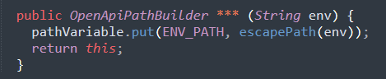 \*

|  |
| --- |
| envPathVal |
| environmentPathValue |

Please kindly explain why the selected option should be preferred.

\*

|  |
| --- |
| □Use of widely recognized abbreviations that do not hinder the understanding of the source code |
| □Excessively lengthy method names significantly impact code readability |
| □Consistency with the naming conventions of identifiers within the method body |
| □Less common abbreviation influences the understanding of the source code |
| □Method name with full terms are not excessively long and full terms tend to be more readable |
| □Others \_\_\_\_\_\_\_\_\_\_\_\_\_\_\_\_\_ |

9. Please read through the following code snippet where the original method name is marked by "\*\*\*". If necessary, you can refer to the enclosing class of the method at [this link](https://r.wjx.com/redirect.aspx?url=https%3A%2F%2Fgithub.com%2Fjiangyanjie%2FsurveyData%2Fblob%2Fmain%2FSecondRound%2F9%2F9.java&activity=267595662" \t "_blank). Among the names provided below, please indicate your preference for the method name.

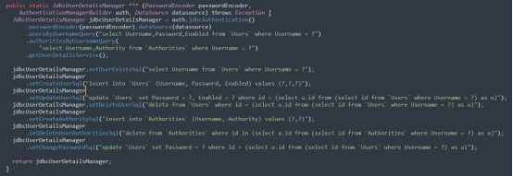

\*

|  |
| --- |
| jdbcUserDetailsManager |
| javaDatabaseConnectivityUserDetailsManager |

Please kindly explain why the selected option should be preferred.

\*

|  |
| --- |
| □Use of widely recognized abbreviations that do not hinder the understanding of the source code |
| □Excessively lengthy method names significantly impact code readability |
| □Consistency with the naming conventions of identifiers within the method body |
| □Less common abbreviation influences the understanding of the source code |
| □Method name with full terms are not excessively long and full terms tend to be more readable |
| □Others \_\_\_\_\_\_\_\_\_\_\_\_\_\_\_\_\_ |

10. Please read through the following code snippet where the original method name is marked by "\*\*\*". If necessary, you can refer to the enclosing class of the method at [this link](https://r.wjx.com/redirect.aspx?url=https%3A%2F%2Fgithub.com%2Fjiangyanjie%2FsurveyData%2Fblob%2Fmain%2FSecondRound%2F10%2F10.java&activity=267595662" \t "_blank). Among the names provided below, please indicate your preference for the method name.

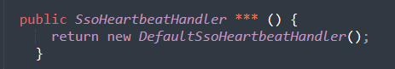

\*

|  |
| --- |
| defaultSsoHeartbeatHandler |
| defaultSingleSignOnHeartbeatHandler |

Please kindly explain why the selected option should be preferred.

\*

|  |
| --- |
| □Use of widely recognized abbreviations that do not hinder the understanding of the source code |
| □Excessively lengthy method names significantly impact code readability |
| □Consistency with the naming conventions of identifiers within the method body |
| □Less common abbreviation influences the understanding of the source code |
| □Method name with full terms are not excessively long and full terms tend to be more readable |
| □Others \_\_\_\_\_\_\_\_\_\_\_\_\_\_\_\_\_ |

11. Please read through the following code snippet where the original method name is marked by "\*\*\*". If necessary, you can refer to the enclosing class of the method at [this link](https://r.wjx.com/redirect.aspx?url=https%3A%2F%2Fgithub.com%2Fjiangyanjie%2FsurveyData%2Fblob%2Fmain%2FSecondRound%2F11%2F11.java&activity=267595662" \t "_blank). Among the names provided below, please indicate your preference for the method name.

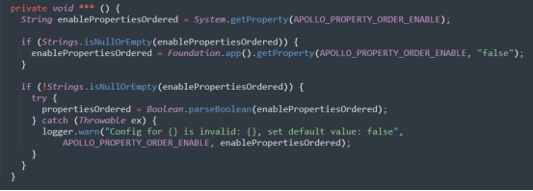

\*

|  |
| --- |
| initPropertiesOrdered |
| initializePropertiesOrdered |

Please kindly explain why the selected option should be preferred.

\*

|  |
| --- |
| □Use of widely recognized abbreviations that do not hinder the understanding of the source code |
| □Excessively lengthy method names significantly impact code readability |
| □Consistency with the naming conventions of identifiers within the method body |
| □Less common abbreviation influences the understanding of the source code |
| □Method name with full terms are not excessively long and full terms tend to be more readable |
| □Others \_\_\_\_\_\_\_\_\_\_\_\_\_\_\_\_\_ |

12. Please read through the following code snippet where the original method name is marked by "\*\*\*". If necessary, you can refer to the enclosing class of the method at [this link](https://r.wjx.com/redirect.aspx?url=https%3A%2F%2Fgithub.com%2Fjiangyanjie%2FsurveyData%2Fblob%2Fmain%2FSecondRound%2F12%2F12.java&activity=267595662" \t "_blank). Among the names provided below, please indicate your preference for the method name.

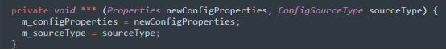

\*

|  |
| --- |
| updateConfig |
| updateConfiguration |

Please kindly explain why the selected option should be preferred.

\*

|  |
| --- |
| □Use of widely recognized abbreviations that do not hinder the understanding of the source code |
| □Excessively lengthy method names significantly impact code readability |
| □Consistency with the naming conventions of identifiers within the method body |
| □Less common abbreviation influences the understanding of the source code |
| □Method name with full terms are not excessively long and full terms tend to be more readable |
| □Others \_\_\_\_\_\_\_\_\_\_\_\_\_\_\_\_\_ |

13. Please read through the following code snippet where the original method name is marked by "\*\*\*". If necessary, you can refer to the enclosing class of the method at [this link](https://r.wjx.com/redirect.aspx?url=https%3A%2F%2Fgithub.com%2Fjiangyanjie%2FsurveyData%2Fblob%2Fmain%2FSecondRound%2F13%2F13.java&activity=267595662" \t "_blank). Among the names provided below, please indicate your preference for the method name.

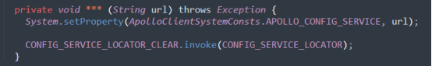

\*

|  |
| --- |
| mockConfigServiceUrl |
| mockConfigurationServiceUniformResourceLocator |

Please kindly explain why the selected option should be preferred.

\*

|  |
| --- |
| □Use of widely recognized abbreviations that do not hinder the understanding of the source code |
| □Excessively lengthy method names significantly impact code readability |
| □Consistency with the naming conventions of identifiers within the method body |
| □Less common abbreviation influences the understanding of the source code |
| □Method name with full terms are not excessively long and full terms tend to be more readable |
| □Others \_\_\_\_\_\_\_\_\_\_\_\_\_\_\_\_\_ |

14. Please read through the following code snippet where the original method name is marked by "\*\*\*". If necessary, you can refer to the enclosing class of the method at [this link](https://r.wjx.com/redirect.aspx?url=https%3A%2F%2Fgithub.com%2Fjiangyanjie%2FsurveyData%2Fblob%2Fmain%2FSecondRound%2F14%2F14.java&activity=267595662" \t "_blank). Among the names provided below, please indicate your preference for the method name.

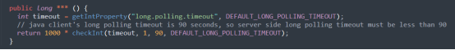

\*

|  |
| --- |
| longPollingTimeoutInMilli |
| longPollingTimeoutInMillisecond |

Please kindly explain why the selected option should be preferred.

\*

|  |
| --- |
| □Use of widely recognized abbreviations that do not hinder the understanding of the source code |
| □Excessively lengthy method names significantly impact code readability |
| □Consistency with the naming conventions of identifiers within the method body |
| □Less common abbreviation influences the understanding of the source code |
| □Method name with full terms are not excessively long and full terms tend to be more readable |
| □Others \_\_\_\_\_\_\_\_\_\_\_\_\_\_\_\_\_ |

15. Please read through the following code snippet where the original method name is marked by "\*\*\*". If necessary, you can refer to the enclosing class of the method at [this link](https://r.wjx.com/redirect.aspx?url=https%3A%2F%2Fgithub.com%2Fjiangyanjie%2FsurveyData%2Fblob%2Fmain%2FSecondRound%2F15%2F15.java&activity=267595662" \t "_blank). Among the names provided below, please indicate your preference for the method name.

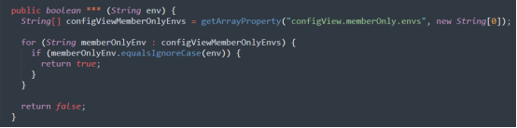

\*

|  |
| --- |
| isConfigViewMemberOnly |
| isConfigurationViewMemberOnly |

Please kindly explain why the selected option should be preferred.

\*

|  |
| --- |
| □Use of widely recognized abbreviations that do not hinder the understanding of the source code |
| □Excessively lengthy method names significantly impact code readability |
| □Consistency with the naming conventions of identifiers within the method body |
| □Less common abbreviation influences the understanding of the source code |
| □Method name with full terms are not excessively long and full terms tend to be more readable |
| □Others \_\_\_\_\_\_\_\_\_\_\_\_\_\_\_\_\_ |

16. Please read through the following code snippet where the original method name is marked by "\*\*\*". If necessary, you can refer to the enclosing class of the method at [this link](https://r.wjx.com/redirect.aspx?url=https%3A%2F%2Fgithub.com%2Fjiangyanjie%2FsurveyData%2Fblob%2Fmain%2FSecondRound%2F16%2F16.java&activity=267595662" \t "_blank). Among the names provided below, please indicate your preference for the method name.

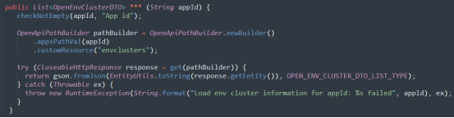

\*

|  |
| --- |
| getEnvClusterInfo |
| getEnvironmentClusterInformation |

Please kindly explain why the selected option should be preferred.

\*

|  |
| --- |
| □Use of widely recognized abbreviations that do not hinder the understanding of the source code |
| □Excessively lengthy method names significantly impact code readability |
| □Consistency with the naming conventions of identifiers within the method body |
| □Less common abbreviation influences the understanding of the source code |
| □Method name with full terms are not excessively long and full terms tend to be more readable |
| □Others \_\_\_\_\_\_\_\_\_\_\_\_\_\_\_\_\_ |

17. Please read through the following code snippet where the original method name is marked by "\*\*\*". If necessary, you can refer to the enclosing class of the method at [this link](https://r.wjx.com/redirect.aspx?url=https%3A%2F%2Fgithub.com%2Fjiangyanjie%2FsurveyData%2Fblob%2Fmain%2FSecondRound%2F17%2F17.java&activity=267595662" \t "_blank). Among the names provided below, please indicate your preference for the method name.

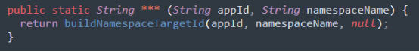

\*

|  |
| --- |
| buildNamespaceTargetId |
| buildNamespaceTargetIdentifier |

Please kindly explain why the selected option should be preferred.

\*

|  |
| --- |
| □Use of widely recognized abbreviations that do not hinder the understanding of the source code |
| □Excessively lengthy method names significantly impact code readability |
| □Consistency with the naming conventions of identifiers within the method body |
| □Less common abbreviation influences the understanding of the source code |
| □Method name with full terms are not excessively long and full terms tend to be more readable |
| □Others \_\_\_\_\_\_\_\_\_\_\_\_\_\_\_\_\_ |

18. Please read through the following code snippet where the original method name is marked by "\*\*\*". If necessary, you can refer to the enclosing class of the method at [this link](https://r.wjx.com/redirect.aspx?url=https%3A%2F%2Fgithub.com%2Fjiangyanjie%2FsurveyData%2Fblob%2Fmain%2FSecondRound%2F18%2F18.java&activity=267595662" \t "_blank). Among the names provided below, please indicate your preference for the method name.

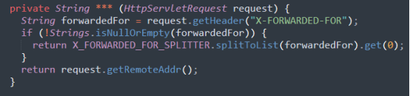

\*

|  |
| --- |
| tryToGetClientIp |
| tryToGetClientInternetProtocol |

Please kindly explain why the selected option should be preferred.

\*

|  |
| --- |
| □Use of widely recognized abbreviations that do not hinder the understanding of the source code |
| □Excessively lengthy method names significantly impact code readability |
| □Consistency with the naming conventions of identifiers within the method body |
| □Less common abbreviation influences the understanding of the source code |
| □Method name with full terms are not excessively long and full terms tend to be more readable |
| □Others \_\_\_\_\_\_\_\_\_\_\_\_\_\_\_\_\_ |

19. Please read through the following code snippet where the original method name is marked by "\*\*\*". If necessary, you can refer to the enclosing class of the method at[this link](https://r.wjx.com/redirect.aspx?url=https%3A%2F%2Fgithub.com%2Fjiangyanjie%2FsurveyData%2Fblob%2Fmain%2FSecondRound%2F19%2F19.java&activity=267595662" \t "_blank). Among the names provided below, please indicate your preference for the method name.

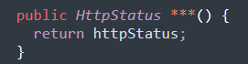

\*

|  |
| --- |
| getHttpStatus |
| getHypertextTransferProtocolStatus |

Please kindly explain why the selected option should be preferred.

\*

|  |
| --- |
| □Use of widely recognized abbreviations that do not hinder the understanding of the source code |
| □Excessively lengthy method names significantly impact code readability |
| □Consistency with the naming conventions of identifiers within the method body |
| □Less common abbreviation influences the understanding of the source code |
| □Method name with full terms are not excessively long and full terms tend to be more readable |
| □Others \_\_\_\_\_\_\_\_\_\_\_\_\_\_\_\_\_ |

20. Please read through the following code snippet where the original method name is marked by "\*\*\*". If necessary, you can refer to the enclosing class of the method at [this link](https://r.wjx.com/redirect.aspx?url=https%3A%2F%2Fgithub.com%2Fjiangyanjie%2FsurveyData%2Fblob%2Fmain%2FSecondRound%2F20%2F20.java&activity=267595662" \t "_blank). Among the names provided below, please indicate your preference for the method name.

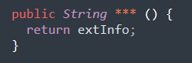

\*

|  |
| --- |
| getExtInfo |
| getExtensionInformation |

Please kindly explain why the selected option should be preferred.

\*

|  |
| --- |
| □Use of widely recognized abbreviations that do not hinder the understanding of the source code |
| □Excessively lengthy method names significantly impact code readability |
| □Consistency with the naming conventions of identifiers within the method body |
| □Less common abbreviation influences the understanding of the source code |
| □Method name with full terms are not excessively long and full terms tend to be more readable |
| □Others \_\_\_\_\_\_\_\_\_\_\_\_\_\_\_\_\_ |

21. Please read through the following code snippet where the original method name is marked by "\*\*\*". If necessary, you can refer to the enclosing class of the method at [this link](https://r.wjx.com/redirect.aspx?url=https%3A%2F%2Fgithub.com%2Fjiangyanjie%2FsurveyData%2Fblob%2Fmain%2FSecondRound%2F21%2F21.java&activity=267595662" \t "_blank). Among the names provided below, please indicate your preference for the method name.

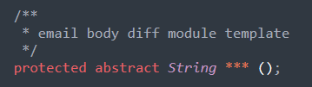

\*

|  |
| --- |
| getDiffModuleTemplate |
| getDifferentModuleTemplate |

Please kindly explain why the selected option should be preferred.

\*

|  |
| --- |
| □Use of widely recognized abbreviations that do not hinder the understanding of the source code |
| □Excessively lengthy method names significantly impact code readability |
| □Consistency with the naming conventions of identifiers within the method body |
| □Less common abbreviation influences the understanding of the source code |
| □Method name with full terms are not excessively long and full terms tend to be more readable |
| □Others \_\_\_\_\_\_\_\_\_\_\_\_\_\_\_\_\_ |

22. Please read through the following code snippet where the original method name is marked by "\*\*\*". If necessary, you can refer to the enclosing class of the method at [this link](https://r.wjx.com/redirect.aspx?url=https%3A%2F%2Fgithub.com%2Fjiangyanjie%2FsurveyData%2Fblob%2Fmain%2FSecondRound%2F22%2F22.java&activity=267595662" \t "_blank). Among the names provided below, please indicate your preference for the method name.

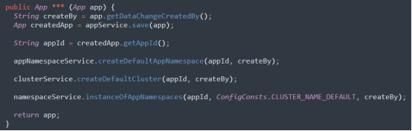

\*

|  |
| --- |
| createNewApp |
| createNewApplication |

Please kindly explain why the selected option should be preferred.

\*

|  |
| --- |
| □Use of widely recognized abbreviations that do not hinder the understanding of the source code |
| □Excessively lengthy method names significantly impact code readability |
| □Consistency with the naming conventions of identifiers within the method body |
| □Less common abbreviation influences the understanding of the source code |
| □Method name with full terms are not excessively long and full terms tend to be more readable |
| □Others \_\_\_\_\_\_\_\_\_\_\_\_\_\_\_\_\_ |

23. Please read through the following code snippet where the original method name is marked by "\*\*\*". If necessary, you can refer to the enclosing class of the method at [this link](https://r.wjx.com/redirect.aspx?url=https%3A%2F%2Fgithub.com%2Fjiangyanjie%2FsurveyData%2Fblob%2Fmain%2FSecondRound%2F23%2F23.java&activity=267595662" \t "_blank). Among the names provided below, please indicate your preference for the method name.

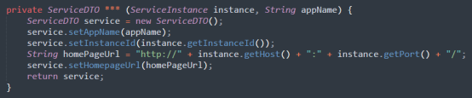

\*

|  |
| --- |
| toServiceDTO |
| toServiceDataTransferObject |

Please kindly explain why the selected option should be preferred.

\*

|  |
| --- |
| □Use of widely recognized abbreviations that do not hinder the understanding of the source code |
| □Excessively lengthy method names significantly impact code readability |
| □Consistency with the naming conventions of identifiers within the method body |
| □Less common abbreviation influences the understanding of the source code |
| □Method name with full terms are not excessively long and full terms tend to be more readable |
| □Others \_\_\_\_\_\_\_\_\_\_\_\_\_\_\_\_\_ |

24. Please read through the following code snippet where the original method name is marked by "\*\*\*". If necessary, you can refer to the enclosing class of the method at[this link](https://r.wjx.com/redirect.aspx?url=https%3A%2F%2Fgithub.com%2Fjiangyanjie%2FsurveyData%2Fblob%2Fmain%2FSecondRound%2F24%2F24.java&activity=267595662" \t "_blank). Among the names provided below, please indicate your preference for the method name.

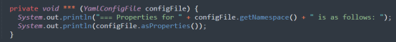

\*

|  |
| --- |
| printYaml |
| printYetAnotherMulticolumnLayout |

Please kindly explain why the selected option should be preferred.

\*

|  |
| --- |
| □Use of widely recognized abbreviations that do not hinder the understanding of the source code |
| □Excessively lengthy method names significantly impact code readability |
| □Consistency with the naming conventions of identifiers within the method body |
| □Less common abbreviation influences the understanding of the source code |
| □Method name with full terms are not excessively long and full terms tend to be more readable |
| □Others \_\_\_\_\_\_\_\_\_\_\_\_\_\_\_\_\_ |

25. Please read through the following code snippet where the original method name is marked by "\*\*\*". If necessary, you can refer to the enclosing class of the method at [this link](https://r.wjx.com/redirect.aspx?url=https%3A%2F%2Fgithub.com%2Fjiangyanjie%2FsurveyData%2Fblob%2Fmain%2FSecondRound%2F25%2F25.java&activity=267595662" \t "_blank). Among the names provided below, please indicate your preference for the method name.

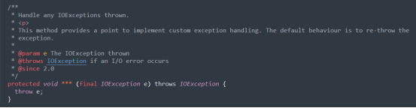

\*

|  |
| --- |
| handleIOException |
| handleInputOutputException |

Please kindly explain why the selected option should be preferred.

\*

|  |
| --- |
| □Use of widely recognized abbreviations that do not hinder the understanding of the source code |
| □Excessively lengthy method names significantly impact code readability |
| □Consistency with the naming conventions of identifiers within the method body |
| □Less common abbreviation influences the understanding of the source code |
| □Method name with full terms are not excessively long and full terms tend to be more readable |
| □Others \_\_\_\_\_\_\_\_\_\_\_\_\_\_\_\_\_ |

26. Please read through the following code snippet where the original method name is marked by "\*\*\*". If necessary, you can refer to the enclosing class of the method at [this link](https://r.wjx.com/redirect.aspx?url=https%3A%2F%2Fgithub.com%2Fjiangyanjie%2FsurveyData%2Fblob%2Fmain%2FSecondRound%2F26%2F26.java&activity=267595662" \t "_blank). Among the names provided below, please indicate your preference for the method name.

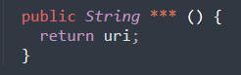

\*

|  |
| --- |
| getUri |
| getUniformResourceIdentifier |

Please kindly explain why the selected option should be preferred.

\*

|  |
| --- |
| □Use of widely recognized abbreviations that do not hinder the understanding of the source code |
| □Excessively lengthy method names significantly impact code readability |
| □Consistency with the naming conventions of identifiers within the method body |
| □Less common abbreviation influences the understanding of the source code |
| □Method name with full terms are not excessively long and full terms tend to be more readable |
| □Others \_\_\_\_\_\_\_\_\_\_\_\_\_\_\_\_\_ |

27. Please read through the following code snippet where the original method name is marked by "\*\*\*". If necessary, you can refer to the enclosing class of the method at [this link](https://r.wjx.com/redirect.aspx?url=https%3A%2F%2Fgithub.com%2Fjiangyanjie%2FsurveyData%2Fblob%2Fmain%2FSecondRound%2F27%2F27.java&activity=267595662" \t "_blank). Among the names provided below, please indicate your preference for the method name.

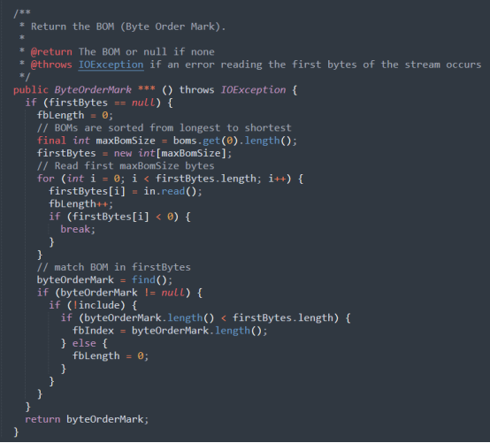

\*

|  |
| --- |
| getBOM |
| getByteOrderMark |

Please kindly explain why the selected option should be preferred.

\*

|  |
| --- |
| □Use of widely recognized abbreviations that do not hinder the understanding of the source code |
| □Excessively lengthy method names significantly impact code readability |
| □Consistency with the naming conventions of identifiers within the method body |
| □Less common abbreviation influences the understanding of the source code |
| □Method name with full terms are not excessively long and full terms tend to be more readable |
| □Others \_\_\_\_\_\_\_\_\_\_\_\_\_\_\_\_\_ |

28. Please read through the following code snippet where the original method name is marked by "\*\*\*". If necessary, you can refer to the enclosing class of the method at [this link](https://r.wjx.com/redirect.aspx?url=https%3A%2F%2Fgithub.com%2Fjiangyanjie%2FsurveyData%2Fblob%2Fmain%2FSecondRound%2F28%2F28.java&activity=267595662" \t "_blank). Among the names provided below, please indicate your preference for the method name.

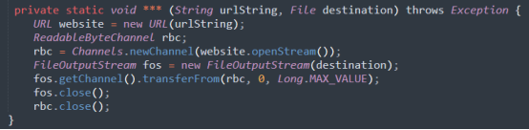

\*

|  |
| --- |
| downloadFileFromURL |
| downloadFileFromUniformResourceLocator |

Please kindly explain why the selected option should be preferred.

\*

|  |
| --- |
| □Use of widely recognized abbreviations that do not hinder the understanding of the source code |
| □Excessively lengthy method names significantly impact code readability |
| □Consistency with the naming conventions of identifiers within the method body |
| □Less common abbreviation influences the understanding of the source code |
| □Method name with full terms are not excessively long and full terms tend to be more readable |
| □Others \_\_\_\_\_\_\_\_\_\_\_\_\_\_\_\_\_ |

29. Please read through the following code snippet where the original method name is marked by "\*\*\*". If necessary, you can refer to the enclosing class of the method at [this link](https://r.wjx.com/redirect.aspx?url=https%3A%2F%2Fgithub.com%2Fjiangyanjie%2FsurveyData%2Fblob%2Fmain%2FSecondRound%2F29%2F29.java&activity=267595662" \t "_blank). Among the names provided below, please indicate your preference for the method name.

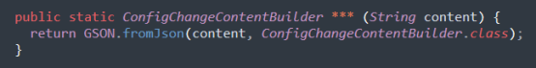

\*

|  |
| --- |
| convertJsonString |
| convertJavaScriptObjectNotationString |

Please kindly explain why the selected option should be preferred.

\*

|  |
| --- |
| □Use of widely recognized abbreviations that do not hinder the understanding of the source code |
| □Excessively lengthy method names significantly impact code readability |
| □Consistency with the naming conventions of identifiers within the method body |
| □Less common abbreviation influences the understanding of the source code |
| □Method name with full terms are not excessively long and full terms tend to be more readable |
| □Others \_\_\_\_\_\_\_\_\_\_\_\_\_\_\_\_\_ |

30. Please read through the following code snippet where the original method name is marked by "\*\*\*". If necessary, you can refer to the enclosing class of the method at [this link](https://r.wjx.com/redirect.aspx?url=https%3A%2F%2Fgithub.com%2Fjiangyanjie%2FsurveyData%2Fblob%2Fmain%2FSecondRound%2F30%2F30.java&activity=267595662" \t "_blank). Among the names provided below, please indicate your preference for the method name.

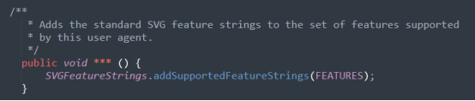

\*

|  |
| --- |
| addStdFeatures |
| addStandardFeatures |

Please kindly explain why the selected option should be preferred.

\*

|  |
| --- |
| □Use of widely recognized abbreviations that do not hinder the understanding of the source code |
| □Excessively lengthy method names significantly impact code readability |
| □Consistency with the naming conventions of identifiers within the method body |
| □Less common abbreviation influences the understanding of the source code |
| □Method name with full terms are not excessively long and full terms tend to be more readable |
| □Others \_\_\_\_\_\_\_\_\_\_\_\_\_\_\_\_\_ |

31. Please read through the following code snippet where the original method name is marked by "\*\*\*". If necessary, you can refer to the enclosing class of the method at [this link](https://r.wjx.com/redirect.aspx?url=https%3A%2F%2Fgithub.com%2Fjiangyanjie%2FsurveyData%2Fblob%2Fmain%2FSecondRound%2F31%2F31.java&activity=267595662" \t "_blank). Among the names provided below, please indicate your preference for the method name.

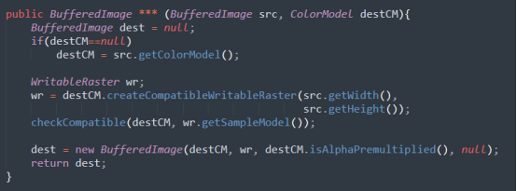

\*

|  |
| --- |
| createCompatibleDestImage |
| createCompatibleDestinationImage |

Please kindly explain why the selected option should be preferred.

\*

|  |
| --- |
| □Use of widely recognized abbreviations that do not hinder the understanding of the source code |
| □Excessively lengthy method names significantly impact code readability |
| □Consistency with the naming conventions of identifiers within the method body |
| □Less common abbreviation influences the understanding of the source code |
| □Method name with full terms are not excessively long and full terms tend to be more readable |
| □Others \_\_\_\_\_\_\_\_\_\_\_\_\_\_\_\_\_ |

32. Please read through the following code snippet where the original method name is marked by "\*\*\*". If necessary, you can refer to the enclosing class of the method at [this link](https://r.wjx.com/redirect.aspx?url=https%3A%2F%2Fgithub.com%2Fjiangyanjie%2FsurveyData%2Fblob%2Fmain%2FSecondRound%2F32%2F32.java&activity=267595662" \t "_blank). Among the names provided below, please indicate your preference for the method name.

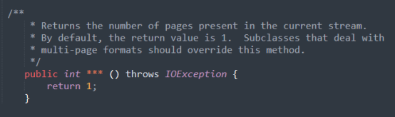

\*

|  |
| --- |
| getNumPages |
| getNumberPages |

Please kindly explain why the selected option should be preferred.

\*

|  |
| --- |
| □Use of widely recognized abbreviations that do not hinder the understanding of the source code |
| □Excessively lengthy method names significantly impact code readability |
| □Consistency with the naming conventions of identifiers within the method body |
| □Less common abbreviation influences the understanding of the source code |
| □Method name with full terms are not excessively long and full terms tend to be more readable |
| □Others \_\_\_\_\_\_\_\_\_\_\_\_\_\_\_\_\_ |

33. Please read through the following code snippet where the original method name is marked by "\*\*\*". If necessary, you can refer to the enclosing class of the method at [this link](https://r.wjx.com/redirect.aspx?url=https%3A%2F%2Fgithub.com%2Fjiangyanjie%2FsurveyData%2Fblob%2Fmain%2FSecondRound%2F33%2F33.java&activity=267595662" \t "_blank). Among the names provided below, please indicate your preference for the method name.

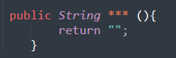

\*

|  |
| --- |
| getRefPrefix |
| getReferencePrefix |

Please kindly explain why the selected option should be preferred.

\*

|  |
| --- |
| □Use of widely recognized abbreviations that do not hinder the understanding of the source code |
| □Excessively lengthy method names significantly impact code readability |
| □Consistency with the naming conventions of identifiers within the method body |
| □Less common abbreviation influences the understanding of the source code |
| □Method name with full terms are not excessively long and full terms tend to be more readable |
| □Others \_\_\_\_\_\_\_\_\_\_\_\_\_\_\_\_\_ |

34. Please read through the following code snippet where the original method name is marked by "\*\*\*". If necessary, you can refer to the enclosing class of the method at [this link](https://r.wjx.com/redirect.aspx?url=https%3A%2F%2Fgithub.com%2Fjiangyanjie%2FsurveyData%2Fblob%2Fmain%2FSecondRound%2F34%2F34.java&activity=267595662" \t "_blank). Among the names provided below, please indicate your preference for the method name.

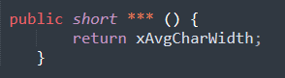

\*

|  |
| --- |
| getAvgCharWidth |
| getAverageCharWidth |

Please kindly explain why the selected option should be preferred.

\*

|  |
| --- |
| □Use of widely recognized abbreviations that do not hinder the understanding of the source code |
| □Excessively lengthy method names significantly impact code readability |
| □Consistency with the naming conventions of identifiers within the method body |
| □Less common abbreviation influences the understanding of the source code |
| □Method name with full terms are not excessively long and full terms tend to be more readable |
| □Others \_\_\_\_\_\_\_\_\_\_\_\_\_\_\_\_\_ |

35. Please read through the following code snippet where the original method name is marked by "\*\*\*". If necessary, you can refer to the enclosing class of the method at [this link](https://r.wjx.com/redirect.aspx?url=https%3A%2F%2Fgithub.com%2Fjiangyanjie%2FsurveyData%2Fblob%2Fmain%2FSecondRound%2F35%2F35.java&activity=267595662" \t "_blank). Among the names provided below, please indicate your preference for the method name.

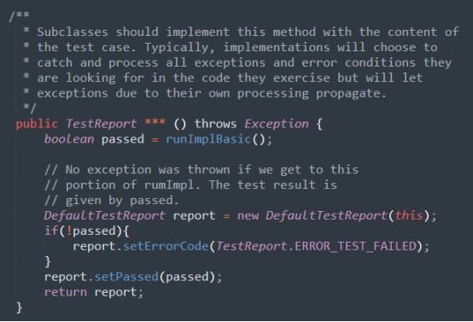

\*

|  |
| --- |
| runImpl |
| runImplementation |

Please kindly explain why the selected option should be preferred.

\*

|  |
| --- |
| □Use of widely recognized abbreviations that do not hinder the understanding of the source code |
| □Excessively lengthy method names significantly impact code readability |
| □Consistency with the naming conventions of identifiers within the method body |
| □Less common abbreviation influences the understanding of the source code |
| □Method name with full terms are not excessively long and full terms tend to be more readable |
| □Others \_\_\_\_\_\_\_\_\_\_\_\_\_\_\_\_\_ |

36. Please read through the following code snippet where the original method name is marked by "\*\*\*". If necessary, you can refer to the enclosing class of the method at [this link](https://r.wjx.com/redirect.aspx?url=https%3A%2F%2Fgithub.com%2Fjiangyanjie%2FsurveyData%2Fblob%2Fmain%2FSecondRound%2F36%2F36.java&activity=267595662" \t "_blank). Among the names provided below, please indicate your preference for the method name.

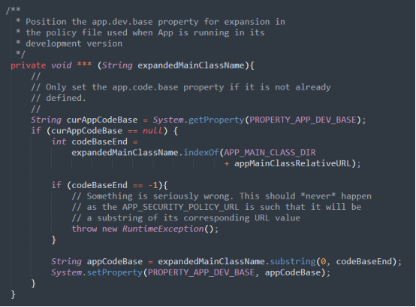

\*

|  |
| --- |
| setDevBase |
| setDevelopmentBase |

Please kindly explain why the selected option should be preferred.

\*

|  |
| --- |
| □Use of widely recognized abbreviations that do not hinder the understanding of the source code |
| □Excessively lengthy method names significantly impact code readability |
| □Consistency with the naming conventions of identifiers within the method body |
| □Less common abbreviation influences the understanding of the source code |
| □Method name with full terms are not excessively long and full terms tend to be more readable |
| □Others \_\_\_\_\_\_\_\_\_\_\_\_\_\_\_\_\_ |

37. Please read through the following code snippet where the original method name is marked by "\*\*\*". If necessary, you can refer to the enclosing class of the method at [this link](https://r.wjx.com/redirect.aspx?url=https%3A%2F%2Fgithub.com%2Fjiangyanjie%2FsurveyData%2Fblob%2Fmain%2FSecondRound%2F37%2F37.java&activity=267595662" \t "_blank). Among the names provided below, please indicate your preference for the method name.

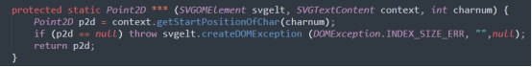

\*

|  |
| --- |
| getStartPos |
| getStartPosition |

Please kindly explain why the selected option should be preferred.

\*

|  |
| --- |
| □Use of widely recognized abbreviations that do not hinder the understanding of the source code |
| □Excessively lengthy method names significantly impact code readability |
| □Consistency with the naming conventions of identifiers within the method body |
| □Less common abbreviation influences the understanding of the source code |
| □Method name with full terms are not excessively long and full terms tend to be more readable |
| □Others \_\_\_\_\_\_\_\_\_\_\_\_\_\_\_\_\_ |

38. Please read through the following code snippet where the original method name is marked by "\*\*\*". If necessary, you can refer to the enclosing class of the method at [this link](https://r.wjx.com/redirect.aspx?url=https%3A%2F%2Fgithub.com%2Fjiangyanjie%2FsurveyData%2Fblob%2Fmain%2FSecondRound%2F38%2F38.java&activity=267595662" \t "_blank). Among the names provided below, please indicate your preference for the method name.

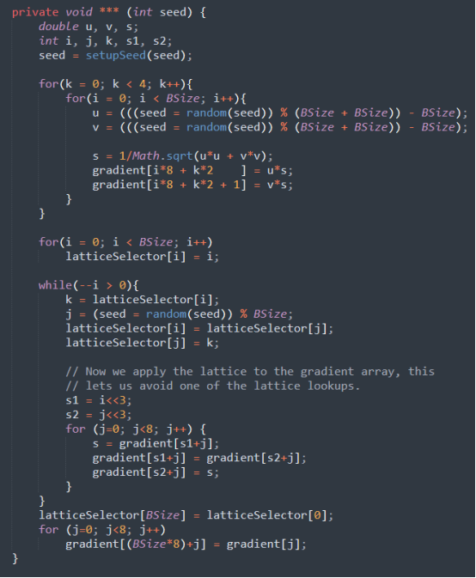

\*

|  |
| --- |
| initLattice |
| initializeLattice |

Please kindly explain why the selected option should be preferred.

\*

|  |
| --- |
| □Use of widely recognized abbreviations that do not hinder the understanding of the source code |
| □Excessively lengthy method names significantly impact code readability |
| □Consistency with the naming conventions of identifiers within the method body |
| □Less common abbreviation influences the understanding of the source code |
| □Method name with full terms are not excessively long and full terms tend to be more readable |
| □Others \_\_\_\_\_\_\_\_\_\_\_\_\_\_\_\_\_ |

39. Please read through the following code snippet where the original method name is marked by "\*\*\*". If necessary, you can refer to the enclosing class of the method at [this link](https://r.wjx.com/redirect.aspx?url=https%3A%2F%2Fgithub.com%2Fjiangyanjie%2FsurveyData%2Fblob%2Fmain%2FSecondRound%2F39%2F39.java&activity=267595662" \t "_blank). Among the names provided below, please indicate your preference for the method name.

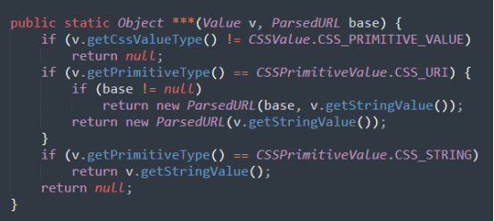

\*

|  |
| --- |
| getSrcValue |
| getSourceValue |

Please kindly explain why the selected option should be preferred.

\*

|  |
| --- |
| □Use of widely recognized abbreviations that do not hinder the understanding of the source code |
| □Excessively lengthy method names significantly impact code readability |
| □Consistency with the naming conventions of identifiers within the method body |
| □Less common abbreviation influences the understanding of the source code |
| □Method name with full terms are not excessively long and full terms tend to be more readable |
| □Others \_\_\_\_\_\_\_\_\_\_\_\_\_\_\_\_\_ |

40. Please read through the following code snippet where the original method name is marked by "\*\*\*". If necessary, you can refer to the enclosing class of the method at [this link](https://r.wjx.com/redirect.aspx?url=https%3A%2F%2Fgithub.com%2Fjiangyanjie%2FsurveyData%2Fblob%2Fmain%2FSecondRound%2F40%2F40.java&activity=267595662" \t "_blank). Among the names provided below, please indicate your preference for the method name.

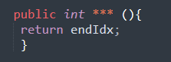

\*

|  |
| --- |
| getEndIdx |
| getEndIndex |

Please kindly explain why the selected option should be preferred.

\*

|  |
| --- |
| □Use of widely recognized abbreviations that do not hinder the understanding of the source code |
| □Excessively lengthy method names significantly impact code readability |
| □Consistency with the naming conventions of identifiers within the method body |
| □Less common abbreviation influences the understanding of the source code |
| □Method name with full terms are not excessively long and full terms tend to be more readable |
| □Others \_\_\_\_\_\_\_\_\_\_\_\_\_\_\_\_\_ |

41. Please read through the following code snippet where the original method name is marked by "\*\*\*". If necessary, you can refer to the enclosing class of the method at[this link](https://r.wjx.com/redirect.aspx?url=https%3A%2F%2Fgithub.com%2Fjiangyanjie%2FsurveyData%2Fblob%2Fmain%2FSecondRound%2F41%2F41.java&activity=267595662" \t "_blank). Among the names provided below, please indicate your preference for the method name.

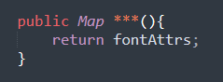

\*

|  |
| --- |
| getFontAttrs |
| getFontAttributes |

Please kindly explain why the selected option should be preferred.

\*

|  |
| --- |
| □Use of widely recognized abbreviations that do not hinder the understanding of the source code |
| □Excessively lengthy method names significantly impact code readability |
| □Consistency with the naming conventions of identifiers within the method body |
| □Less common abbreviation influences the understanding of the source code |
| □Method name with full terms are not excessively long and full terms tend to be more readable |
| □Others \_\_\_\_\_\_\_\_\_\_\_\_\_\_\_\_\_ |

42. Please read through the following code snippet where the original method name is marked by "\*\*\*". If necessary, you can refer to the enclosing class of the method at[this link](https://r.wjx.com/redirect.aspx?url=https%3A%2F%2Fgithub.com%2Fjiangyanjie%2FsurveyData%2Fblob%2Fmain%2FSecondRound%2F42%2F42.java&activity=267595662" \t "_blank). Among the names provided below, please indicate your preference for the method name.

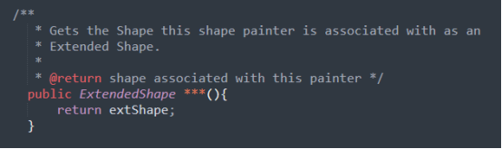

\*

|  |
| --- |
| getExtShape |
| getExtendedShape |

Please kindly explain why the selected option should be preferred.

\*

|  |
| --- |
| □Use of widely recognized abbreviations that do not hinder the understanding of the source code |
| □Excessively lengthy method names significantly impact code readability |
| □Consistency with the naming conventions of identifiers within the method body |
| □Less common abbreviation influences the understanding of the source code |
| □Method name with full terms are not excessively long and full terms tend to be more readable |
| □Others \_\_\_\_\_\_\_\_\_\_\_\_\_\_\_\_\_ |

43. Please read through the following code snippet where the original method name is marked by "\*\*\*". If necessary, you can refer to the enclosing class of the method at [this link](https://r.wjx.com/redirect.aspx?url=https%3A%2F%2Fgithub.com%2Fjiangyanjie%2FsurveyData%2Fblob%2Fmain%2FSecondRound%2F43%2F43.java&activity=267595662" \t "_blank). Among the names provided below, please indicate your preference for the method name.

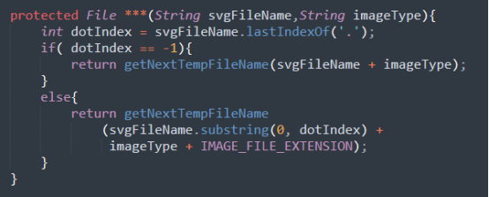

\*

|  |
| --- |
| makeTempFileName |
| makeTemporaryFileName |

Please kindly explain why the selected option should be preferred.

\*

|  |
| --- |
| □Use of widely recognized abbreviations that do not hinder the understanding of the source code |
| □Excessively lengthy method names significantly impact code readability |
| □Consistency with the naming conventions of identifiers within the method body |
| □Less common abbreviation influences the understanding of the source code |
| □Method name with full terms are not excessively long and full terms tend to be more readable |
| □Others \_\_\_\_\_\_\_\_\_\_\_\_\_\_\_\_\_ |

44. Please read through the following code snippet where the original method name is marked by "\*\*\*". If necessary, you can refer to the enclosing class of the method at [this link](https://r.wjx.com/redirect.aspx?url=https%3A%2F%2Fgithub.com%2Fjiangyanjie%2FsurveyData%2Fblob%2Fmain%2FSecondRound%2F44%2F44.java&activity=267595662" \t "_blank). Among the names provided below, please indicate your preference for the method name.

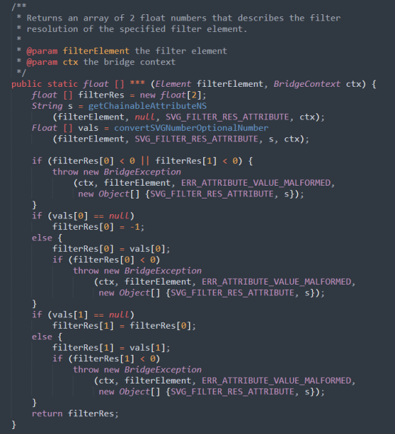

\*

|  |
| --- |
| convertFilterRes |
| convertFilterResolution |

Please kindly explain why the selected option should be preferred.

\*

|  |
| --- |
| □Use of widely recognized abbreviations that do not hinder the understanding of the source code |
| □Excessively lengthy method names significantly impact code readability |
| □Consistency with the naming conventions of identifiers within the method body |
| □Less common abbreviation influences the understanding of the source code |
| □Method name with full terms are not excessively long and full terms tend to be more readable |
| □Others \_\_\_\_\_\_\_\_\_\_\_\_\_\_\_\_\_ |

45. Please read through the following code snippet where the original method name is marked by "\*\*\*". If necessary, you can refer to the enclosing class of the method at[this link](https://r.wjx.com/redirect.aspx?url=https%3A%2F%2Fgithub.com%2Fjiangyanjie%2FsurveyData%2Fblob%2Fmain%2FSecondRound%2F45%2F45.java&activity=267595662" \t "_blank). Among the names provided below, please indicate your preference for the method name.

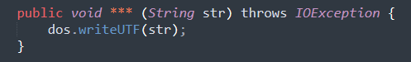

\*

|  |
| --- |
| writeUTF |
| writeUnicodeTransformationFormat |

Please kindly explain why the selected option should be preferred.

\*

|  |
| --- |
| □Use of widely recognized abbreviations that do not hinder the understanding of the source code |
| □Excessively lengthy method names significantly impact code readability |
| □Consistency with the naming conventions of identifiers within the method body |
| □Less common abbreviation influences the understanding of the source code |
| □Method name with full terms are not excessively long and full terms tend to be more readable |
| □Others \_\_\_\_\_\_\_\_\_\_\_\_\_\_\_\_\_ |

46. Please read through the following code snippet where the original method name is marked by "\*\*\*". If necessary, you can refer to the enclosing class of the method at [this link](https://r.wjx.com/redirect.aspx?url=https%3A%2F%2Fgithub.com%2Fjiangyanjie%2FsurveyData%2Fblob%2Fmain%2FSecondRound%2F46%2F46.java&activity=267595662" \t "_blank). Among the names provided below, please indicate your preference for the method name.

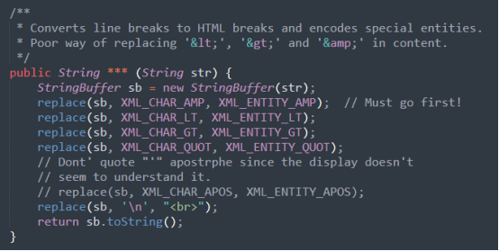

\*

|  |
| --- |
| toFormattedHTML |
| toFormattedHyperTextMarkupLanguage |

Please kindly explain why the selected option should be preferred.

\*

|  |
| --- |
| □Use of widely recognized abbreviations that do not hinder the understanding of the source code |
| □Excessively lengthy method names significantly impact code readability |
| □Consistency with the naming conventions of identifiers within the method body |
| □Less common abbreviation influences the understanding of the source code |
| □Method name with full terms are not excessively long and full terms tend to be more readable |
| □Others \_\_\_\_\_\_\_\_\_\_\_\_\_\_\_\_\_ |

47. Please read through the following code snippet where the original method name is marked by "\*\*\*". If necessary, you can refer to the enclosing class of the method at [this link](https://r.wjx.com/redirect.aspx?url=https%3A%2F%2Fgithub.com%2Fjiangyanjie%2FsurveyData%2Fblob%2Fmain%2FSecondRound%2F47%2F47.java&activity=267595662" \t "_blank). Among the names provided below, please indicate your preference for the method name.

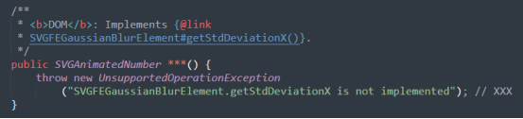

\*

|  |
| --- |
| getStdDeviationX |
| getStandardDeviationX |

Please kindly explain why the selected option should be preferred.

\*

|  |
| --- |
| □Use of widely recognized abbreviations that do not hinder the understanding of the source code |
| □Excessively lengthy method names significantly impact code readability |
| □Consistency with the naming conventions of identifiers within the method body |
| □Less common abbreviation influences the understanding of the source code |
| □Method name with full terms are not excessively long and full terms tend to be more readable |
| □Others \_\_\_\_\_\_\_\_\_\_\_\_\_\_\_\_\_ |

48. Please read through the following code snippet where the original method name is marked by "\*\*\*". If necessary, you can refer to the enclosing class of the method at [this link](https://r.wjx.com/redirect.aspx?url=https%3A%2F%2Fgithub.com%2Fjiangyanjie%2FsurveyData%2Fblob%2Fmain%2FSecondRound%2F48%2F48.java&activity=267595662" \t "_blank). Among the names provided below, please indicate your preference for the method name.

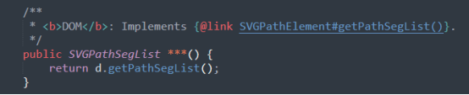

\*

|  |
| --- |
| getPathSegList |
| getPathSegmentList |

Please kindly explain why the selected option should be preferred.

\*

|  |
| --- |
| □Use of widely recognized abbreviations that do not hinder the understanding of the source code |
| □Excessively lengthy method names significantly impact code readability |
| □Consistency with the naming conventions of identifiers within the method body |
| □Less common abbreviation influences the understanding of the source code |
| □Method name with full terms are not excessively long and full terms tend to be more readable |
| □Others \_\_\_\_\_\_\_\_\_\_\_\_\_\_\_\_\_ |

49. Please read through the following code snippet where the original method name is marked by "\*\*\*". If necessary, you can refer to the enclosing class of the method at [this link](https://r.wjx.com/redirect.aspx?url=https%3A%2F%2Fgithub.com%2Fjiangyanjie%2FsurveyData%2Fblob%2Fmain%2FSecondRound%2F49%2F49.java&activity=267595662" \t "_blank). Among the names provided below, please indicate your preference for the method name.

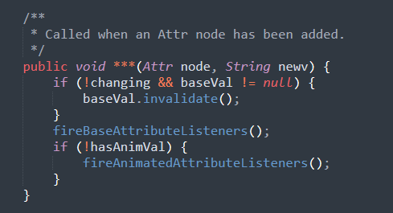

\*

|  |
| --- |
| attrAdded |
| attributeAdded |

Please kindly explain why the selected option should be preferred.

\*

|  |
| --- |
| □Use of widely recognized abbreviations that do not hinder the understanding of the source code |
| □Excessively lengthy method names significantly impact code readability |
| □Consistency with the naming conventions of identifiers within the method body |
| □Less common abbreviation influences the understanding of the source code |
| □Method name with full terms are not excessively long and full terms tend to be more readable |
| □Others \_\_\_\_\_\_\_\_\_\_\_\_\_\_\_\_\_ |

50. Please read through the following code snippet where the original method name is marked by "\*\*\*". If necessary, you can refer to the enclosing class of the method at [this link](https://r.wjx.com/redirect.aspx?url=https%3A%2F%2Fgithub.com%2Fjiangyanjie%2FsurveyData%2Fblob%2Fmain%2FSecondRound%2F50%2F50.java&activity=267595662" \t "_blank). Among the names provided below, please indicate your preference for the method name.

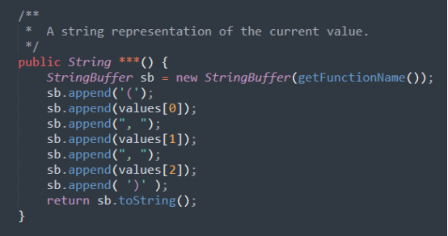

\*

|  |
| --- |
| getCssText |
| getCascadingStyleSheetsText |

Please kindly explain why the selected option should be preferred.

\*

|  |
| --- |
| □Use of widely recognized abbreviations that do not hinder the understanding of the source code |
| □Excessively lengthy method names significantly impact code readability |
| □Consistency with the naming conventions of identifiers within the method body |
| □Less common abbreviation influences the understanding of the source code |
| □Method name with full terms are not excessively long and full terms tend to be more readable |
| □Others \_\_\_\_\_\_\_\_\_\_\_\_\_\_\_\_\_ |

51. Please read through the following code snippet where the original method name is marked by "\*\*\*". If necessary, you can refer to the enclosing class of the method at [this link](https://r.wjx.com/redirect.aspx?url=https%3A%2F%2Fgithub.com%2Fjiangyanjie%2FsurveyData%2Fblob%2Fmain%2FSecondRound%2F51%2F51.java&activity=267595662" \t "_blank). Among the names provided below, please indicate your preference for the method name.

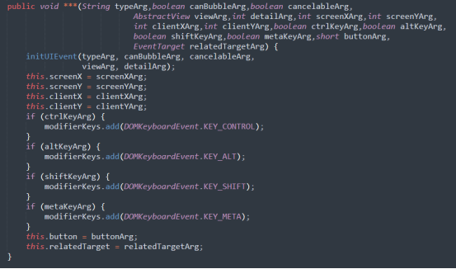

\*

|  |
| --- |
| initMouseEvent |
| initializeMouseEvent |

Please kindly explain why the selected option should be preferred.

\*

|  |
| --- |
| □Use of widely recognized abbreviations that do not hinder the understanding of the source code |
| □Excessively lengthy method names significantly impact code readability |
| □Consistency with the naming conventions of identifiers within the method body |
| □Less common abbreviation influences the understanding of the source code |
| □Method name with full terms are not excessively long and full terms tend to be more readable |
| □Others \_\_\_\_\_\_\_\_\_\_\_\_\_\_\_\_\_ |

52. Please read through the following code snippet where the original method name is marked by "\*\*\*". If necessary, you can refer to the enclosing class of the method at [this link](https://r.wjx.com/redirect.aspx?url=https%3A%2F%2Fgithub.com%2Fjiangyanjie%2FsurveyData%2Fblob%2Fmain%2FSecondRound%2F52%2F52.java&activity=267595662" \t "_blank). Among the names provided below, please indicate your preference for the method name.

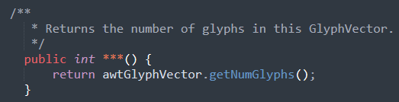

\*

|  |
| --- |
| getNumGlyphs |
| getNumberGlyphs |

Please kindly explain why the selected option should be preferred.

\*

|  |
| --- |
| □Use of widely recognized abbreviations that do not hinder the understanding of the source code |
| □Excessively lengthy method names significantly impact code readability |
| □Consistency with the naming conventions of identifiers within the method body |
| □Less common abbreviation influences the understanding of the source code |
| □Method name with full terms are not excessively long and full terms tend to be more readable |
| □Others \_\_\_\_\_\_\_\_\_\_\_\_\_\_\_\_\_ |

53. Please read through the following code snippet where the original method name is marked by "\*\*\*". If necessary, you can refer to the enclosing class of the method at [this link](https://r.wjx.com/redirect.aspx?url=https%3A%2F%2Fgithub.com%2Fjiangyanjie%2FsurveyData%2Fblob%2Fmain%2FSecondRound%2F53%2F53.java&activity=267595662" \t "_blank). Among the names provided below, please indicate your preference for the method name.

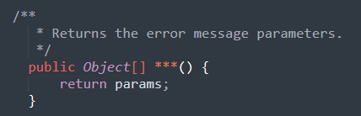

\*

|  |
| --- |
| getParams |
| getParameters |

Please kindly explain why the selected option should be preferred.

\*

|  |
| --- |
| □Use of widely recognized abbreviations that do not hinder the understanding of the source code |
| □Excessively lengthy method names significantly impact code readability |
| □Consistency with the naming conventions of identifiers within the method body |
| □Less common abbreviation influences the understanding of the source code |
| □Method name with full terms are not excessively long and full terms tend to be more readable |
| □Others \_\_\_\_\_\_\_\_\_\_\_\_\_\_\_\_\_ |

54. Please read through the following code snippet where the original method name is marked by "\*\*\*". If necessary, you can refer to the enclosing class of the method at [this link](https://r.wjx.com/redirect.aspx?url=https%3A%2F%2Fgithub.com%2Fjiangyanjie%2FsurveyData%2Fblob%2Fmain%2FSecondRound%2F54%2F54.java&activity=267595662" \t "_blank). Among the names provided below, please indicate your preference for the method name.

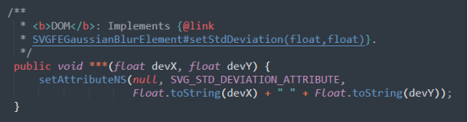

\*

|  |
| --- |
| setStdDeviation |
| setStandardDeviation |

Please kindly explain why the selected option should be preferred.

\*

|  |
| --- |
| □Use of widely recognized abbreviations that do not hinder the understanding of the source code |
| □Excessively lengthy method names significantly impact code readability |
| □Consistency with the naming conventions of identifiers within the method body |
| □Less common abbreviation influences the understanding of the source code |
| □Method name with full terms are not excessively long and full terms tend to be more readable |
| □Others \_\_\_\_\_\_\_\_\_\_\_\_\_\_\_\_\_ |

55. Please read through the following code snippet where the original method name is marked by "\*\*\*". If necessary, you can refer to the enclosing class of the method at [this link](https://r.wjx.com/redirect.aspx?url=https%3A%2F%2Fgithub.com%2Fjiangyanjie%2FsurveyData%2Fblob%2Fmain%2FSecondRound%2F55%2F55.java&activity=267595662" \t "_blank). Among the names provided below, please indicate your preference for the method name.

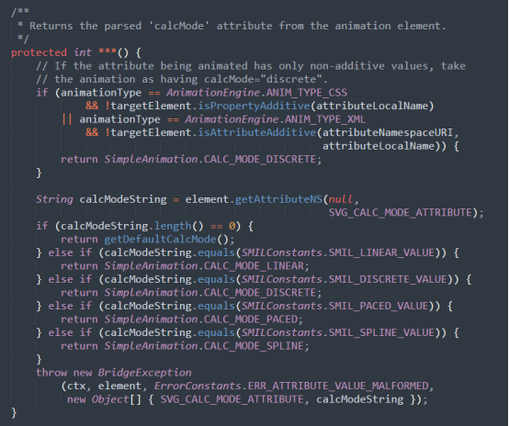

\*

|  |
| --- |
| parseCalcMode |
| parseCalculationMode |

Please kindly explain why the selected option should be preferred.

\*

|  |
| --- |
| □Use of widely recognized abbreviations that do not hinder the understanding of the source code |
| □Excessively lengthy method names significantly impact code readability |
| □Consistency with the naming conventions of identifiers within the method body |
| □Less common abbreviation influences the understanding of the source code |
| □Method name with full terms are not excessively long and full terms tend to be more readable |
| □Others \_\_\_\_\_\_\_\_\_\_\_\_\_\_\_\_\_ |

56. Please read through the following code snippet where the original method name is marked by "\*\*\*". If necessary, you can refer to the enclosing class of the method at [this link](https://r.wjx.com/redirect.aspx?url=https%3A%2F%2Fgithub.com%2Fjiangyanjie%2FsurveyData%2Fblob%2Fmain%2FSecondRound%2F56%2F56.java&activity=267595662" \t "_blank). Among the names provided below, please indicate your preference for the method name.

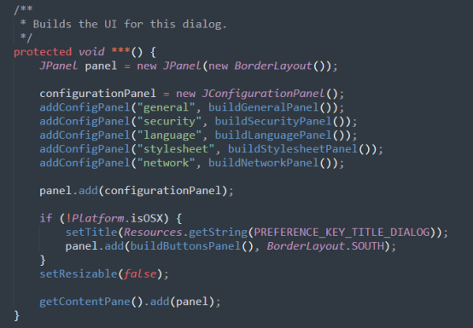

\*

|  |
| --- |
| buildGUI |
| buildGraphicalUserInterface |

Please kindly explain why the selected option should be preferred.

\*

|  |
| --- |
| □Use of widely recognized abbreviations that do not hinder the understanding of the source code |
| □Excessively lengthy method names significantly impact code readability |
| □Consistency with the naming conventions of identifiers within the method body |
| □Less common abbreviation influences the understanding of the source code |
| □Method name with full terms are not excessively long and full terms tend to be more readable |
| □Others \_\_\_\_\_\_\_\_\_\_\_\_\_\_\_\_\_ |

57. Please read through the following code snippet where the original method name is marked by "\*\*\*". If necessary, you can refer to the enclosing class of the method at [this link](https://r.wjx.com/redirect.aspx?url=https%3A%2F%2Fgithub.com%2Fjiangyanjie%2FsurveyData%2Fblob%2Fmain%2FSecondRound%2F57%2F57.java&activity=267595662" \t "_blank). Among the names provided below, please indicate your preference for the method name.



\*

|  |
| --- |
| isJdk |
| isJavaDevelopmentKit |

Please kindly explain why the selected option should be preferred.

\*

|  |
| --- |
| □Use of widely recognized abbreviations that do not hinder the understanding of the source code |
| □Excessively lengthy method names significantly impact code readability |
| □Consistency with the naming conventions of identifiers within the method body |
| □Less common abbreviation influences the understanding of the source code |
| □Method name with full terms are not excessively long and full terms tend to be more readable |
| □Others \_\_\_\_\_\_\_\_\_\_\_\_\_\_\_\_\_ |

58. Please read through the following code snippet where the original method name is marked by "\*\*\*". If necessary, you can refer to the enclosing class of the method at [this link](https://r.wjx.com/redirect.aspx?url=https%3A%2F%2Fgithub.com%2Fjiangyanjie%2FsurveyData%2Fblob%2Fmain%2FSecondRound%2F58%2F58.java&activity=267595662" \t "_blank). Among the names provided below, please indicate your preference for the method name.

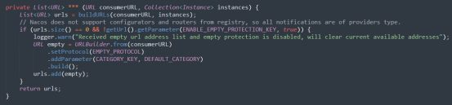

\*

|  |
| --- |
| toUrlWithEmpty |
| toUniformResourceLocatorWithEmpty |

Please kindly explain why the selected option should be preferred.

\*

|  |
| --- |
| □Use of widely recognized abbreviations that do not hinder the understanding of the source code |
| □Excessively lengthy method names significantly impact code readability |
| □Consistency with the naming conventions of identifiers within the method body |
| □Less common abbreviation influences the understanding of the source code |
| □Method name with full terms are not excessively long and full terms tend to be more readable |
| □Others \_\_\_\_\_\_\_\_\_\_\_\_\_\_\_\_\_ |

59. Please read through the following code snippet where the original method name is marked by "\*\*\*". If necessary, you can refer to the enclosing class of the method at [this link](https://r.wjx.com/redirect.aspx?url=https%3A%2F%2Fgithub.com%2Fjiangyanjie%2FsurveyData%2Fblob%2Fmain%2FSecondRound%2F59%2F59.java&activity=267595662" \t "_blank). Among the names provided below, please indicate your preference for the method name.

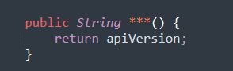

\*

|  |
| --- |
| getApiVersion |
| getApplicationProgramInterfaceVersion |

Please kindly explain why the selected option should be preferred.

\*

|  |
| --- |
| □Use of widely recognized abbreviations that do not hinder the understanding of the source code |
| □Excessively lengthy method names significantly impact code readability |
| □Consistency with the naming conventions of identifiers within the method body |
| □Less common abbreviation influences the understanding of the source code |
| □Method name with full terms are not excessively long and full terms tend to be more readable |
| □Others \_\_\_\_\_\_\_\_\_\_\_\_\_\_\_\_\_ |

60. Please read through the following code snippet where the original method name is marked by "\*\*\*". If necessary, you can refer to the enclosing class of the method at [this link](https://r.wjx.com/redirect.aspx?url=https%3A%2F%2Fgithub.com%2Fjiangyanjie%2FsurveyData%2Fblob%2Fmain%2FSecondRound%2F60%2F60.java&activity=267595662" \t "_blank). Among the names provided below, please indicate your preference for the method name.

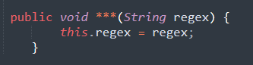

\*

|  |
| --- |
| setRegex |
| setRegularExpression |

Please kindly explain why the selected option should be preferred.

\*

|  |
| --- |
| □Use of widely recognized abbreviations that do not hinder the understanding of the source code |
| □Excessively lengthy method names significantly impact code readability |
| □Consistency with the naming conventions of identifiers within the method body |
| □Less common abbreviation influences the understanding of the source code |
| □Method name with full terms are not excessively long and full terms tend to be more readable |
| □Others \_\_\_\_\_\_\_\_\_\_\_\_\_\_\_\_\_ |

61. Please read through the following code snippet where the original method name is marked by "\*\*\*". If necessary, you can refer to the enclosing class of the method at [this link](https://r.wjx.com/redirect.aspx?url=https%3A%2F%2Fgithub.com%2Fjiangyanjie%2FsurveyData%2Fblob%2Fmain%2FSecondRound%2F61%2F61.java&activity=267595662" \t "_blank). Among the names provided below, please indicate your preference for the method name.

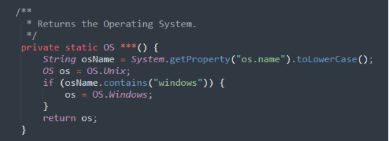

\*

|  |
| --- |
| getOS |
| getOperatingSystem |

Please kindly explain why the selected option should be preferred.

\*

|  |
| --- |
| □Use of widely recognized abbreviations that do not hinder the understanding of the source code |
| □Excessively lengthy method names significantly impact code readability |
| □Consistency with the naming conventions of identifiers within the method body |
| □Less common abbreviation influences the understanding of the source code |
| □Method name with full terms are not excessively long and full terms tend to be more readable |
| □Others \_\_\_\_\_\_\_\_\_\_\_\_\_\_\_\_\_ |

62. Please read through the following code snippet where the original method name is marked by "\*\*\*". If necessary, you can refer to the enclosing class of the method at [this link](https://r.wjx.com/redirect.aspx?url=https%3A%2F%2Fgithub.com%2Fjiangyanjie%2FsurveyData%2Fblob%2Fmain%2FSecondRound%2F62%2F62.java&activity=267595662" \t "_blank). Among the names provided below, please indicate your preference for the method name.

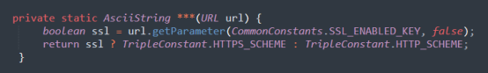

\*

|  |
| --- |
| getSchemeFromUrl |
| getSchemeFromUniformResourceLocator |

Please kindly explain why the selected option should be preferred.

\*

|  |
| --- |
| □Use of widely recognized abbreviations that do not hinder the understanding of the source code |
| □Excessively lengthy method names significantly impact code readability |
| □Consistency with the naming conventions of identifiers within the method body |
| □Less common abbreviation influences the understanding of the source code |
| □Method name with full terms are not excessively long and full terms tend to be more readable |
| □Others \_\_\_\_\_\_\_\_\_\_\_\_\_\_\_\_\_ |

63. Please read through the following code snippet where the original method name is marked by "\*\*\*". If necessary, you can refer to the enclosing class of the method at [this link](https://r.wjx.com/redirect.aspx?url=https%3A%2F%2Fgithub.com%2Fjiangyanjie%2FsurveyData%2Fblob%2Fmain%2FSecondRound%2F63%2F63.java&activity=267595662" \t "_blank). Among the names provided below, please indicate your preference for the method name.

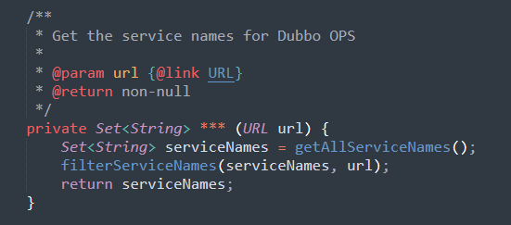

\*

|  |
| --- |
| getServiceNamesForOps |
| getServiceNamesForOperations |

Please kindly explain why the selected option should be preferred.

\*

|  |
| --- |
| □Use of widely recognized abbreviations that do not hinder the understanding of the source code |
| □Excessively lengthy method names significantly impact code readability |
| □Consistency with the naming conventions of identifiers within the method body |
| □Less common abbreviation influences the understanding of the source code |
| □Method name with full terms are not excessively long and full terms tend to be more readable |
| □Others \_\_\_\_\_\_\_\_\_\_\_\_\_\_\_\_\_ |

64. Please read through the following code snippet where the original method name is marked by "\*\*\*". If necessary, you can refer to the enclosing class of the method at [this link](https://r.wjx.com/redirect.aspx?url=https%3A%2F%2Fgithub.com%2Fjiangyanjie%2FsurveyData%2Fblob%2Fmain%2FSecondRound%2F64%2F64.java&activity=267595662" \t "_blank). Among the names provided below, please indicate your preference for the method name.

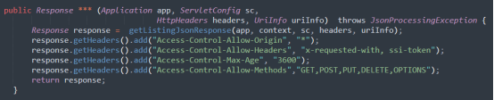

\*

|  |
| --- |
| getListingJson |
| getListingJavaScriptObjectNotation |

Please kindly explain why the selected option should be preferred.

\*

|  |
| --- |
| □Use of widely recognized abbreviations that do not hinder the understanding of the source code |
| □Excessively lengthy method names significantly impact code readability |
| □Consistency with the naming conventions of identifiers within the method body |
| □Less common abbreviation influences the understanding of the source code |
| □Method name with full terms are not excessively long and full terms tend to be more readable |
| □Others \_\_\_\_\_\_\_\_\_\_\_\_\_\_\_\_\_ |

65. Please read through the following code snippet where the original method name is marked by "\*\*\*". If necessary, you can refer to the enclosing class of the method at [this link](https://r.wjx.com/redirect.aspx?url=https%3A%2F%2Fgithub.com%2Fjiangyanjie%2FsurveyData%2Fblob%2Fmain%2FSecondRound%2F65%2F65.java&activity=267595662" \t "_blank). Among the names provided below, please indicate your preference for the method name.

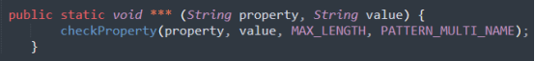

\*

|  |
| --- |
| checkMultiName |
| checkMultipleName |

Please kindly explain why the selected option should be preferred.

\*

|  |
| --- |
| □Use of widely recognized abbreviations that do not hinder the understanding of the source code |
| □Excessively lengthy method names significantly impact code readability |
| □Consistency with the naming conventions of identifiers within the method body |
| □Less common abbreviation influences the understanding of the source code |
| □Method name with full terms are not excessively long and full terms tend to be more readable |
| □Others \_\_\_\_\_\_\_\_\_\_\_\_\_\_\_\_\_ |

66. Please read through the following code snippet where the original method name is marked by "\*\*\*". If necessary, you can refer to the enclosing class of the method at [this link](https://r.wjx.com/redirect.aspx?url=https%3A%2F%2Fgithub.com%2Fjiangyanjie%2FsurveyData%2Fblob%2Fmain%2FSecondRound%2F66%2F66.java&activity=267595662" \t "_blank). Among the names provided below, please indicate your preference for the method name.

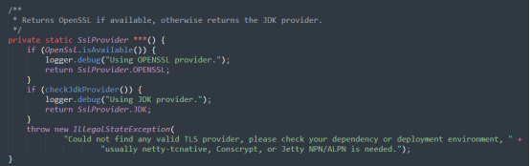

\*

|  |
| --- |
| findSslProvider |
| findSecureSocketsLayerProvider |

Please kindly explain why the selected option should be preferred.

\*

|  |
| --- |
| □Use of widely recognized abbreviations that do not hinder the understanding of the source code |
| □Excessively lengthy method names significantly impact code readability |
| □Consistency with the naming conventions of identifiers within the method body |
| □Less common abbreviation influences the understanding of the source code |
| □Method name with full terms are not excessively long and full terms tend to be more readable |
| □Others \_\_\_\_\_\_\_\_\_\_\_\_\_\_\_\_\_ |

67. Please read through the following code snippet where the original method name is marked by "\*\*\*". If necessary, you can refer to the enclosing class of the method at [this link](https://r.wjx.com/redirect.aspx?url=https%3A%2F%2Fgithub.com%2Fjiangyanjie%2FsurveyData%2Fblob%2Fmain%2FSecondRound%2F67%2F67.java&activity=267595662" \t "_blank). Among the names provided below, please indicate your preference for the method name.

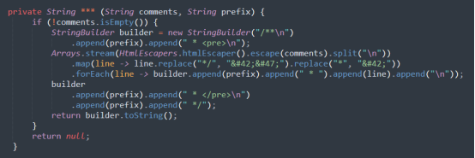

\*

|  |
| --- |
| getJavaDoc |
| getJavaDocument |

Please kindly explain why the selected option should be preferred.

\*

|  |
| --- |
| □Use of widely recognized abbreviations that do not hinder the understanding of the source code |
| □Excessively lengthy method names significantly impact code readability |
| □Consistency with the naming conventions of identifiers within the method body |
| □Less common abbreviation influences the understanding of the source code |
| □Method name with full terms are not excessively long and full terms tend to be more readable |
| □Others \_\_\_\_\_\_\_\_\_\_\_\_\_\_\_\_\_ |

68. Please read through the following code snippet where the original method name is marked by "\*\*\*". If necessary, you can refer to the enclosing class of the method at [this link](https://r.wjx.com/redirect.aspx?url=https%3A%2F%2Fgithub.com%2Fjiangyanjie%2FsurveyData%2Fblob%2Fmain%2FSecondRound%2F68%2F68.java&activity=267595662" \t "_blank). Among the names provided below, please indicate your preference for the method name.

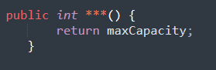

\*

|  |
| --- |
| getMaxCapacity |
| getMaximumCapacity |

Please kindly explain why the selected option should be preferred.

\*

|  |
| --- |
| □Use of widely recognized abbreviations that do not hinder the understanding of the source code |
| □Excessively lengthy method names significantly impact code readability |
| □Consistency with the naming conventions of identifiers within the method body |
| □Less common abbreviation influences the understanding of the source code |
| □Method name with full terms are not excessively long and full terms tend to be more readable |
| □Others \_\_\_\_\_\_\_\_\_\_\_\_\_\_\_\_\_ |

69. Please read through the following code snippet where the original method name is marked by "\*\*\*". If necessary, you can refer to the enclosing class of the method at [this link](https://r.wjx.com/redirect.aspx?url=https%3A%2F%2Fgithub.com%2Fjiangyanjie%2FsurveyData%2Fblob%2Fmain%2FSecondRound%2F69%2F69.java&activity=267595662" \t "_blank). Among the names provided below, please indicate your preference for the method name.

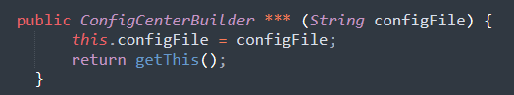

\*

|  |
| --- |
| configFile |
| configurationFile |

Please kindly explain why the selected option should be preferred.

\*

|  |
| --- |
| □Use of widely recognized abbreviations that do not hinder the understanding of the source code |
| □Excessively lengthy method names significantly impact code readability |
| □Consistency with the naming conventions of identifiers within the method body |
| □Less common abbreviation influences the understanding of the source code |
| □Method name with full terms are not excessively long and full terms tend to be more readable |
| □Others \_\_\_\_\_\_\_\_\_\_\_\_\_\_\_\_\_ |

70. Please read through the following code snippet where the original method name is marked by "\*\*\*". If necessary, you can refer to the enclosing class of the method at [this link](https://r.wjx.com/redirect.aspx?url=https%3A%2F%2Fgithub.com%2Fjiangyanjie%2FsurveyData%2Fblob%2Fmain%2FSecondRound%2F70%2F70.java&activity=267595662" \t "_blank). Among the names provided below, please indicate your preference for the method name.

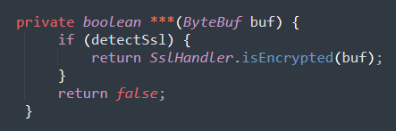

\*

|  |
| --- |
| isSsl |
| isSecureSocketsLayer |

Please kindly explain why the selected option should be preferred.

\*

|  |
| --- |
| □Use of widely recognized abbreviations that do not hinder the understanding of the source code |
| □Excessively lengthy method names significantly impact code readability |
| □Consistency with the naming conventions of identifiers within the method body |
| □Less common abbreviation influences the understanding of the source code |
| □Method name with full terms are not excessively long and full terms tend to be more readable |
| □Others \_\_\_\_\_\_\_\_\_\_\_\_\_\_\_\_\_ |

71. Please read through the following code snippet where the original method name is marked by "\*\*\*". If necessary, you can refer to the enclosing class of the method at [this link](https://r.wjx.com/redirect.aspx?url=https%3A%2F%2Fgithub.com%2Fjiangyanjie%2FsurveyData%2Fblob%2Fmain%2FSecondRound%2F71%2F71.java&activity=267595662" \t "_blank). Among the names provided below, please indicate your preference for the method name.

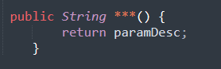

\*

|  |
| --- |
| getParamDesc |
| getParameterDescription |

Please kindly explain why the selected option should be preferred.

\*

|  |
| --- |
| □Use of widely recognized abbreviations that do not hinder the understanding of the source code |
| □Excessively lengthy method names significantly impact code readability |
| □Consistency with the naming conventions of identifiers within the method body |
| □Less common abbreviation influences the understanding of the source code |
| □Method name with full terms are not excessively long and full terms tend to be more readable |
| □Others \_\_\_\_\_\_\_\_\_\_\_\_\_\_\_\_\_ |

72. Please read through the following code snippet where the original method name is marked by "\*\*\*". If necessary, you can refer to the enclosing class of the method at [this link](https://r.wjx.com/redirect.aspx?url=https%3A%2F%2Fgithub.com%2Fjiangyanjie%2FsurveyData%2Fblob%2Fmain%2FSecondRound%2F72%2F72.java&activity=267595662" \t "_blank). Among the names provided below, please indicate your preference for the method name.

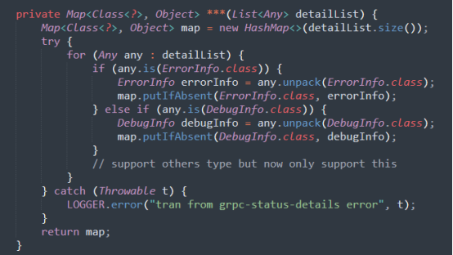

\*

|  |
| --- |
| tranFromStatusDetails |
| transferFromStatusDetails |

Please kindly explain why the selected option should be preferred.

\*

|  |
| --- |
| □Use of widely recognized abbreviations that do not hinder the understanding of the source code |
| □Excessively lengthy method names significantly impact code readability |
| □Consistency with the naming conventions of identifiers within the method body |
| □Less common abbreviation influences the understanding of the source code |
| □Method name with full terms are not excessively long and full terms tend to be more readable |
| □Others \_\_\_\_\_\_\_\_\_\_\_\_\_\_\_\_\_ |

73. Please read through the following code snippet where the original method name is marked by "\*\*\*". If necessary, you can refer to the enclosing class of the method at [this link](https://r.wjx.com/redirect.aspx?url=https%3A%2F%2Fgithub.com%2Fjiangyanjie%2FsurveyData%2Fblob%2Fmain%2FSecondRound%2F73%2F73.java&activity=267595662" \t "_blank). Among the names provided below, please indicate your preference for the method name.



\*

|  |
| --- |
| getClassDesc |
| getClassDescription |

Please kindly explain why the selected option should be preferred.

\*

|  |
| --- |
| □Use of widely recognized abbreviations that do not hinder the understanding of the source code |
| □Excessively lengthy method names significantly impact code readability |
| □Consistency with the naming conventions of identifiers within the method body |
| □Less common abbreviation influences the understanding of the source code |
| □Method name with full terms are not excessively long and full terms tend to be more readable |
| □Others \_\_\_\_\_\_\_\_\_\_\_\_\_\_\_\_\_ |

74. Please read through the following code snippet where the original method name is marked by "\*\*\*". If necessary, you can refer to the enclosing class of the method at [this link](https://r.wjx.com/redirect.aspx?url=https%3A%2F%2Fgithub.com%2Fjiangyanjie%2FsurveyData%2Fblob%2Fmain%2FSecondRound%2F74%2F74.java&activity=267595662" \t "_blank). Among the names provided below, please indicate your preference for the method name.

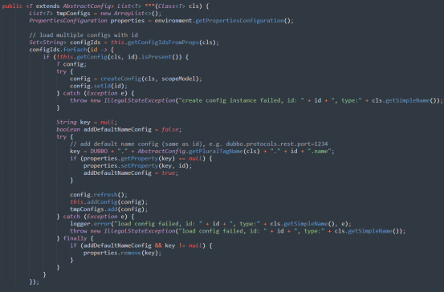

\*

|  |
| --- |
| loadConfigsOfTypeFromProps |
| loadConfigurationsOfTypeFromProperties |

Please kindly explain why the selected option should be preferred.

\*

|  |
| --- |
| □Use of widely recognized abbreviations that do not hinder the understanding of the source code |
| □Excessively lengthy method names significantly impact code readability |
| □Consistency with the naming conventions of identifiers within the method body |
| □Less common abbreviation influences the understanding of the source code |
| □Method name with full terms are not excessively long and full terms tend to be more readable |
| □Others \_\_\_\_\_\_\_\_\_\_\_\_\_\_\_\_\_ |

75. Please read through the following code snippet where the original method name is marked by "\*\*\*". If necessary, you can refer to the enclosing class of the method at [this link](https://r.wjx.com/redirect.aspx?url=https%3A%2F%2Fgithub.com%2Fjiangyanjie%2FsurveyData%2Fblob%2Fmain%2FSecondRound%2F75%2F75.java&activity=267595662" \t "_blank). Among the names provided below, please indicate your preference for the method name.

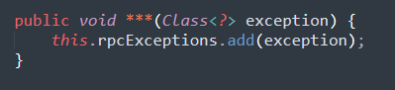

\*

|  |
| --- |
| addRpcException |
| addRemoteProcedureCallException |

Please kindly explain why the selected option should be preferred.

\*

|  |
| --- |
| □Use of widely recognized abbreviations that do not hinder the understanding of the source code |
| □Excessively lengthy method names significantly impact code readability |
| □Consistency with the naming conventions of identifiers within the method body |
| □Less common abbreviation influences the understanding of the source code |
| □Method name with full terms are not excessively long and full terms tend to be more readable |
| □Others \_\_\_\_\_\_\_\_\_\_\_\_\_\_\_\_\_ |

76. Please read through the following code snippet where the original method name is marked by "\*\*\*". If necessary, you can refer to the enclosing class of the method at [this link](https://r.wjx.com/redirect.aspx?url=https%3A%2F%2Fgithub.com%2Fjiangyanjie%2FsurveyData%2Fblob%2Fmain%2FSecondRound%2F76%2F76.java&activity=267595662" \t "_blank). Among the names provided below, please indicate your preference for the method name.

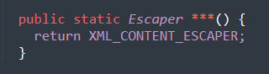

\*

|  |
| --- |
| xmlContentEscaper |
| extensibleMarkupLanguageContentEscaper |

Please kindly explain why the selected option should be preferred.

\*

|  |
| --- |
| □Use of widely recognized abbreviations that do not hinder the understanding of the source code |
| □Excessively lengthy method names significantly impact code readability |
| □Consistency with the naming conventions of identifiers within the method body |
| □Less common abbreviation influences the understanding of the source code |
| □Method name with full terms are not excessively long and full terms tend to be more readable |
| □Others \_\_\_\_\_\_\_\_\_\_\_\_\_\_\_\_\_ |

77. Please read through the following code snippet where the original method name is marked by "\*\*\*". If necessary, you can refer to the enclosing class of the method at [this link](https://r.wjx.com/redirect.aspx?url=https%3A%2F%2Fgithub.com%2Fjiangyanjie%2FsurveyData%2Fblob%2Fmain%2FSecondRound%2F77%2F77.java&activity=267595662" \t "_blank). Among the names provided below, please indicate your preference for the method name.

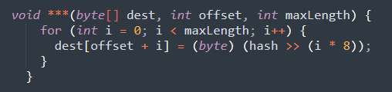

\*

|  |
| --- |
| writeBytesToImpl |
| writeBytesToImplementation |

Please kindly explain why the selected option should be preferred.

\*

|  |
| --- |
| □Use of widely recognized abbreviations that do not hinder the understanding of the source code |
| □Excessively lengthy method names significantly impact code readability |
| □Consistency with the naming conventions of identifiers within the method body |
| □Less common abbreviation influences the understanding of the source code |
| □Method name with full terms are not excessively long and full terms tend to be more readable |
| □Others \_\_\_\_\_\_\_\_\_\_\_\_\_\_\_\_\_ |

78. Please read through the following code snippet where the original method name is marked by "\*\*\*". If necessary, you can refer to the enclosing class of the method at [this link](https://r.wjx.com/redirect.aspx?url=https%3A%2F%2Fgithub.com%2Fjiangyanjie%2FsurveyData%2Fblob%2Fmain%2FSecondRound%2F78%2F78.java&activity=267595662" \t "_blank). Among the names provided below, please indicate your preference for the method name.

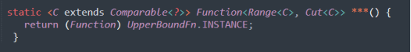

\*

|  |
| --- |
| upperBoundFn |
| upperBoundFunction |

Please kindly explain why the selected option should be preferred.

\*

|  |
| --- |
| □Use of widely recognized abbreviations that do not hinder the understanding of the source code |
| □Excessively lengthy method names significantly impact code readability |
| □Consistency with the naming conventions of identifiers within the method body |
| □Less common abbreviation influences the understanding of the source code |
| □Method name with full terms are not excessively long and full terms tend to be more readable |
| □Others \_\_\_\_\_\_\_\_\_\_\_\_\_\_\_\_\_ |

79. Please read through the following code snippet where the original method name is marked by "\*\*\*". If necessary, you can refer to the enclosing class of the method at [this link](https://r.wjx.com/redirect.aspx?url=https%3A%2F%2Fgithub.com%2Fjiangyanjie%2FsurveyData%2Fblob%2Fmain%2FSecondRound%2F79%2F79.java&activity=267595662" \t "_blank). Among the names provided below, please indicate your preference for the method name.

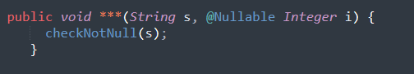

\*

|  |
| --- |
| twoMixedArgs |
| twoMixedArguments |

Please kindly explain why the selected option should be preferred.

\*

|  |
| --- |
| □Use of widely recognized abbreviations that do not hinder the understanding of the source code |
| □Excessively lengthy method names significantly impact code readability |
| □Consistency with the naming conventions of identifiers within the method body |
| □Less common abbreviation influences the understanding of the source code |
| □Method name with full terms are not excessively long and full terms tend to be more readable |
| □Others \_\_\_\_\_\_\_\_\_\_\_\_\_\_\_\_\_ |

80. Please read through the following code snippet where the original method name is marked by "\*\*\*". If necessary, you can refer to the enclosing class of the method at [this link](https://r.wjx.com/redirect.aspx?url=https%3A%2F%2Fgithub.com%2Fjiangyanjie%2FsurveyData%2Fblob%2Fmain%2FSecondRound%2F80%2F80.java&activity=267595662" \t "_blank). Among the names provided below, please indicate your preference for the method name.

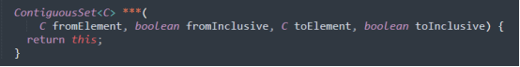

\*

|  |
| --- |
| subSetImpl |
| subSetImplementation |

Please kindly explain why the selected option should be preferred.

\*

|  |
| --- |
| □Use of widely recognized abbreviations that do not hinder the understanding of the source code |
| □Excessively lengthy method names significantly impact code readability |
| □Consistency with the naming conventions of identifiers within the method body |
| □Less common abbreviation influences the understanding of the source code |
| □Method name with full terms are not excessively long and full terms tend to be more readable |
| □Others \_\_\_\_\_\_\_\_\_\_\_\_\_\_\_\_\_ |

81. Please read through the following code snippet where the original method name is marked by "\*\*\*". If necessary, you can refer to the enclosing class of the method at [this link](https://r.wjx.com/redirect.aspx?url=https%3A%2F%2Fgithub.com%2Fjiangyanjie%2FsurveyData%2Fblob%2Fmain%2FSecondRound%2F81%2F81.java&activity=267595662" \t "_blank). Among the names provided below, please indicate your preference for the method name.

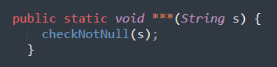

\*

|  |
| --- |
| staticOneArg |
| staticOneArgument |

Please kindly explain why the selected option should be preferred.

\*

|  |
| --- |
| □Use of widely recognized abbreviations that do not hinder the understanding of the source code |
| □Excessively lengthy method names significantly impact code readability |
| □Consistency with the naming conventions of identifiers within the method body |
| □Less common abbreviation influences the understanding of the source code |
| □Method name with full terms are not excessively long and full terms tend to be more readable |
| □Others \_\_\_\_\_\_\_\_\_\_\_\_\_\_\_\_\_ |

82. Please read through the following code snippet where the original method name is marked by "\*\*\*". If necessary, you can refer to the enclosing class of the method at [this link](https://r.wjx.com/redirect.aspx?url=https%3A%2F%2Fgithub.com%2Fjiangyanjie%2FsurveyData%2Fblob%2Fmain%2FSecondRound%2F82%2F82.java&activity=267595662" \t "_blank). Among the names provided below, please indicate your preference for the method name.

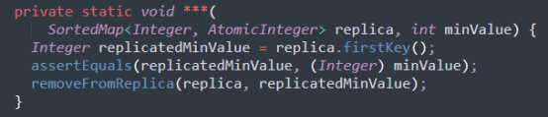

\*

|  |
| --- |
| removeMinFromReplica |
| removeMinimumFromReplica |

Please kindly explain why the selected option should be preferred.

\*

|  |
| --- |
| □Use of widely recognized abbreviations that do not hinder the understanding of the source code |
| □Excessively lengthy method names significantly impact code readability |
| □Consistency with the naming conventions of identifiers within the method body |
| □Less common abbreviation influences the understanding of the source code |
| □Method name with full terms are not excessively long and full terms tend to be more readable |
| □Others \_\_\_\_\_\_\_\_\_\_\_\_\_\_\_\_\_ |

83. Please read through the following code snippet where the original method name is marked by "\*\*\*". If necessary, you can refer to the enclosing class of the method at [this link](https://r.wjx.com/redirect.aspx?url=https%3A%2F%2Fgithub.com%2Fjiangyanjie%2FsurveyData%2Fblob%2Fmain%2FSecondRound%2F83%2F83.java&activity=267595662" \t "_blank). Among the names provided below, please indicate your preference for the method name.

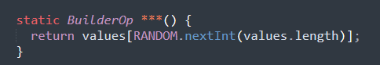

\*

|  |
| --- |
| randomOp |
| randomOperation |

Please kindly explain why the selected option should be preferred.

\*

|  |
| --- |
| □Use of widely recognized abbreviations that do not hinder the understanding of the source code |
| □Excessively lengthy method names significantly impact code readability |
| □Consistency with the naming conventions of identifiers within the method body |
| □Less common abbreviation influences the understanding of the source code |
| □Method name with full terms are not excessively long and full terms tend to be more readable |
| □Others \_\_\_\_\_\_\_\_\_\_\_\_\_\_\_\_\_ |

84. Please read through the following code snippet where the original method name is marked by "\*\*\*". If necessary, you can refer to the enclosing class of the method at [this link](https://r.wjx.com/redirect.aspx?url=https%3A%2F%2Fgithub.com%2Fjiangyanjie%2FsurveyData%2Fblob%2Fmain%2FSecondRound%2F84%2F84.java&activity=267595662" \t "_blank). Among the names provided below, please indicate your preference for the method name.

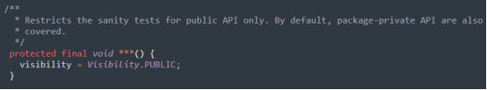

\*

|  |
| --- |
| publicApiOnly |
| publicApplicationProgramInterfaceOnly |

Please kindly explain why the selected option should be preferred.

\*

|  |
| --- |
| □Use of widely recognized abbreviations that do not hinder the understanding of the source code |
| □Excessively lengthy method names significantly impact code readability |
| □Consistency with the naming conventions of identifiers within the method body |
| □Less common abbreviation influences the understanding of the source code |
| □Method name with full terms are not excessively long and full terms tend to be more readable |
| □Others \_\_\_\_\_\_\_\_\_\_\_\_\_\_\_\_\_ |

85. Please read through the following code snippet where the original method name is marked by "\*\*\*". If necessary, you can refer to the enclosing class of the method at [this link](https://r.wjx.com/redirect.aspx?url=https%3A%2F%2Fgithub.com%2Fjiangyanjie%2FsurveyData%2Fblob%2Fmain%2FSecondRound%2F85%2F85.java&activity=267595662" \t "_blank). Among the names provided below, please indicate your preference for the method name.

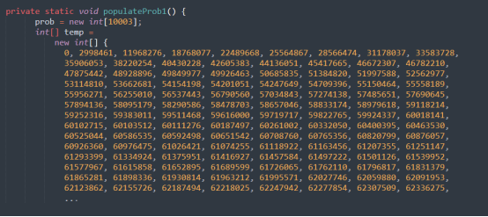

\*

|  |
| --- |
| populateProb1 |
| populateProbability1 |

Please kindly explain why the selected option should be preferred.

\*

|  |
| --- |
| □Use of widely recognized abbreviations that do not hinder the understanding of the source code |
| □Excessively lengthy method names significantly impact code readability |
| □Consistency with the naming conventions of identifiers within the method body |
| □Less common abbreviation influences the understanding of the source code |
| □Method name with full terms are not excessively long and full terms tend to be more readable |
| □Others \_\_\_\_\_\_\_\_\_\_\_\_\_\_\_\_\_ |

86. Please read through the following code snippet where the original method name is marked by "\*\*\*". If necessary, you can refer to the enclosing class of the method at [this link](https://r.wjx.com/redirect.aspx?url=https%3A%2F%2Fgithub.com%2Fjiangyanjie%2FsurveyData%2Fblob%2Fmain%2FSecondRound%2F86%2F86.java&activity=267595662" \t "_blank). Among the names provided below, please indicate your preference for the method name.

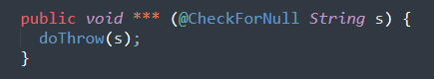

\*

|  |
| --- |
| oneNullableArgThrows |
| oneNullableArgumentThrows |

Please kindly explain why the selected option should be preferred.

\*

|  |
| --- |
| □Use of widely recognized abbreviations that do not hinder the understanding of the source code |
| □Excessively lengthy method names significantly impact code readability |
| □Consistency with the naming conventions of identifiers within the method body |
| □Less common abbreviation influences the understanding of the source code |
| □Method name with full terms are not excessively long and full terms tend to be more readable |
| □Others \_\_\_\_\_\_\_\_\_\_\_\_\_\_\_\_\_ |

87. Please read through the following code snippet where the original method name is marked by "\*\*\*". If necessary, you can refer to the enclosing class of the method at [this link](https://r.wjx.com/redirect.aspx?url=https%3A%2F%2Fgithub.com%2Fjiangyanjie%2FsurveyData%2Fblob%2Fmain%2FSecondRound%2F87%2F87.java&activity=267595662" \t "_blank). Among the names provided below, please indicate your preference for the method name.

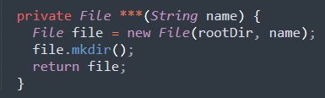

\*

|  |
| --- |
| newDir |
| newDirectory |

Please kindly explain why the selected option should be preferred.

\*

|  |
| --- |
| □Use of widely recognized abbreviations that do not hinder the understanding of the source code |
| □Excessively lengthy method names significantly impact code readability |
| □Consistency with the naming conventions of identifiers within the method body |
| □Less common abbreviation influences the understanding of the source code |
| □Method name with full terms are not excessively long and full terms tend to be more readable |
| □Others \_\_\_\_\_\_\_\_\_\_\_\_\_\_\_\_\_ |

88. Please read through the following code snippet where the original method name is marked by "\*\*\*". If necessary, you can refer to the enclosing class of the method at[this link](https://r.wjx.com/redirect.aspx?url=https%3A%2F%2Fgithub.com%2Fjiangyanjie%2FsurveyData%2Fblob%2Fmain%2FSecondRound%2F88%2F88.java&activity=267595662" \t "_blank). Among the names provided below, please indicate your preference for the method name.

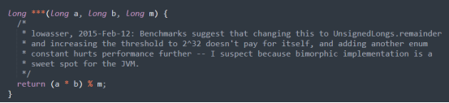

\*

|  |
| --- |
| mulMod |
| multipleMod |

Please kindly explain why the selected option should be preferred.

\*

|  |
| --- |
| □Use of widely recognized abbreviations that do not hinder the understanding of the source code |
| □Excessively lengthy method names significantly impact code readability |
| □Consistency with the naming conventions of identifiers within the method body |
| □Less common abbreviation influences the understanding of the source code |
| □Method name with full terms are not excessively long and full terms tend to be more readable |
| □Others \_\_\_\_\_\_\_\_\_\_\_\_\_\_\_\_\_ |

89. Please read through the following code snippet where the original method name is marked by "\*\*\*". If necessary, you can refer to the enclosing class of the method at [this link](https://r.wjx.com/redirect.aspx?url=https%3A%2F%2Fgithub.com%2Fjiangyanjie%2FsurveyData%2Fblob%2Fmain%2FSecondRound%2F89%2F89.java&activity=267595662" \t "_blank). Among the names provided below, please indicate your preference for the method name.

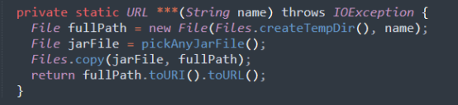

\*

|  |
| --- |
| makeJarUrlWithName |
| makeJarUniformResourceLocatorWithName |

Please kindly explain why the selected option should be preferred.

\*

|  |
| --- |
| □Use of widely recognized abbreviations that do not hinder the understanding of the source code |
| □Excessively lengthy method names significantly impact code readability |
| □Consistency with the naming conventions of identifiers within the method body |
| □Less common abbreviation influences the understanding of the source code |
| □Method name with full terms are not excessively long and full terms tend to be more readable |
| □Others \_\_\_\_\_\_\_\_\_\_\_\_\_\_\_\_\_ |

90. Please read through the following code snippet where the original method name is marked by "\*\*\*". If necessary, you can refer to the enclosing class of the method at [this link](https://r.wjx.com/redirect.aspx?url=https%3A%2F%2Fgithub.com%2Fjiangyanjie%2FsurveyData%2Fblob%2Fmain%2FSecondRound%2F90%2F90.java&activity=267595662" \t "_blank). Among the names provided below, please indicate your preference for the method name.

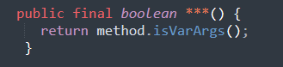

\*

|  |
| --- |
| isVarArgs |
| isVariableArguments |

Please kindly explain why the selected option should be preferred.

\*

|  |
| --- |
| □Use of widely recognized abbreviations that do not hinder the understanding of the source code |
| □Excessively lengthy method names significantly impact code readability |
| □Consistency with the naming conventions of identifiers within the method body |
| □Less common abbreviation influences the understanding of the source code |
| □Method name with full terms are not excessively long and full terms tend to be more readable |
| □Others \_\_\_\_\_\_\_\_\_\_\_\_\_\_\_\_\_ |

91. Please read through the following code snippet where the original method name is marked by "\*\*\*". If necessary, you can refer to the enclosing class of the method at [this link](https://r.wjx.com/redirect.aspx?url=https%3A%2F%2Fgithub.com%2Fjiangyanjie%2FsurveyData%2Fblob%2Fmain%2FSecondRound%2F91%2F91.java&activity=267595662" \t "_blank). Among the names provided below, please indicate your preference for the method name.

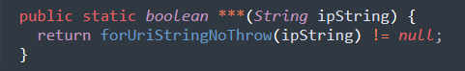

\*

|  |
| --- |
| isUriInetAddress |
| isUniformResourceIdentifierInternetAddress |

Please kindly explain why the selected option should be preferred.

\*

|  |
| --- |
| □Use of widely recognized abbreviations that do not hinder the understanding of the source code |
| □Excessively lengthy method names significantly impact code readability |
| □Consistency with the naming conventions of identifiers within the method body |
| □Less common abbreviation influences the understanding of the source code |
| □Method name with full terms are not excessively long and full terms tend to be more readable |
| □Others \_\_\_\_\_\_\_\_\_\_\_\_\_\_\_\_\_ |

92. Please read through the following code snippet where the original method name is marked by "\*\*\*". If necessary, you can refer to the enclosing class of the method at [this link](https://r.wjx.com/redirect.aspx?url=https%3A%2F%2Fgithub.com%2Fjiangyanjie%2FsurveyData%2Fblob%2Fmain%2FSecondRound%2F92%2F92.java&activity=267595662" \t "_blank). Among the names provided below, please indicate your preference for the method name.

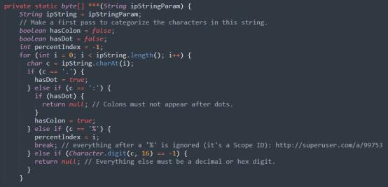

\*

|  |
| --- |
| ipStringToBytes |
| internetProtocolStringToBytes |

Please kindly explain why the selected option should be preferred.

\*

|  |
| --- |
| □Use of widely recognized abbreviations that do not hinder the understanding of the source code |
| □Excessively lengthy method names significantly impact code readability |
| □Consistency with the naming conventions of identifiers within the method body |
| □Less common abbreviation influences the understanding of the source code |
| □Method name with full terms are not excessively long and full terms tend to be more readable |
| □Others \_\_\_\_\_\_\_\_\_\_\_\_\_\_\_\_\_ |

93. Please read through the following code snippet where the original method name is marked by "\*\*\*". If necessary, you can refer to the enclosing class of the method at [this link](https://r.wjx.com/redirect.aspx?url=https%3A%2F%2Fgithub.com%2Fjiangyanjie%2FsurveyData%2Fblob%2Fmain%2FSecondRound%2F93%2F93.java&activity=267595662" \t "_blank). Among the names provided below, please indicate your preference for the method name.

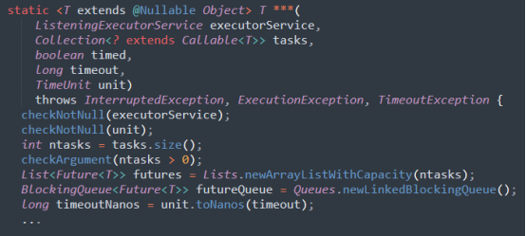

\*

|  |
| --- |
| invokeAnyImpl |
| invokeAnyImplementation |

Please kindly explain why the selected option should be preferred.

\*

|  |
| --- |
| □Use of widely recognized abbreviations that do not hinder the understanding of the source code |
| □Excessively lengthy method names significantly impact code readability |
| □Consistency with the naming conventions of identifiers within the method body |
| □Less common abbreviation influences the understanding of the source code |
| □Method name with full terms are not excessively long and full terms tend to be more readable |
| □Others \_\_\_\_\_\_\_\_\_\_\_\_\_\_\_\_\_ |

94. Please read through the following code snippet where the original method name is marked by "\*\*\*". If necessary, you can refer to the enclosing class of the method at [this link](https://r.wjx.com/redirect.aspx?url=https%3A%2F%2Fgithub.com%2Fjiangyanjie%2FsurveyData%2Fblob%2Fmain%2FSecondRound%2F94%2F94.java&activity=267595662" \t "_blank). Among the names provided below, please indicate your preference for the method name.

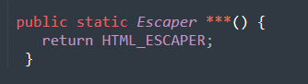

\*

|  |
| --- |
| htmlEscaper |
| hyperTextMarkupLanguageEscaper |

Please kindly explain why the selected option should be preferred.

\*

|  |
| --- |
| □Use of widely recognized abbreviations that do not hinder the understanding of the source code |
| □Excessively lengthy method names significantly impact code readability |
| □Consistency with the naming conventions of identifiers within the method body |
| □Less common abbreviation influences the understanding of the source code |
| □Method name with full terms are not excessively long and full terms tend to be more readable |
| □Others \_\_\_\_\_\_\_\_\_\_\_\_\_\_\_\_\_ |

95. Please read through the following code snippet where the original method name is marked by "\*\*\*". If necessary, you can refer to the enclosing class of the method at [this link](https://r.wjx.com/redirect.aspx?url=https%3A%2F%2Fgithub.com%2Fjiangyanjie%2FsurveyData%2Fblob%2Fmain%2FSecondRound%2F95%2F95.java&activity=267595662" \t "_blank). Among the names provided below, please indicate your preference for the method name.

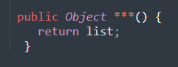

\*

|  |
| --- |
| getImpl |
| getImplementation |

Please kindly explain why the selected option should be preferred.

\*

|  |
| --- |
| □Use of widely recognized abbreviations that do not hinder the understanding of the source code |
| □Excessively lengthy method names significantly impact code readability |
| □Consistency with the naming conventions of identifiers within the method body |
| □Less common abbreviation influences the understanding of the source code |
| □Method name with full terms are not excessively long and full terms tend to be more readable |
| □Others \_\_\_\_\_\_\_\_\_\_\_\_\_\_\_\_\_ |

96. Please read through the following code snippet where the original method name is marked by "\*\*\*". If necessary, you can refer to the enclosing class of the method at [this link](https://r.wjx.com/redirect.aspx?url=https%3A%2F%2Fgithub.com%2Fjiangyanjie%2FsurveyData%2Fblob%2Fmain%2FSecondRound%2F96%2F96.java&activity=267595662" \t "_blank). Among the names provided below, please indicate your preference for the method name.

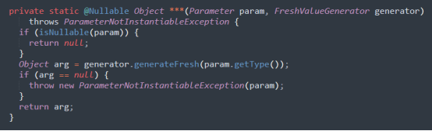

\*

|  |
| --- |
| generateDummyArg |
| generateDummyArgument |

Please kindly explain why the selected option should be preferred.

\*

|  |
| --- |
| □Use of widely recognized abbreviations that do not hinder the understanding of the source code |
| □Excessively lengthy method names significantly impact code readability |
| □Consistency with the naming conventions of identifiers within the method body |
| □Less common abbreviation influences the understanding of the source code |
| □Method name with full terms are not excessively long and full terms tend to be more readable |
| □Others \_\_\_\_\_\_\_\_\_\_\_\_\_\_\_\_\_ |

97. Please read through the following code snippet where the original method name is marked by "\*\*\*". If necessary, you can refer to the enclosing class of the method at [this link](https://r.wjx.com/redirect.aspx?url=https%3A%2F%2Fgithub.com%2Fjiangyanjie%2FsurveyData%2Fblob%2Fmain%2FSecondRound%2F97%2F97.java&activity=267595662" \t "_blank). Among the names provided below, please indicate your preference for the method name.

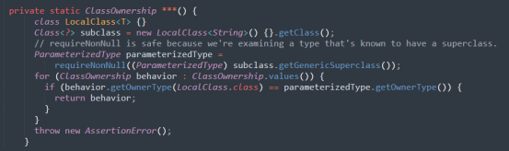

\*

|  |
| --- |
| detectJvmBehavior |
| detectJavaVirtualMachineBehavior |

Please kindly explain why the selected option should be preferred.

\*

|  |
| --- |
| □Use of widely recognized abbreviations that do not hinder the understanding of the source code |
| □Excessively lengthy method names significantly impact code readability |
| □Consistency with the naming conventions of identifiers within the method body |
| □Less common abbreviation influences the understanding of the source code |
| □Method name with full terms are not excessively long and full terms tend to be more readable |
| □Others \_\_\_\_\_\_\_\_\_\_\_\_\_\_\_\_\_ |

98. Please read through the following code snippet where the original method name is marked by "\*\*\*". If necessary, you can refer to the enclosing class of the method at[this link](https://r.wjx.com/redirect.aspx?url=https%3A%2F%2Fgithub.com%2Fjiangyanjie%2FsurveyData%2Fblob%2Fmain%2FSecondRound%2F98%2F98.java&activity=267595662" \t "_blank). Among the names provided below, please indicate your preference for the method name.

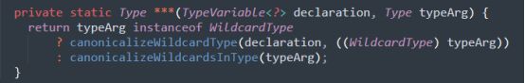

\*

|  |
| --- |
| canonicalizeTypeArg |
| canonicalizeTypeArgument |

Please kindly explain why the selected option should be preferred.

\*

|  |
| --- |
| □Use of widely recognized abbreviations that do not hinder the understanding of the source code |
| □Excessively lengthy method names significantly impact code readability |
| □Consistency with the naming conventions of identifiers within the method body |
| □Less common abbreviation influences the understanding of the source code |
| □Method name with full terms are not excessively long and full terms tend to be more readable |
| □Others \_\_\_\_\_\_\_\_\_\_\_\_\_\_\_\_\_ |

99. Please read through the following code snippet where the original method name is marked by "\*\*\*". If necessary, you can refer to the enclosing class of the method at [this link](https://r.wjx.com/redirect.aspx?url=https%3A%2F%2Fgithub.com%2Fjiangyanjie%2FsurveyData%2Fblob%2Fmain%2FSecondRound%2F99%2F99.java&activity=267595662" \t "_blank). Among the names provided below, please indicate your preference for the method name.

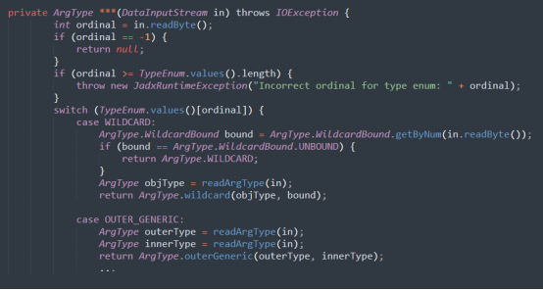

\*

|  |
| --- |
| readArgType |
| readArgumentType |

Please kindly explain why the selected option should be preferred.

\*

|  |
| --- |
| □Use of widely recognized abbreviations that do not hinder the understanding of the source code |
| □Excessively lengthy method names significantly impact code readability |
| □Consistency with the naming conventions of identifiers within the method body |
| □Less common abbreviation influences the understanding of the source code |
| □Method name with full terms are not excessively long and full terms tend to be more readable |
| □Others \_\_\_\_\_\_\_\_\_\_\_\_\_\_\_\_\_ |

100. Please read through the following code snippet where the original method name is marked by "\*\*\*". If necessary, you can refer to the enclosing class of the method at [this link](https://r.wjx.com/redirect.aspx?url=https%3A%2F%2Fgithub.com%2Fjiangyanjie%2FsurveyData%2Fblob%2Fmain%2FSecondRound%2F100%2F100.java&activity=267595662" \t "_blank). Among the names provided below, please indicate your preference for the method name.

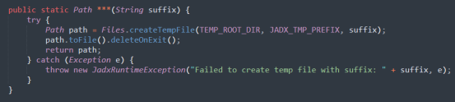

\*

|  |
| --- |
| createTempFile |
| createTemporaryFile |

Please kindly explain why the selected option should be preferred.

\*

|  |
| --- |
| □Use of widely recognized abbreviations that do not hinder the understanding of the source code |
| □Excessively lengthy method names significantly impact code readability |
| □Consistency with the naming conventions of identifiers within the method body |
| □Less common abbreviation influences the understanding of the source code |
| □Method name with full terms are not excessively long and full terms tend to be more readable |
| □Others \_\_\_\_\_\_\_\_\_\_\_\_\_\_\_\_\_ |

101. Please read through the following code snippet where the original method name is marked by "\*\*\*". If necessary, you can refer to the enclosing class of the method at [this link](https://r.wjx.com/redirect.aspx?url=https%3A%2F%2Fgithub.com%2Fjiangyanjie%2FsurveyData%2Fblob%2Fmain%2FSecondRound%2F101%2F101.java&activity=267595662" \t "_blank). Among the names provided below, please indicate your preference for the method name.

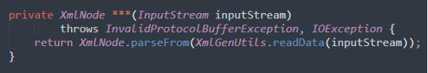

\*

|  |
| --- |
| decodeProto |
| decodePrototype |

Please kindly explain why the selected option should be preferred.

\*

|  |
| --- |
| □Use of widely recognized abbreviations that do not hinder the understanding of the source code |
| □Excessively lengthy method names significantly impact code readability |
| □Consistency with the naming conventions of identifiers within the method body |
| □Less common abbreviation influences the understanding of the source code |
| □Method name with full terms are not excessively long and full terms tend to be more readable |
| □Others \_\_\_\_\_\_\_\_\_\_\_\_\_\_\_\_\_ |

102. Please read through the following code snippet where the original method name is marked by "\*\*\*". If necessary, you can refer to the enclosing class of the method at [this link](https://r.wjx.com/redirect.aspx?url=https%3A%2F%2Fgithub.com%2Fjiangyanjie%2FsurveyData%2Fblob%2Fmain%2FSecondRound%2F102%2F102.java&activity=267595662" \t "_blank). Among the names provided below, please indicate your preference for the method name.

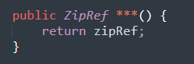

\*

|  |
| --- |
| getZipRef |
| getZipReference |

Please kindly explain why the selected option should be preferred.

\*

|  |
| --- |
| □Use of widely recognized abbreviations that do not hinder the understanding of the source code |
| □Excessively lengthy method names significantly impact code readability |
| □Consistency with the naming conventions of identifiers within the method body |
| □Less common abbreviation influences the understanding of the source code |
| □Method name with full terms are not excessively long and full terms tend to be more readable |
| □Others \_\_\_\_\_\_\_\_\_\_\_\_\_\_\_\_\_ |

103. Please read through the following code snippet where the original method name is marked by "\*\*\*". If necessary, you can refer to the enclosing class of the method at [this link](https://r.wjx.com/redirect.aspx?url=https%3A%2F%2Fgithub.com%2Fjiangyanjie%2FsurveyData%2Fblob%2Fmain%2FSecondRound%2F103%2F103.java&activity=267595662" \t "_blank). Among the names provided below, please indicate your preference for the method name.

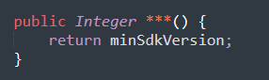

\*

|  |
| --- |
| getMinSdkVersion |
| getMinimumSoftwareDevelopmentKitVersion |

Please kindly explain why the selected option should be preferred.

\*

|  |
| --- |
| □Use of widely recognized abbreviations that do not hinder the understanding of the source code |
| □Excessively lengthy method names significantly impact code readability |
| □Consistency with the naming conventions of identifiers within the method body |
| □Less common abbreviation influences the understanding of the source code |
| □Method name with full terms are not excessively long and full terms tend to be more readable |
| □Others \_\_\_\_\_\_\_\_\_\_\_\_\_\_\_\_\_ |

104. Please read through the following code snippet where the original method name is marked by "\*\*\*". If necessary, you can refer to the enclosing class of the method at [this link](https://r.wjx.com/redirect.aspx?url=https%3A%2F%2Fgithub.com%2Fjiangyanjie%2FsurveyData%2Fblob%2Fmain%2FSecondRound%2F104%2F104.java&activity=267595662" \t "_blank). Among the names provided below, please indicate your preference for the method name.

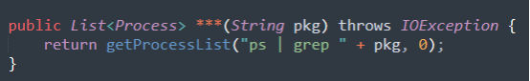

\*

|  |
| --- |
| getProcessByPkg |
| getProcessByPackage |

Please kindly explain why the selected option should be preferred.

\*

|  |
| --- |
| □Use of widely recognized abbreviations that do not hinder the understanding of the source code |
| □Excessively lengthy method names significantly impact code readability |
| □Consistency with the naming conventions of identifiers within the method body |
| □Less common abbreviation influences the understanding of the source code |
| □Method name with full terms are not excessively long and full terms tend to be more readable |
| □Others \_\_\_\_\_\_\_\_\_\_\_\_\_\_\_\_\_ |

105. Please read through the following code snippet where the original method name is marked by "\*\*\*". If necessary, you can refer to the enclosing class of the method at [this link](https://r.wjx.com/redirect.aspx?url=https%3A%2F%2Fgithub.com%2Fjiangyanjie%2FsurveyData%2Fblob%2Fmain%2FSecondRound%2F105%2F105.java&activity=267595662" \t "_blank). Among the names provided below, please indicate your preference for the method name.

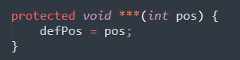

\*

|  |
| --- |
| setDefPos |
| setDefinitePosition |

Please kindly explain why the selected option should be preferred.

\*

|  |
| --- |
| □Use of widely recognized abbreviations that do not hinder the understanding of the source code |
| □Excessively lengthy method names significantly impact code readability |
| □Consistency with the naming conventions of identifiers within the method body |
| □Less common abbreviation influences the understanding of the source code |
| □Method name with full terms are not excessively long and full terms tend to be more readable |
| □Others \_\_\_\_\_\_\_\_\_\_\_\_\_\_\_\_\_ |

106. Please read through the following code snippet where the original method name is marked by "\*\*\*". If necessary, you can refer to the enclosing class of the method at [this link](https://r.wjx.com/redirect.aspx?url=https%3A%2F%2Fgithub.com%2Fjiangyanjie%2FsurveyData%2Fblob%2Fmain%2FSecondRound%2F106%2F106.java&activity=267595662" \t "_blank). Among the names provided below, please indicate your preference for the method name.

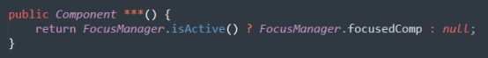

\*

|  |
| --- |
| getFocusedComp |
| getFocusedComponent |

Please kindly explain why the selected option should be preferred.

\*

|  |
| --- |
| □Use of widely recognized abbreviations that do not hinder the understanding of the source code |
| □Excessively lengthy method names significantly impact code readability |
| □Consistency with the naming conventions of identifiers within the method body |
| □Less common abbreviation influences the understanding of the source code |
| □Method name with full terms are not excessively long and full terms tend to be more readable |
| □Others \_\_\_\_\_\_\_\_\_\_\_\_\_\_\_\_\_ |

107. Please read through the following code snippet where the original method name is marked by "\*\*\*". If necessary, you can refer to the enclosing class of the method at [this link](https://r.wjx.com/redirect.aspx?url=https%3A%2F%2Fgithub.com%2Fjiangyanjie%2FsurveyData%2Fblob%2Fmain%2FSecondRound%2F107%2F107.java&activity=267595662" \t "_blank). Among the names provided below, please indicate your preference for the method name.

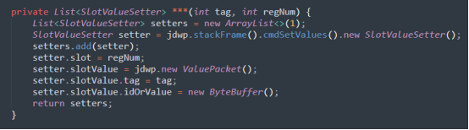

\*

|  |
| --- |
| buildRegValueSetter |
| buildRegisterValueSetter |

Please kindly explain why the selected option should be preferred.

\*

|  |
| --- |
| □Use of widely recognized abbreviations that do not hinder the understanding of the source code |
| □Excessively lengthy method names significantly impact code readability |
| □Consistency with the naming conventions of identifiers within the method body |
| □Less common abbreviation influences the understanding of the source code |
| □Method name with full terms are not excessively long and full terms tend to be more readable |
| □Others \_\_\_\_\_\_\_\_\_\_\_\_\_\_\_\_\_ |

108. Please read through the following code snippet where the original method name is marked by "\*\*\*". If necessary, you can refer to the enclosing class of the method at [this link](https://r.wjx.com/redirect.aspx?url=https%3A%2F%2Fgithub.com%2Fjiangyanjie%2FsurveyData%2Fblob%2Fmain%2FSecondRound%2F108%2F108.java&activity=267595662" \t "_blank). Among the names provided below, please indicate your preference for the method name.

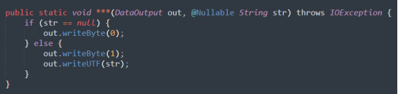

\*

|  |
| --- |
| writeNullableUTF |
| writeNullableUnicodeTransformationFormat |

Please kindly explain why the selected option should be preferred.

\*

|  |
| --- |
| □Use of widely recognized abbreviations that do not hinder the understanding of the source code |
| □Excessively lengthy method names significantly impact code readability |
| □Consistency with the naming conventions of identifiers within the method body |
| □Less common abbreviation influences the understanding of the source code |
| □Method name with full terms are not excessively long and full terms tend to be more readable |
| □Others \_\_\_\_\_\_\_\_\_\_\_\_\_\_\_\_\_ |

109. Please read through the following code snippet where the original method name is marked by "\*\*\*". If necessary, you can refer to the enclosing class of the method at [this link](https://r.wjx.com/redirect.aspx?url=https%3A%2F%2Fgithub.com%2Fjiangyanjie%2FsurveyData%2Fblob%2Fmain%2FSecondRound%2F109%2F109.java&activity=267595662" \t "_blank). Among the names provided below, please indicate your preference for the method name.

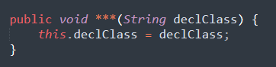

\*

|  |
| --- |
| setDeclClass |
| setDeclaringClass |

Please kindly explain why the selected option should be preferred.

\*

|  |
| --- |
| □Use of widely recognized abbreviations that do not hinder the understanding of the source code |
| □Excessively lengthy method names significantly impact code readability |
| □Consistency with the naming conventions of identifiers within the method body |
| □Less common abbreviation influences the understanding of the source code |
| □Method name with full terms are not excessively long and full terms tend to be more readable |
| □Others \_\_\_\_\_\_\_\_\_\_\_\_\_\_\_\_\_ |

110. Please read through the following code snippet where the original method name is marked by "\*\*\*". If necessary, you can refer to the enclosing class of the method at [this link](https://r.wjx.com/redirect.aspx?url=https%3A%2F%2Fgithub.com%2Fjiangyanjie%2FsurveyData%2Fblob%2Fmain%2FSecondRound%2F110%2F110.java&activity=267595662" \t "_blank). Among the names provided below, please indicate your preference for the method name.

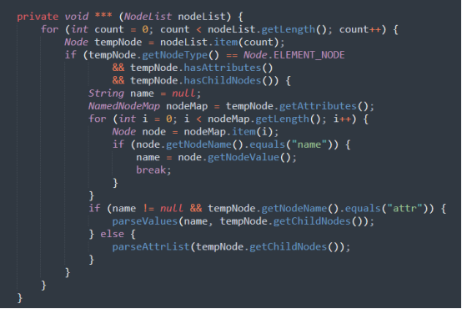

\*

|  |
| --- |
| parseAttrList |
| parseAttributesList |

Please kindly explain why the selected option should be preferred.

\*

|  |
| --- |
| □Use of widely recognized abbreviations that do not hinder the understanding of the source code |
| □Excessively lengthy method names significantly impact code readability |
| □Consistency with the naming conventions of identifiers within the method body |
| □Less common abbreviation influences the understanding of the source code |
| □Method name with full terms are not excessively long and full terms tend to be more readable |
| □Others \_\_\_\_\_\_\_\_\_\_\_\_\_\_\_\_\_ |

111. Please read through the following code snippet where the original method name is marked by "\*\*\*". If necessary, you can refer to the enclosing class of the method at [this link](https://r.wjx.com/redirect.aspx?url=https%3A%2F%2Fgithub.com%2Fjiangyanjie%2FsurveyData%2Fblob%2Fmain%2FSecondRound%2F111%2F111.java&activity=267595662" \t "_blank). Among the names provided below, please indicate your preference for the method name.

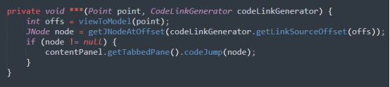

\*

|  |
| --- |
| navToDecl |
| navToDeclaration |

Please kindly explain why the selected option should be preferred.

\*

|  |
| --- |
| □Use of widely recognized abbreviations that do not hinder the understanding of the source code |
| □Excessively lengthy method names significantly impact code readability |
| □Consistency with the naming conventions of identifiers within the method body |
| □Less common abbreviation influences the understanding of the source code |
| □Method name with full terms are not excessively long and full terms tend to be more readable |
| □Others \_\_\_\_\_\_\_\_\_\_\_\_\_\_\_\_\_ |

112. Please read through the following code snippet where the original method name is marked by "\*\*\*". If necessary, you can refer to the enclosing class of the method at [this link](https://r.wjx.com/redirect.aspx?url=https%3A%2F%2Fgithub.com%2Fjiangyanjie%2FsurveyData%2Fblob%2Fmain%2FSecondRound%2F112%2F112.java&activity=267595662" \t "_blank). Among the names provided below, please indicate your preference for the method name.

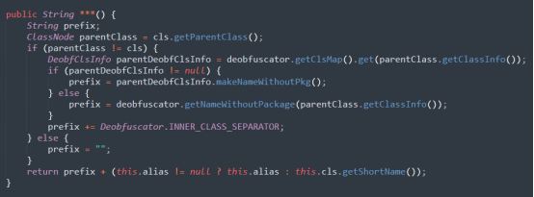

\*

|  |
| --- |
| makeNameWithoutPkg |
| makeNameWithoutPackage |

Please kindly explain why the selected option should be preferred.

\*

|  |
| --- |
| □Use of widely recognized abbreviations that do not hinder the understanding of the source code |
| □Excessively lengthy method names significantly impact code readability |
| □Consistency with the naming conventions of identifiers within the method body |
| □Less common abbreviation influences the understanding of the source code |
| □Method name with full terms are not excessively long and full terms tend to be more readable |
| □Others \_\_\_\_\_\_\_\_\_\_\_\_\_\_\_\_\_ |

113. Please read through the following code snippet where the original method name is marked by "\*\*\*". If necessary, you can refer to the enclosing class of the method at [this link](https://r.wjx.com/redirect.aspx?url=https%3A%2F%2Fgithub.com%2Fjiangyanjie%2FsurveyData%2Fblob%2Fmain%2FSecondRound%2F113%2F113.java&activity=267595662" \t "_blank). Among the names provided below, please indicate your preference for the method name.

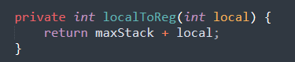

\*

|  |
| --- |
| localToReg |
| localToRegister |

Please kindly explain why the selected option should be preferred.

\*

|  |
| --- |
| □Use of widely recognized abbreviations that do not hinder the understanding of the source code |
| □Excessively lengthy method names significantly impact code readability |
| □Consistency with the naming conventions of identifiers within the method body |
| □Less common abbreviation influences the understanding of the source code |
| □Method name with full terms are not excessively long and full terms tend to be more readable |
| □Others \_\_\_\_\_\_\_\_\_\_\_\_\_\_\_\_\_ |

114. Please read through the following code snippet where the original method name is marked by "\*\*\*". If necessary, you can refer to the enclosing class of the method at [this link](https://r.wjx.com/redirect.aspx?url=https%3A%2F%2Fgithub.com%2Fjiangyanjie%2FsurveyData%2Fblob%2Fmain%2FSecondRound%2F114%2F114.java&activity=267595662" \t "_blank). Among the names provided below, please indicate your preference for the method name.

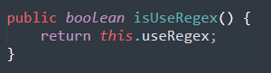

\*

|  |
| --- |
| isUseRegex |
| isUseRegularExpression |

Please kindly explain why the selected option should be preferred.

\*

|  |
| --- |
| □Use of widely recognized abbreviations that do not hinder the understanding of the source code |
| □Excessively lengthy method names significantly impact code readability |
| □Consistency with the naming conventions of identifiers within the method body |
| □Less common abbreviation influences the understanding of the source code |
| □Method name with full terms are not excessively long and full terms tend to be more readable |
| □Others \_\_\_\_\_\_\_\_\_\_\_\_\_\_\_\_\_ |

115. Please read through the following code snippet where the original method name is marked by "\*\*\*". If necessary, you can refer to the enclosing class of the method at [this link](https://r.wjx.com/redirect.aspx?url=https%3A%2F%2Fgithub.com%2Fjiangyanjie%2FsurveyData%2Fblob%2Fmain%2FSecondRound%2F115%2F115.java&activity=267595662" \t "_blank). Among the names provided below, please indicate your preference for the method name.

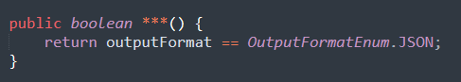

\*

|  |
| --- |
| isJsonOutput |
| isJavaScriptObjectNotationOutput |

Please kindly explain why the selected option should be preferred.

\*

|  |
| --- |
| □Use of widely recognized abbreviations that do not hinder the understanding of the source code |
| □Excessively lengthy method names significantly impact code readability |
| □Consistency with the naming conventions of identifiers within the method body |
| □Less common abbreviation influences the understanding of the source code |
| □Method name with full terms are not excessively long and full terms tend to be more readable |
| □Others \_\_\_\_\_\_\_\_\_\_\_\_\_\_\_\_\_ |

116. Please read through the following code snippet where the original method name is marked by "\*\*\*". If necessary, you can refer to the enclosing class of the method at [this link](https://r.wjx.com/redirect.aspx?url=https%3A%2F%2Fgithub.com%2Fjiangyanjie%2FsurveyData%2Fblob%2Fmain%2FSecondRound%2F116%2F116.java&activity=267595662" \t "_blank). Among the names provided below, please indicate your preference for the method name.

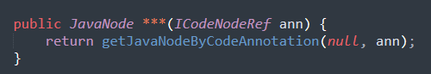

\*

|  |
| --- |
| getJavaNodeByRef |
| getJavaNodeByReference |

Please kindly explain why the selected option should be preferred.

\*

|  |
| --- |
| □Use of widely recognized abbreviations that do not hinder the understanding of the source code |
| □Excessively lengthy method names significantly impact code readability |
| □Consistency with the naming conventions of identifiers within the method body |
| □Less common abbreviation influences the understanding of the source code |
| □Method name with full terms are not excessively long and full terms tend to be more readable |
| □Others \_\_\_\_\_\_\_\_\_\_\_\_\_\_\_\_\_ |

117. Please read through the following code snippet where the original method name is marked by "\*\*\*". If necessary, you can refer to the enclosing class of the method at [this link](https://r.wjx.com/redirect.aspx?url=https%3A%2F%2Fgithub.com%2Fjiangyanjie%2FsurveyData%2Fblob%2Fmain%2FSecondRound%2F117%2F117.java&activity=267595662" \t "_blank). Among the names provided below, please indicate your preference for the method name.

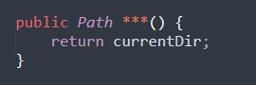

\*

|  |
| --- |
| getCurrentDir |
| getCurrentDirectory |

Please kindly explain why the selected option should be preferred.

\*

|  |
| --- |
| □Use of widely recognized abbreviations that do not hinder the understanding of the source code |
| □Excessively lengthy method names significantly impact code readability |
| □Consistency with the naming conventions of identifiers within the method body |
| □Less common abbreviation influences the understanding of the source code |
| □Method name with full terms are not excessively long and full terms tend to be more readable |
| □Others \_\_\_\_\_\_\_\_\_\_\_\_\_\_\_\_\_ |

118. Please read through the following code snippet where the original method name is marked by "\*\*\*". If necessary, you can refer to the enclosing class of the method at[this link](https://r.wjx.com/redirect.aspx?url=https%3A%2F%2Fgithub.com%2Fjiangyanjie%2FsurveyData%2Fblob%2Fmain%2FSecondRound%2F118%2F118.java&activity=267595662" \t "_blank). Among the names provided below, please indicate your preference for the method name.



\*

|  |
| --- |
| formatMsg |
| formatMessage |

Please kindly explain why the selected option should be preferred.

\*

|  |
| --- |
| □Use of widely recognized abbreviations that do not hinder the understanding of the source code |
| □Excessively lengthy method names significantly impact code readability |
| □Consistency with the naming conventions of identifiers within the method body |
| □Less common abbreviation influences the understanding of the source code |
| □Method name with full terms are not excessively long and full terms tend to be more readable |
| □Others \_\_\_\_\_\_\_\_\_\_\_\_\_\_\_\_\_ |

119. Please read through the following code snippet where the original method name is marked by "\*\*\*". If necessary, you can refer to the enclosing class of the method at [this link](https://r.wjx.com/redirect.aspx?url=https%3A%2F%2Fgithub.com%2Fjiangyanjie%2FsurveyData%2Fblob%2Fmain%2FSecondRound%2F119%2F119.java&activity=267595662" \t "_blank). Among the names provided below, please indicate your preference for the method name.

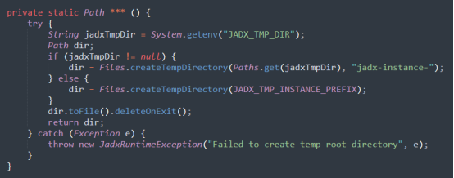

\*

|  |
| --- |
| createTempRootDir |
| createTemporaryRootDirectory |

Please kindly explain why the selected option should be preferred.

\*

|  |
| --- |
| □Use of widely recognized abbreviations that do not hinder the understanding of the source code |
| □Excessively lengthy method names significantly impact code readability |
| □Consistency with the naming conventions of identifiers within the method body |
| □Less common abbreviation influences the understanding of the source code |
| □Method name with full terms are not excessively long and full terms tend to be more readable |
| □Others \_\_\_\_\_\_\_\_\_\_\_\_\_\_\_\_\_ |

120. Please read through the following code snippet where the original method name is marked by "\*\*\*". If necessary, you can refer to the enclosing class of the method at [this link](https://r.wjx.com/redirect.aspx?url=https%3A%2F%2Fgithub.com%2Fjiangyanjie%2FsurveyData%2Fblob%2Fmain%2FSecondRound%2F120%2F120.java&activity=267595662" \t "_blank). Among the names provided below, please indicate your preference for the method name.

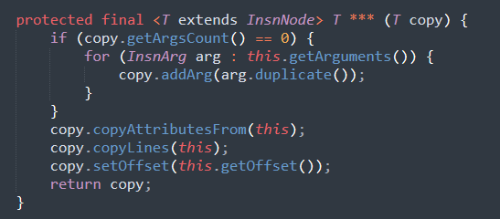

\*

|  |
| --- |
| copyCommonParams |
| copyCommonParameters |

Please kindly explain why the selected option should be preferred.

\*

|  |
| --- |
| □Use of widely recognized abbreviations that do not hinder the understanding of the source code |
| □Excessively lengthy method names significantly impact code readability |
| □Consistency with the naming conventions of identifiers within the method body |
| □Less common abbreviation influences the understanding of the source code |
| □Method name with full terms are not excessively long and full terms tend to be more readable |
| □Others \_\_\_\_\_\_\_\_\_\_\_\_\_\_\_\_\_ |

121. Please read through the following code snippet where the original method name is marked by "\*\*\*". If necessary, you can refer to the enclosing class of the method at[this link](https://r.wjx.com/redirect.aspx?url=https%3A%2F%2Fgithub.com%2Fjiangyanjie%2FsurveyData%2Fblob%2Fmain%2FSecondRound%2F121%2F121.java&activity=267595662" \t "_blank). Among the names provided below, please indicate your preference for the method name.

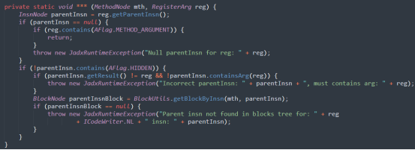

\*

|  |
| --- |
| checkRegisterArg |
| checkRegisterArgument |

Please kindly explain why the selected option should be preferred.

\*

|  |
| --- |
| □Use of widely recognized abbreviations that do not hinder the understanding of the source code |
| □Excessively lengthy method names significantly impact code readability |
| □Consistency with the naming conventions of identifiers within the method body |
| □Less common abbreviation influences the understanding of the source code |
| □Method name with full terms are not excessively long and full terms tend to be more readable |
| □Others \_\_\_\_\_\_\_\_\_\_\_\_\_\_\_\_\_ |

122. Please read through the following code snippet where the original method name is marked by "\*\*\*". If necessary, you can refer to the enclosing class of the method at [this link](https://r.wjx.com/redirect.aspx?url=https%3A%2F%2Fgithub.com%2Fjiangyanjie%2FsurveyData%2Fblob%2Fmain%2FSecondRound%2F122%2F122.java&activity=267595662" \t "_blank). Among the names provided below, please indicate your preference for the method name.

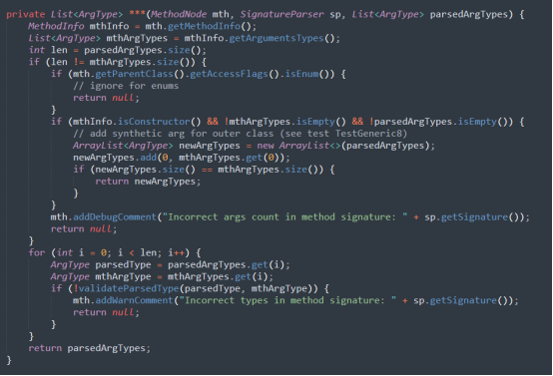

\*

|  |
| --- |
| checkArgTypes |
| checkArgumentTypes |

Please kindly explain why the selected option should be preferred.

\*

|  |
| --- |
| □Use of widely recognized abbreviations that do not hinder the understanding of the source code |
| □Excessively lengthy method names significantly impact code readability |
| □Consistency with the naming conventions of identifiers within the method body |
| □Less common abbreviation influences the understanding of the source code |
| □Method name with full terms are not excessively long and full terms tend to be more readable |
| □Others \_\_\_\_\_\_\_\_\_\_\_\_\_\_\_\_\_ |

123. Please read through the following code snippet where the original method name is marked by "\*\*\*". If necessary, you can refer to the enclosing class of the method at [this link](https://r.wjx.com/redirect.aspx?url=https%3A%2F%2Fgithub.com%2Fjiangyanjie%2FsurveyData%2Fblob%2Fmain%2FSecondRound%2F123%2F123.java&activity=267595662" \t "_blank). Among the names provided below, please indicate your preference for the method name.

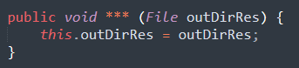

\*

|  |
| --- |
| setOutDirRes |
| setOutDirectoryResource |

Please kindly explain why the selected option should be preferred.

\*

|  |
| --- |
| □Use of widely recognized abbreviations that do not hinder the understanding of the source code |
| □Excessively lengthy method names significantly impact code readability |
| □Consistency with the naming conventions of identifiers within the method body |
| □Less common abbreviation influences the understanding of the source code |
| □Method name with full terms are not excessively long and full terms tend to be more readable |
| □Others \_\_\_\_\_\_\_\_\_\_\_\_\_\_\_\_\_ |

124. Please read through the following code snippet where the original method name is marked by "\*\*\*". If necessary, you can refer to the enclosing class of the method at [this link](https://r.wjx.com/redirect.aspx?url=https%3A%2F%2Fgithub.com%2Fjiangyanjie%2FsurveyData%2Fblob%2Fmain%2FSecondRound%2F124%2F124.java&activity=267595662" \t "_blank). Among the names provided below, please indicate your preference for the method name.

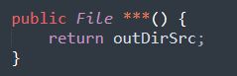

\*

|  |
| --- |
| getOutDirSrc |
| getOutDirectorySource |

Please kindly explain why the selected option should be preferred.

\*

|  |
| --- |
| □Use of widely recognized abbreviations that do not hinder the understanding of the source code |
| □Excessively lengthy method names significantly impact code readability |
| □Consistency with the naming conventions of identifiers within the method body |
| □Less common abbreviation influences the understanding of the source code |
| □Method name with full terms are not excessively long and full terms tend to be more readable |
| □Others \_\_\_\_\_\_\_\_\_\_\_\_\_\_\_\_\_ |

125. Please read through the following code snippet where the original method name is marked by "\*\*\*". If necessary, you can refer to the enclosing class of the method at [this link](https://r.wjx.com/redirect.aspx?url=https%3A%2F%2Fgithub.com%2Fjiangyanjie%2FsurveyData%2Fblob%2Fmain%2FSecondRound%2F125%2F125.java&activity=267595662" \t "_blank). Among the names provided below, please indicate your preference for the method name.

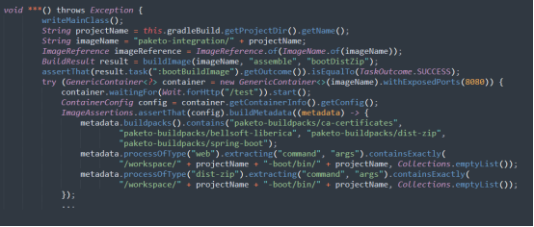

\*

|  |
| --- |
| bootDistZipJarApp |
| bootDistributedZipJarApplication |

Please kindly explain why the selected option should be preferred.

\*

|  |
| --- |
| □Use of widely recognized abbreviations that do not hinder the understanding of the source code |
| □Excessively lengthy method names significantly impact code readability |
| □Consistency with the naming conventions of identifiers within the method body |
| □Less common abbreviation influences the understanding of the source code |
| □Method name with full terms are not excessively long and full terms tend to be more readable |
| □Others \_\_\_\_\_\_\_\_\_\_\_\_\_\_\_\_\_ |

126. Please read through the following code snippet where the original method name is marked by "\*\*\*". If necessary, you can refer to the enclosing class of the method at [this link](https://r.wjx.com/redirect.aspx?url=https%3A%2F%2Fgithub.com%2Fjiangyanjie%2FsurveyData%2Fblob%2Fmain%2FSecondRound%2F126%2F126.java&activity=267595662" \t "_blank). Among the names provided below, please indicate your preference for the method name.

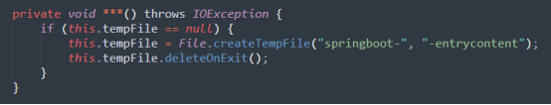

\*

|  |
| --- |
| initializeTempFile |
| initializeTemporaryFile |

Please kindly explain why the selected option should be preferred.

\*

|  |
| --- |
| □Use of widely recognized abbreviations that do not hinder the understanding of the source code |
| □Excessively lengthy method names significantly impact code readability |
| □Consistency with the naming conventions of identifiers within the method body |
| □Less common abbreviation influences the understanding of the source code |
| □Method name with full terms are not excessively long and full terms tend to be more readable |
| □Others \_\_\_\_\_\_\_\_\_\_\_\_\_\_\_\_\_ |

127. Please read through the following code snippet where the original method name is marked by "\*\*\*". If necessary, you can refer to the enclosing class of the method at [this link](https://r.wjx.com/redirect.aspx?url=https%3A%2F%2Fgithub.com%2Fjiangyanjie%2FsurveyData%2Fblob%2Fmain%2FSecondRound%2F127%2F127.java&activity=267595662" \t "_blank). Among the names provided below, please indicate your preference for the method name.

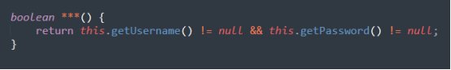

\*

|  |
| --- |
| hasUserAuth |
| hasUserAuthentication |

Please kindly explain why the selected option should be preferred.

\*

|  |
| --- |
| □Use of widely recognized abbreviations that do not hinder the understanding of the source code |
| □Excessively lengthy method names significantly impact code readability |
| □Consistency with the naming conventions of identifiers within the method body |
| □Less common abbreviation influences the understanding of the source code |
| □Method name with full terms are not excessively long and full terms tend to be more readable |
| □Others \_\_\_\_\_\_\_\_\_\_\_\_\_\_\_\_\_ |

128. Please read through the following code snippet where the original method name is marked by "\*\*\*". If necessary, you can refer to the enclosing class of the method at [this link](https://r.wjx.com/redirect.aspx?url=https%3A%2F%2Fgithub.com%2Fjiangyanjie%2FsurveyData%2Fblob%2Fmain%2FSecondRound%2F128%2F128.java&activity=267595662" \t "_blank). Among the names provided below, please indicate your preference for the method name.

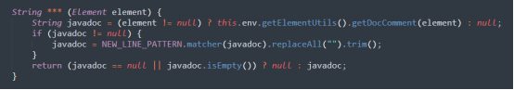

\*

|  |
| --- |
| getJavaDoc |
| getJavaDocument |

Please kindly explain why the selected option should be preferred.

\*

|  |
| --- |
| □Use of widely recognized abbreviations that do not hinder the understanding of the source code |
| □Excessively lengthy method names significantly impact code readability |
| □Consistency with the naming conventions of identifiers within the method body |
| □Less common abbreviation influences the understanding of the source code |
| □Method name with full terms are not excessively long and full terms tend to be more readable |
| □Others \_\_\_\_\_\_\_\_\_\_\_\_\_\_\_\_\_ |

129. Please read through the following code snippet where the original method name is marked by "\*\*\*". If necessary, you can refer to the enclosing class of the method at [this link](https://r.wjx.com/redirect.aspx?url=https%3A%2F%2Fgithub.com%2Fjiangyanjie%2FsurveyData%2Fblob%2Fmain%2FSecondRound%2F129%2F129.java&activity=267595662" \t "_blank). Among the names provided below, please indicate your preference for the method name.

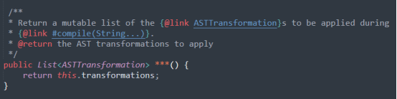

\*

|  |
| --- |
| getAstTransformations |
| getAbstractSyntaxTreeTransformations |

Please kindly explain why the selected option should be preferred.

\*

|  |
| --- |
| □Use of widely recognized abbreviations that do not hinder the understanding of the source code |
| □Excessively lengthy method names significantly impact code readability |
| □Consistency with the naming conventions of identifiers within the method body |
| □Less common abbreviation influences the understanding of the source code |
| □Method name with full terms are not excessively long and full terms tend to be more readable |
| □Others \_\_\_\_\_\_\_\_\_\_\_\_\_\_\_\_\_ |

130. Please read through the following code snippet where the original method name is marked by "\*\*\*". If necessary, you can refer to the enclosing class of the method at [this link](https://r.wjx.com/redirect.aspx?url=https%3A%2F%2Fgithub.com%2Fjiangyanjie%2FsurveyData%2Fblob%2Fmain%2FSecondRound%2F130%2F130.java&activity=267595662" \t "_blank). Among the names provided below, please indicate your preference for the method name.

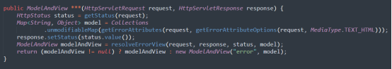

\*

|  |
| --- |
| errorHtml |
| errorHyperTextMarkupLanguage |

Please kindly explain why the selected option should be preferred.

\*

|  |
| --- |
| □Use of widely recognized abbreviations that do not hinder the understanding of the source code |
| □Excessively lengthy method names significantly impact code readability |
| □Consistency with the naming conventions of identifiers within the method body |
| □Less common abbreviation influences the understanding of the source code |
| □Method name with full terms are not excessively long and full terms tend to be more readable |
| □Others \_\_\_\_\_\_\_\_\_\_\_\_\_\_\_\_\_ |

131. Please read through the following code snippet where the original method name is marked by "\*\*\*". If necessary, you can refer to the enclosing class of the method at [this link](https://r.wjx.com/redirect.aspx?url=https%3A%2F%2Fgithub.com%2Fjiangyanjie%2FsurveyData%2Fblob%2Fmain%2FSecondRound%2F131%2F131.java&activity=267595662" \t "_blank). Among the names provided below, please indicate your preference for the method name.

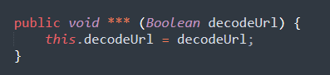

\*

|  |
| --- |
| setDecodeUrl |
| setDecodeUniformResourceLocator |

Please kindly explain why the selected option should be preferred.

\*

|  |
| --- |
| □Use of widely recognized abbreviations that do not hinder the understanding of the source code |
| □Excessively lengthy method names significantly impact code readability |
| □Consistency with the naming conventions of identifiers within the method body |
| □Less common abbreviation influences the understanding of the source code |
| □Method name with full terms are not excessively long and full terms tend to be more readable |
| □Others \_\_\_\_\_\_\_\_\_\_\_\_\_\_\_\_\_ |

132. Please read through the following code snippet where the original method name is marked by "\*\*\*". If necessary, you can refer to the enclosing class of the method at [this link](https://r.wjx.com/redirect.aspx?url=https%3A%2F%2Fgithub.com%2Fjiangyanjie%2FsurveyData%2Fblob%2Fmain%2FSecondRound%2F132%2F132.java&activity=267595662" \t "_blank). Among the names provided below, please indicate your preference for the method name.

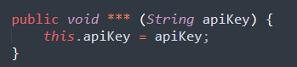

\*

|  |
| --- |
| setApiKey |
| setApplicationProgramInterfaceKey |

Please kindly explain why the selected option should be preferred.

\*

|  |
| --- |
| □Use of widely recognized abbreviations that do not hinder the understanding of the source code |
| □Excessively lengthy method names significantly impact code readability |
| □Consistency with the naming conventions of identifiers within the method body |
| □Less common abbreviation influences the understanding of the source code |
| □Method name with full terms are not excessively long and full terms tend to be more readable |
| □Others \_\_\_\_\_\_\_\_\_\_\_\_\_\_\_\_\_ |

133. Please read through the following code snippet where the original method name is marked by "\*\*\*". If necessary, you can refer to the enclosing class of the method at [this link](https://r.wjx.com/redirect.aspx?url=https%3A%2F%2Fgithub.com%2Fjiangyanjie%2FsurveyData%2Fblob%2Fmain%2FSecondRound%2F133%2F133.java&activity=267595662" \t "_blank). Among the names provided below, please indicate your preference for the method name.

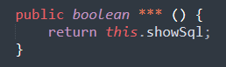

\*

|  |
| --- |
| isShowSql |
| isShowStructuredQueryLanguage |

Please kindly explain why the selected option should be preferred.

\*

|  |
| --- |
| □Use of widely recognized abbreviations that do not hinder the understanding of the source code |
| □Excessively lengthy method names significantly impact code readability |
| □Consistency with the naming conventions of identifiers within the method body |
| □Less common abbreviation influences the understanding of the source code |
| □Method name with full terms are not excessively long and full terms tend to be more readable |
| □Others \_\_\_\_\_\_\_\_\_\_\_\_\_\_\_\_\_ |

134. Please read through the following code snippet where the original method name is marked by "\*\*\*". If necessary, you can refer to the enclosing class of the method at [this link](https://r.wjx.com/redirect.aspx?url=https%3A%2F%2Fgithub.com%2Fjiangyanjie%2FsurveyData%2Fblob%2Fmain%2FSecondRound%2F134%2F134.java&activity=267595662" \t "_blank). Among the names provided below, please indicate your preference for the method name.

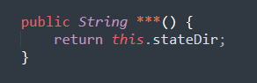

\*

|  |
| --- |
| getStateDir |
| getStateDirectory |

Please kindly explain why the selected option should be preferred.

\*

|  |
| --- |
| □Use of widely recognized abbreviations that do not hinder the understanding of the source code |
| □Excessively lengthy method names significantly impact code readability |
| □Consistency with the naming conventions of identifiers within the method body |
| □Less common abbreviation influences the understanding of the source code |
| □Method name with full terms are not excessively long and full terms tend to be more readable |
| □Others \_\_\_\_\_\_\_\_\_\_\_\_\_\_\_\_\_ |

135. Please read through the following code snippet where the original method name is marked by "\*\*\*". If necessary, you can refer to the enclosing class of the method at [this link](https://r.wjx.com/redirect.aspx?url=https%3A%2F%2Fgithub.com%2Fjiangyanjie%2FsurveyData%2Fblob%2Fmain%2FSecondRound%2F135%2F135.java&activity=267595662" \t "_blank). Among the names provided below, please indicate your preference for the method name.

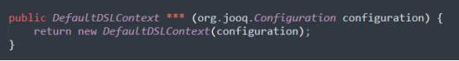

\*

|  |
| --- |
| dslContext |
| digitalSubscriberLineContext |

Please kindly explain why the selected option should be preferred.

\*

|  |
| --- |
| □Use of widely recognized abbreviations that do not hinder the understanding of the source code |
| □Excessively lengthy method names significantly impact code readability |
| □Consistency with the naming conventions of identifiers within the method body |
| □Less common abbreviation influences the understanding of the source code |
| □Method name with full terms are not excessively long and full terms tend to be more readable |
| □Others \_\_\_\_\_\_\_\_\_\_\_\_\_\_\_\_\_ |

136. Please read through the following code snippet where the original method name is marked by "\*\*\*". If necessary, you can refer to the enclosing class of the method at [this link](https://r.wjx.com/redirect.aspx?url=https%3A%2F%2Fgithub.com%2Fjiangyanjie%2FsurveyData%2Fblob%2Fmain%2FSecondRound%2F136%2F136.java&activity=267595662" \t "_blank). Among the names provided below, please indicate your preference for the method name.

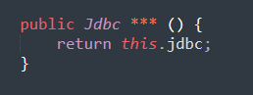

\*

|  |
| --- |
| getJdbc |
| getJavaDatabaseConnectivity |

Please kindly explain why the selected option should be preferred.

\*

|  |
| --- |
| □Use of widely recognized abbreviations that do not hinder the understanding of the source code |
| □Excessively lengthy method names significantly impact code readability |
| □Consistency with the naming conventions of identifiers within the method body |
| □Less common abbreviation influences the understanding of the source code |
| □Method name with full terms are not excessively long and full terms tend to be more readable |
| □Others \_\_\_\_\_\_\_\_\_\_\_\_\_\_\_\_\_ |

137. Please read through the following code snippet where the original method name is marked by "\*\*\*". If necessary, you can refer to the enclosing class of the method at [this link](https://r.wjx.com/redirect.aspx?url=https%3A%2F%2Fgithub.com%2Fjiangyanjie%2FsurveyData%2Fblob%2Fmain%2FSecondRound%2F137%2F137.java&activity=267595662" \t "_blank). Among the names provided below, please indicate your preference for the method name.

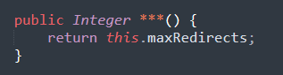

\*

|  |
| --- |
| getMaxRedirects |
| getMaximumRedirects |

Please kindly explain why the selected option should be preferred.

\*

|  |
| --- |
| □Use of widely recognized abbreviations that do not hinder the understanding of the source code |
| □Excessively lengthy method names significantly impact code readability |
| □Consistency with the naming conventions of identifiers within the method body |
| □Less common abbreviation influences the understanding of the source code |
| □Method name with full terms are not excessively long and full terms tend to be more readable |
| □Others \_\_\_\_\_\_\_\_\_\_\_\_\_\_\_\_\_ |

138. Please read through the following code snippet where the original method name is marked by "\*\*\*". If necessary, you can refer to the enclosing class of the method at [this link](https://r.wjx.com/redirect.aspx?url=https%3A%2F%2Fgithub.com%2Fjiangyanjie%2FsurveyData%2Fblob%2Fmain%2FSecondRound%2F138%2F138.java&activity=267595662" \t "_blank). Among the names provided below, please indicate your preference for the method name.

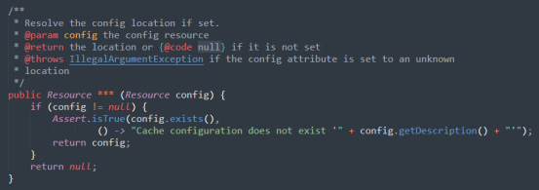

\*

|  |
| --- |
| resolveConfigLocation |
| resolveConfigurationLocation |

Please kindly explain why the selected option should be preferred.

\*

|  |
| --- |
| □Use of widely recognized abbreviations that do not hinder the understanding of the source code |
| □Excessively lengthy method names significantly impact code readability |
| □Consistency with the naming conventions of identifiers within the method body |
| □Less common abbreviation influences the understanding of the source code |
| □Method name with full terms are not excessively long and full terms tend to be more readable |
| □Others \_\_\_\_\_\_\_\_\_\_\_\_\_\_\_\_\_ |

139. Please read through the following code snippet where the original method name is marked by "\*\*\*". If necessary, you can refer to the enclosing class of the method at [this link](https://r.wjx.com/redirect.aspx?url=https%3A%2F%2Fgithub.com%2Fjiangyanjie%2FsurveyData%2Fblob%2Fmain%2FSecondRound%2F139%2F139.java&activity=267595662" \t "_blank). Among the names provided below, please indicate your preference for the method name.

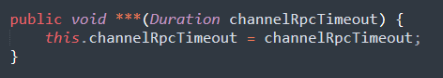

\*

|  |
| --- |
| setChannelRpcTimeout |
| setChannelRemoteProcedureCallTimeout |

Please kindly explain why the selected option should be preferred.

\*

|  |
| --- |
| □Use of widely recognized abbreviations that do not hinder the understanding of the source code |
| □Excessively lengthy method names significantly impact code readability |
| □Consistency with the naming conventions of identifiers within the method body |
| □Less common abbreviation influences the understanding of the source code |
| □Method name with full terms are not excessively long and full terms tend to be more readable |
| □Others \_\_\_\_\_\_\_\_\_\_\_\_\_\_\_\_\_ |

140. Please read through the following code snippet where the original method name is marked by "\*\*\*". If necessary, you can refer to the enclosing class of the method at [this link](https://r.wjx.com/redirect.aspx?url=https%3A%2F%2Fgithub.com%2Fjiangyanjie%2FsurveyData%2Fblob%2Fmain%2FSecondRound%2F140%2F140.java&activity=267595662" \t "_blank). Among the names provided below, please indicate your preference for the method name.

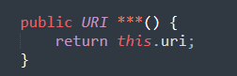

\*

|  |
| --- |
| getUri |
| getUniformResourceIdentifier |

Please kindly explain why the selected option should be preferred.

\*

|  |
| --- |
| □Use of widely recognized abbreviations that do not hinder the understanding of the source code |
| □Excessively lengthy method names significantly impact code readability |
| □Consistency with the naming conventions of identifiers within the method body |
| □Less common abbreviation influences the understanding of the source code |
| □Method name with full terms are not excessively long and full terms tend to be more readable |
| □Others \_\_\_\_\_\_\_\_\_\_\_\_\_\_\_\_\_ |

141. Please read through the following code snippet where the original method name is marked by "\*\*\*". If necessary, you can refer to the enclosing class of the method at [this link](https://r.wjx.com/redirect.aspx?url=https%3A%2F%2Fgithub.com%2Fjiangyanjie%2FsurveyData%2Fblob%2Fmain%2FSecondRound%2F141%2F141.java&activity=267595662" \t "_blank). Among the names provided below, please indicate your preference for the method name.

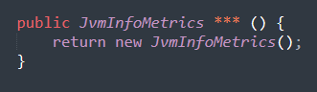

\*

|  |
| --- |
| jvmInfoMetrics |
| javaVirtualMachineInformationMetrics |

Please kindly explain why the selected option should be preferred.

\*

|  |
| --- |
| □Use of widely recognized abbreviations that do not hinder the understanding of the source code |
| □Excessively lengthy method names significantly impact code readability |
| □Consistency with the naming conventions of identifiers within the method body |
| □Less common abbreviation influences the understanding of the source code |
| □Method name with full terms are not excessively long and full terms tend to be more readable |
| □Others \_\_\_\_\_\_\_\_\_\_\_\_\_\_\_\_\_ |

142. Please read through the following code snippet where the original method name is marked by "\*\*\*". If necessary, you can refer to the enclosing class of the method at [this link](https://r.wjx.com/redirect.aspx?url=https%3A%2F%2Fgithub.com%2Fjiangyanjie%2FsurveyData%2Fblob%2Fmain%2FSecondRound%2F142%2F142.java&activity=267595662" \t "_blank). Among the names provided below, please indicate your preference for the method name.

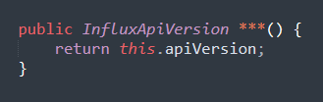

\*

|  |
| --- |
| getApiVersion |
| getApplicationProgramInterfaceVersion |

Please kindly explain why the selected option should be preferred.

\*

|  |
| --- |
| □Use of widely recognized abbreviations that do not hinder the understanding of the source code |
| □Excessively lengthy method names significantly impact code readability |
| □Consistency with the naming conventions of identifiers within the method body |
| □Less common abbreviation influences the understanding of the source code |
| □Method name with full terms are not excessively long and full terms tend to be more readable |
| □Others \_\_\_\_\_\_\_\_\_\_\_\_\_\_\_\_\_ |

143. Please read through the following code snippet where the original method name is marked by "\*\*\*". If necessary, you can refer to the enclosing class of the method at [this link](https://r.wjx.com/redirect.aspx?url=https%3A%2F%2Fgithub.com%2Fjiangyanjie%2FsurveyData%2Fblob%2Fmain%2FSecondRound%2F143%2F143.java&activity=267595662" \t "_blank). Among the names provided below, please indicate your preference for the method name.

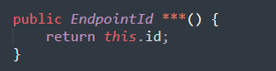

\*

|  |
| --- |
| getEndpointId |
| getEndpointIdentifier |

Please kindly explain why the selected option should be preferred.

\*

|  |
| --- |
| □Use of widely recognized abbreviations that do not hinder the understanding of the source code |
| □Excessively lengthy method names significantly impact code readability |
| □Consistency with the naming conventions of identifiers within the method body |
| □Less common abbreviation influences the understanding of the source code |
| □Method name with full terms are not excessively long and full terms tend to be more readable |
| □Others \_\_\_\_\_\_\_\_\_\_\_\_\_\_\_\_\_ |

144. Please read through the following code snippet where the original method name is marked by "\*\*\*". If necessary, you can refer to the enclosing class of the method at [this link](https://r.wjx.com/redirect.aspx?url=https%3A%2F%2Fgithub.com%2Fjiangyanjie%2FsurveyData%2Fblob%2Fmain%2FSecondRound%2F144%2F144.java&activity=267595662" \t "_blank). Among the names provided below, please indicate your preference for the method name.

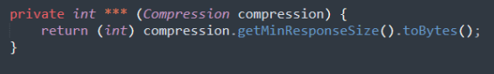

\*

|  |
| --- |
| getMinResponseSize |
| getMinimumResponseSize |

Please kindly explain why the selected option should be preferred.

\*

|  |
| --- |
| □Use of widely recognized abbreviations that do not hinder the understanding of the source code |
| □Excessively lengthy method names significantly impact code readability |
| □Consistency with the naming conventions of identifiers within the method body |
| □Less common abbreviation influences the understanding of the source code |
| □Method name with full terms are not excessively long and full terms tend to be more readable |
| □Others \_\_\_\_\_\_\_\_\_\_\_\_\_\_\_\_\_ |

145. Please read through the following code snippet where the original method name is marked by "\*\*\*". If necessary, you can refer to the enclosing class of the method at [this link](https://r.wjx.com/redirect.aspx?url=https%3A%2F%2Fgithub.com%2Fjiangyanjie%2FsurveyData%2Fblob%2Fmain%2FSecondRound%2F145%2F145.java&activity=267595662" \t "_blank). Among the names provided below, please indicate your preference for the method name.

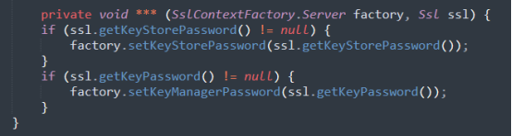

\*

|  |
| --- |
| configureSslPasswords |
| configureSecureSocketsLayerPasswords |

Please kindly explain why the selected option should be preferred.

\*

|  |
| --- |
| □Use of widely recognized abbreviations that do not hinder the understanding of the source code |
| □Excessively lengthy method names significantly impact code readability |
| □Consistency with the naming conventions of identifiers within the method body |
| □Less common abbreviation influences the understanding of the source code |
| □Method name with full terms are not excessively long and full terms tend to be more readable |
| □Others \_\_\_\_\_\_\_\_\_\_\_\_\_\_\_\_\_ |

146. Please read through the following code snippet where the original method name is marked by "\*\*\*". If necessary, you can refer to the enclosing class of the method at [this link](https://r.wjx.com/redirect.aspx?url=https%3A%2F%2Fgithub.com%2Fjiangyanjie%2FsurveyData%2Fblob%2Fmain%2FSecondRound%2F146%2F146.java&activity=267595662" \t "_blank). Among the names provided below, please indicate your preference for the method name.

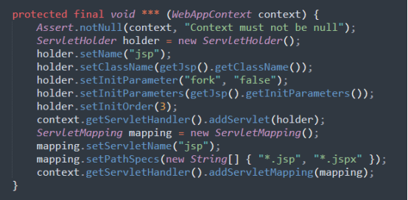

\*

|  |
| --- |
| addJspServlet |
| addJavaServerPagesServlet |

Please kindly explain why the selected option should be preferred.

\*

|  |
| --- |
| □Use of widely recognized abbreviations that do not hinder the understanding of the source code |
| □Excessively lengthy method names significantly impact code readability |
| □Consistency with the naming conventions of identifiers within the method body |
| □Less common abbreviation influences the understanding of the source code |
| □Method name with full terms are not excessively long and full terms tend to be more readable |
| □Others \_\_\_\_\_\_\_\_\_\_\_\_\_\_\_\_\_ |

147. Please read through the following code snippet where the original method name is marked by "\*\*\*". If necessary, you can refer to the enclosing class of the method at [this link](https://r.wjx.com/redirect.aspx?url=https%3A%2F%2Fgithub.com%2Fjiangyanjie%2FsurveyData%2Fblob%2Fmain%2FSecondRound%2F147%2F147.java&activity=267595662" \t "_blank). Among the names provided below, please indicate your preference for the method name.

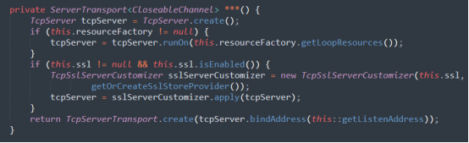

\*

|  |
| --- |
| createTcpTransport |
| createTransmissionControlProtocolTransport |

Please kindly explain why the selected option should be preferred.

\*

|  |
| --- |
| □Use of widely recognized abbreviations that do not hinder the understanding of the source code |
| □Excessively lengthy method names significantly impact code readability |
| □Consistency with the naming conventions of identifiers within the method body |
| □Less common abbreviation influences the understanding of the source code |
| □Method name with full terms are not excessively long and full terms tend to be more readable |
| □Others \_\_\_\_\_\_\_\_\_\_\_\_\_\_\_\_\_ |

148. Please read through the following code snippet where the original method name is marked by "\*\*\*". If necessary, you can refer to the enclosing class of the method at [this link](https://r.wjx.com/redirect.aspx?url=https%3A%2F%2Fgithub.com%2Fjiangyanjie%2FsurveyData%2Fblob%2Fmain%2FSecondRound%2F148%2F148.java&activity=267595662" \t "_blank). Among the names provided below, please indicate your preference for the method name.

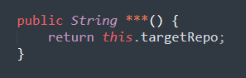

\*

|  |
| --- |
| getTargetRepo |
| getTargetRepository |

Please kindly explain why the selected option should be preferred.

\*

|  |
| --- |
| □Use of widely recognized abbreviations that do not hinder the understanding of the source code |
| □Excessively lengthy method names significantly impact code readability |
| □Consistency with the naming conventions of identifiers within the method body |
| □Less common abbreviation influences the understanding of the source code |
| □Method name with full terms are not excessively long and full terms tend to be more readable |
| □Others \_\_\_\_\_\_\_\_\_\_\_\_\_\_\_\_\_ |

149. Please read through the following code snippet where the original method name is marked by "\*\*\*". If necessary, you can refer to the enclosing class of the method at [this link](https://r.wjx.com/redirect.aspx?url=https%3A%2F%2Fgithub.com%2Fjiangyanjie%2FsurveyData%2Fblob%2Fmain%2FSecondRound%2F149%2F149.java&activity=267595662" \t "_blank). Among the names provided below, please indicate your preference for the method name.

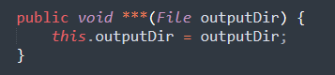

\*

|  |
| --- |
| setOutputDir |
| setOutputDirectory |

Please kindly explain why the selected option should be preferred.

\*

|  |
| --- |
| □Use of widely recognized abbreviations that do not hinder the understanding of the source code |
| □Excessively lengthy method names significantly impact code readability |
| □Consistency with the naming conventions of identifiers within the method body |
| □Less common abbreviation influences the understanding of the source code |
| □Method name with full terms are not excessively long and full terms tend to be more readable |
| □Others \_\_\_\_\_\_\_\_\_\_\_\_\_\_\_\_\_ |

150. Please read through the following code snippet where the original method name is marked by "\*\*\*". If necessary, you can refer to the enclosing class of the method at [this link](https://r.wjx.com/redirect.aspx?url=https%3A%2F%2Fgithub.com%2Fjiangyanjie%2FsurveyData%2Fblob%2Fmain%2FSecondRound%2F150%2F150.java&activity=267595662" \t "_blank). Among the names provided below, please indicate your preference for the method name.

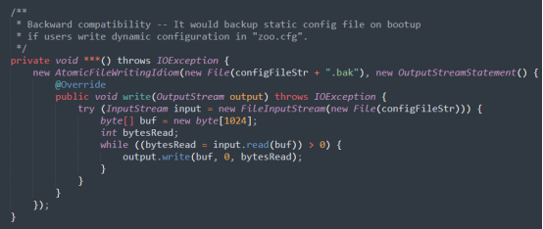

\*

|  |
| --- |
| backupOldConfig |
| backupOldConfiguration |

Please kindly explain why the selected option should be preferred.

\*

|  |
| --- |
| □Use of widely recognized abbreviations that do not hinder the understanding of the source code |
| □Excessively lengthy method names significantly impact code readability |
| □Consistency with the naming conventions of identifiers within the method body |
| □Less common abbreviation influences the understanding of the source code |
| □Method name with full terms are not excessively long and full terms tend to be more readable |
| □Others \_\_\_\_\_\_\_\_\_\_\_\_\_\_\_\_\_ |

151. Please read through the following code snippet where the original method name is marked by "\*\*\*". If necessary, you can refer to the enclosing class of the method at [this link](https://r.wjx.com/redirect.aspx?url=https%3A%2F%2Fgithub.com%2Fjiangyanjie%2FsurveyData%2Fblob%2Fmain%2FSecondRound%2F151%2F151.java&activity=267595662" \t "_blank). Among the names provided below, please indicate your preference for the method name.

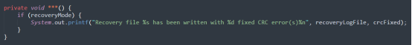

\*

|  |
| --- |
| printStat |
| printStatement |

Please kindly explain why the selected option should be preferred.

\*

|  |
| --- |
| □Use of widely recognized abbreviations that do not hinder the understanding of the source code |
| □Excessively lengthy method names significantly impact code readability |
| □Consistency with the naming conventions of identifiers within the method body |
| □Less common abbreviation influences the understanding of the source code |
| □Method name with full terms are not excessively long and full terms tend to be more readable |
| □Others \_\_\_\_\_\_\_\_\_\_\_\_\_\_\_\_\_ |

152. Please read through the following code snippet where the original method name is marked by "\*\*\*". If necessary, you can refer to the enclosing class of the method at [this link](https://r.wjx.com/redirect.aspx?url=https%3A%2F%2Fgithub.com%2Fjiangyanjie%2FsurveyData%2Fblob%2Fmain%2FSecondRound%2F152%2F152.java&activity=267595662" \t "_blank). Among the names provided below, please indicate your preference for the method name.

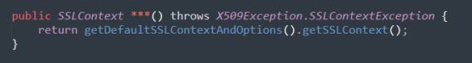

\*

|  |
| --- |
| getDefaultSSLContext |
| getDefaultSecureSocketsLayerContext |

Please kindly explain why the selected option should be preferred.

\*

|  |
| --- |
| □Use of widely recognized abbreviations that do not hinder the understanding of the source code |
| □Excessively lengthy method names significantly impact code readability |
| □Consistency with the naming conventions of identifiers within the method body |
| □Less common abbreviation influences the understanding of the source code |
| □Method name with full terms are not excessively long and full terms tend to be more readable |
| □Others \_\_\_\_\_\_\_\_\_\_\_\_\_\_\_\_\_ |

153. Please read through the following code snippet where the original method name is marked by "\*\*\*". If necessary, you can refer to the enclosing class of the method at [this link](https://r.wjx.com/redirect.aspx?url=https%3A%2F%2Fgithub.com%2Fjiangyanjie%2FsurveyData%2Fblob%2Fmain%2FSecondRound%2F153%2F153.java&activity=267595662" \t "_blank). Among the names provided below, please indicate your preference for the method name.

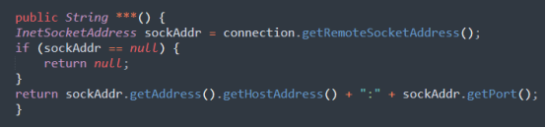

\*

|  |
| --- |
| getSourceIP |
| getSourceInternetProtocol |

Please kindly explain why the selected option should be preferred.

\*

|  |
| --- |
| □Use of widely recognized abbreviations that do not hinder the understanding of the source code |
| □Excessively lengthy method names significantly impact code readability |
| □Consistency with the naming conventions of identifiers within the method body |
| □Less common abbreviation influences the understanding of the source code |
| □Method name with full terms are not excessively long and full terms tend to be more readable |
| □Others \_\_\_\_\_\_\_\_\_\_\_\_\_\_\_\_\_ |

154. Please read through the following code snippet where the original method name is marked by "\*\*\*". If necessary, you can refer to the enclosing class of the method at [this link](https://r.wjx.com/redirect.aspx?url=https%3A%2F%2Fgithub.com%2Fjiangyanjie%2FsurveyData%2Fblob%2Fmain%2FSecondRound%2F154%2F154.java&activity=267595662" \t "_blank). Among the names provided below, please indicate your preference for the method name.

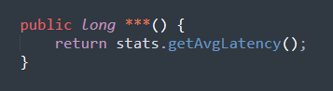

\*

|  |
| --- |
| getAvgLatency |
| getAverageLatency |

Please kindly explain why the selected option should be preferred.

\*

|  |
| --- |
| □Use of widely recognized abbreviations that do not hinder the understanding of the source code |
| □Excessively lengthy method names significantly impact code readability |
| □Consistency with the naming conventions of identifiers within the method body |
| □Less common abbreviation influences the understanding of the source code |
| □Method name with full terms are not excessively long and full terms tend to be more readable |
| □Others \_\_\_\_\_\_\_\_\_\_\_\_\_\_\_\_\_ |

155. Please read through the following code snippet where the original method name is marked by "\*\*\*". If necessary, you can refer to the enclosing class of the method at [this link](https://r.wjx.com/redirect.aspx?url=https%3A%2F%2Fgithub.com%2Fjiangyanjie%2FsurveyData%2Fblob%2Fmain%2FSecondRound%2F155%2F155.java&activity=267595662" \t "_blank). Among the names provided below, please indicate your preference for the method name.

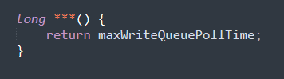

\*

|  |
| --- |
| getMaxWriteQueuePollTime |
| getMaximumWriteQueuePollTime |

Please kindly explain why the selected option should be preferred.

\*

|  |
| --- |
| □Use of widely recognized abbreviations that do not hinder the understanding of the source code |
| □Excessively lengthy method names significantly impact code readability |
| □Consistency with the naming conventions of identifiers within the method body |
| □Less common abbreviation influences the understanding of the source code |
| □Method name with full terms are not excessively long and full terms tend to be more readable |
| □Others \_\_\_\_\_\_\_\_\_\_\_\_\_\_\_\_\_ |

156. Please read through the following code snippet where the original method name is marked by "\*\*\*". If necessary, you can refer to the enclosing class of the method at [this link](https://r.wjx.com/redirect.aspx?url=https%3A%2F%2Fgithub.com%2Fjiangyanjie%2FsurveyData%2Fblob%2Fmain%2FSecondRound%2F156%2F156.java&activity=267595662" \t "_blank). Among the names provided below, please indicate your preference for the method name.

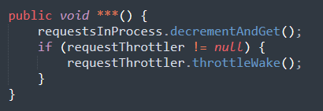

\*

|  |
| --- |
| decInProcess |
| decrementInProcess |

Please kindly explain why the selected option should be preferred.

\*

|  |
| --- |
| □Use of widely recognized abbreviations that do not hinder the understanding of the source code |
| □Excessively lengthy method names significantly impact code readability |
| □Consistency with the naming conventions of identifiers within the method body |
| □Less common abbreviation influences the understanding of the source code |
| □Method name with full terms are not excessively long and full terms tend to be more readable |
| □Others \_\_\_\_\_\_\_\_\_\_\_\_\_\_\_\_\_ |

157. Please read through the following code snippet where the original method name is marked by "\*\*\*". If necessary, you can refer to the enclosing class of the method at [this link](https://r.wjx.com/redirect.aspx?url=https%3A%2F%2Fgithub.com%2Fjiangyanjie%2FsurveyData%2Fblob%2Fmain%2FSecondRound%2F157%2F157.java&activity=267595662" \t "_blank). Among the names provided below, please indicate your preference for the method name.

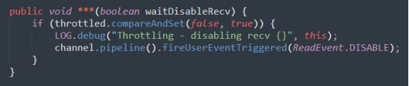

\*

|  |
| --- |
| disableRecv |
| disableReceive |

Please kindly explain why the selected option should be preferred.

\*

|  |
| --- |
| □Use of widely recognized abbreviations that do not hinder the understanding of the source code |
| □Excessively lengthy method names significantly impact code readability |
| □Consistency with the naming conventions of identifiers within the method body |
| □Less common abbreviation influences the understanding of the source code |
| □Method name with full terms are not excessively long and full terms tend to be more readable |
| □Others \_\_\_\_\_\_\_\_\_\_\_\_\_\_\_\_\_ |

158. Please read through the following code snippet where the original method name is marked by "\*\*\*". If necessary, you can refer to the enclosing class of the method at[this link](https://r.wjx.com/redirect.aspx?url=https%3A%2F%2Fgithub.com%2Fjiangyanjie%2FsurveyData%2Fblob%2Fmain%2FSecondRound%2F158%2F158.java&activity=267595662" \t "_blank). Among the names provided below, please indicate your preference for the method name.

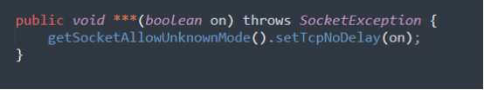

\*

|  |
| --- |
| setTcpNoDelay |
| setTransmissionControlProtocolNoDelay |

Please kindly explain why the selected option should be preferred.

\*

|  |
| --- |
| □Use of widely recognized abbreviations that do not hinder the understanding of the source code |
| □Excessively lengthy method names significantly impact code readability |
| □Consistency with the naming conventions of identifiers within the method body |
| □Less common abbreviation influences the understanding of the source code |
| □Method name with full terms are not excessively long and full terms tend to be more readable |
| □Others \_\_\_\_\_\_\_\_\_\_\_\_\_\_\_\_\_ |

159. Please read through the following code snippet where the original method name is marked by "\*\*\*". If necessary, you can refer to the enclosing class of the method at [this link](https://r.wjx.com/redirect.aspx?url=https%3A%2F%2Fgithub.com%2Fjiangyanjie%2FsurveyData%2Fblob%2Fmain%2FSecondRound%2F159%2F159.java&activity=267595662" \t "_blank). Among the names provided below, please indicate your preference for the method name.

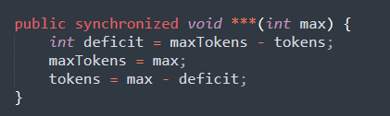

\*

|  |
| --- |
| setMaxTokens |
| setMaximumTokens |

Please kindly explain why the selected option should be preferred.

\*

|  |
| --- |
| □Use of widely recognized abbreviations that do not hinder the understanding of the source code |
| □Excessively lengthy method names significantly impact code readability |
| □Consistency with the naming conventions of identifiers within the method body |
| □Less common abbreviation influences the understanding of the source code |
| □Method name with full terms are not excessively long and full terms tend to be more readable |
| □Others \_\_\_\_\_\_\_\_\_\_\_\_\_\_\_\_\_ |

160. Please read through the following code snippet where the original method name is marked by "\*\*\*". If necessary, you can refer to the enclosing class of the method at [this link](https://r.wjx.com/redirect.aspx?url=https%3A%2F%2Fgithub.com%2Fjiangyanjie%2FsurveyData%2Fblob%2Fmain%2FSecondRound%2F160%2F160.java&activity=267595662" \t "_blank). Among the names provided below, please indicate your preference for the method name.

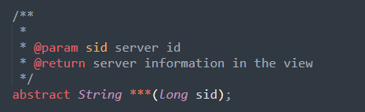

\*

|  |
| --- |
| getPeerInfo |
| getPeerInformation |

Please kindly explain why the selected option should be preferred.

\*

|  |
| --- |
| □Use of widely recognized abbreviations that do not hinder the understanding of the source code |
| □Excessively lengthy method names significantly impact code readability |
| □Consistency with the naming conventions of identifiers within the method body |
| □Less common abbreviation influences the understanding of the source code |
| □Method name with full terms are not excessively long and full terms tend to be more readable |
| □Others \_\_\_\_\_\_\_\_\_\_\_\_\_\_\_\_\_ |

161. Please read through the following code snippet where the original method name is marked by "\*\*\*". If necessary, you can refer to the enclosing class of the method at [this link](https://r.wjx.com/redirect.aspx?url=https%3A%2F%2Fgithub.com%2Fjiangyanjie%2FsurveyData%2Fblob%2Fmain%2FSecondRound%2F161%2F161.java&activity=267595662" \t "_blank). Among the names provided below, please indicate your preference for the method name.

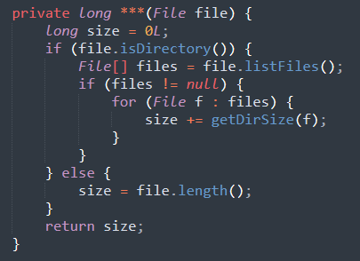

\*

|  |
| --- |
| getDirSize |
| getDirectorySize |

Please kindly explain why the selected option should be preferred.

\*

|  |
| --- |
| □Use of widely recognized abbreviations that do not hinder the understanding of the source code |
| □Excessively lengthy method names significantly impact code readability |
| □Consistency with the naming conventions of identifiers within the method body |
| □Less common abbreviation influences the understanding of the source code |
| □Method name with full terms are not excessively long and full terms tend to be more readable |
| □Others \_\_\_\_\_\_\_\_\_\_\_\_\_\_\_\_\_ |

162. Please read through the following code snippet where the original method name is marked by "\*\*\*". If necessary, you can refer to the enclosing class of the method at [this link](https://r.wjx.com/redirect.aspx?url=https%3A%2F%2Fgithub.com%2Fjiangyanjie%2FsurveyData%2Fblob%2Fmain%2FSecondRound%2F162%2F162.java&activity=267595662" \t "_blank). Among the names provided below, please indicate your preference for the method name.

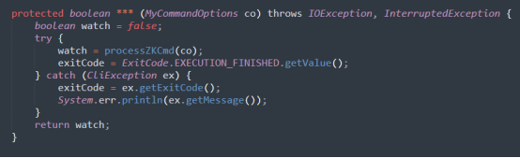

\*

|  |
| --- |
| processCmd |
| processCommand |

Please kindly explain why the selected option should be preferred.

\*

|  |
| --- |
| □Use of widely recognized abbreviations that do not hinder the understanding of the source code |
| □Excessively lengthy method names significantly impact code readability |
| □Consistency with the naming conventions of identifiers within the method body |
| □Less common abbreviation influences the understanding of the source code |
| □Method name with full terms are not excessively long and full terms tend to be more readable |
| □Others \_\_\_\_\_\_\_\_\_\_\_\_\_\_\_\_\_ |

163. Please read through the following code snippet where the original method name is marked by "\*\*\*". If necessary, you can refer to the enclosing class of the method at [this link](https://r.wjx.com/redirect.aspx?url=https%3A%2F%2Fgithub.com%2Fjiangyanjie%2FsurveyData%2Fblob%2Fmain%2FSecondRound%2F163%2F163.java&activity=267595662" \t "_blank). Among the names provided below, please indicate your preference for the method name.

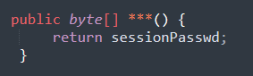

\*

|  |
| --- |
| getSessionPasswd |
| getSessionPassword |

Please kindly explain why the selected option should be preferred.

\*

|  |
| --- |
| □Use of widely recognized abbreviations that do not hinder the understanding of the source code |
| □Excessively lengthy method names significantly impact code readability |
| □Consistency with the naming conventions of identifiers within the method body |
| □Less common abbreviation influences the understanding of the source code |
| □Method name with full terms are not excessively long and full terms tend to be more readable |
| □Others \_\_\_\_\_\_\_\_\_\_\_\_\_\_\_\_\_ |

164. Please read through the following code snippet where the original method name is marked by "\*\*\*". If necessary, you can refer to the enclosing class of the method at [this link](https://r.wjx.com/redirect.aspx?url=https%3A%2F%2Fgithub.com%2Fjiangyanjie%2FsurveyData%2Fblob%2Fmain%2FSecondRound%2F164%2F164.java&activity=267595662" \t "_blank). Among the names provided below, please indicate your preference for the method name.

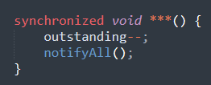

\*

|  |
| --- |
| decOutstanding |
| descendingOutstanding |

Please kindly explain why the selected option should be preferred.

\*

|  |
| --- |
| □Use of widely recognized abbreviations that do not hinder the understanding of the source code |
| □Excessively lengthy method names significantly impact code readability |
| □Consistency with the naming conventions of identifiers within the method body |
| □Less common abbreviation influences the understanding of the source code |
| □Method name with full terms are not excessively long and full terms tend to be more readable |
| □Others \_\_\_\_\_\_\_\_\_\_\_\_\_\_\_\_\_ |

165. Please read through the following code snippet where the original method name is marked by "\*\*\*". If necessary, you can refer to the enclosing class of the method at [this link](https://r.wjx.com/redirect.aspx?url=https%3A%2F%2Fgithub.com%2Fjiangyanjie%2FsurveyData%2Fblob%2Fmain%2FSecondRound%2F165%2F165.java&activity=267595662" \t "_blank). Among the names provided below, please indicate your preference for the method name.

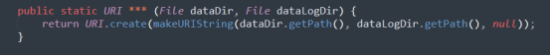

\*

|  |
| --- |
| makeFileLoggerURL |
| makeFileLoggerUniformResourceLocator |

Please kindly explain why the selected option should be preferred.

\*

|  |
| --- |
| □Use of widely recognized abbreviations that do not hinder the understanding of the source code |
| □Excessively lengthy method names significantly impact code readability |
| □Consistency with the naming conventions of identifiers within the method body |
| □Less common abbreviation influences the understanding of the source code |
| □Method name with full terms are not excessively long and full terms tend to be more readable |
| □Others \_\_\_\_\_\_\_\_\_\_\_\_\_\_\_\_\_ |

166. Please read through the following code snippet where the original method name is marked by "\*\*\*". If necessary, you can refer to the enclosing class of the method at [this link](https://r.wjx.com/redirect.aspx?url=https%3A%2F%2Fgithub.com%2Fjiangyanjie%2FsurveyData%2Fblob%2Fmain%2FSecondRound%2F166%2F166.java&activity=267595662" \t "_blank). Among the names provided below, please indicate your preference for the method name.

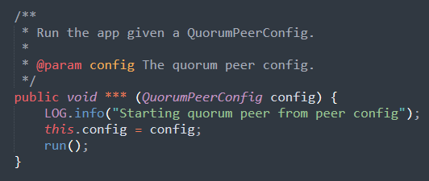

\*

|  |
| --- |
| runFromConfig |
| runFromConfiguration |

Please kindly explain why the selected option should be preferred.

\*

|  |
| --- |
| □Use of widely recognized abbreviations that do not hinder the understanding of the source code |
| □Excessively lengthy method names significantly impact code readability |
| □Consistency with the naming conventions of identifiers within the method body |
| □Less common abbreviation influences the understanding of the source code |
| □Method name with full terms are not excessively long and full terms tend to be more readable |
| □Others \_\_\_\_\_\_\_\_\_\_\_\_\_\_\_\_\_ |

167. Please read through the following code snippet where the original method name is marked by "\*\*\*". If necessary, you can refer to the enclosing class of the method at [this link](https://r.wjx.com/redirect.aspx?url=https%3A%2F%2Fgithub.com%2Fjiangyanjie%2FsurveyData%2Fblob%2Fmain%2FSecondRound%2F167%2F167.java&activity=267595662" \t "_blank). Among the names provided below, please indicate your preference for the method name.

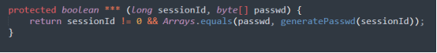

\*

|  |
| --- |
| checkPasswd |
| checkPassword |

Please kindly explain why the selected option should be preferred.

\*

|  |
| --- |
| □Use of widely recognized abbreviations that do not hinder the understanding of the source code |
| □Excessively lengthy method names significantly impact code readability |
| □Consistency with the naming conventions of identifiers within the method body |
| □Less common abbreviation influences the understanding of the source code |
| □Method name with full terms are not excessively long and full terms tend to be more readable |
| □Others \_\_\_\_\_\_\_\_\_\_\_\_\_\_\_\_\_ |

168. Please read through the following code snippet where the original method name is marked by "\*\*\*". If necessary, you can refer to the enclosing class of the method at [this link](https://r.wjx.com/redirect.aspx?url=https%3A%2F%2Fgithub.com%2Fjiangyanjie%2FsurveyData%2Fblob%2Fmain%2FSecondRound%2F168%2F168.java&activity=267595662" \t "_blank). Among the names provided below, please indicate your preference for the method name.

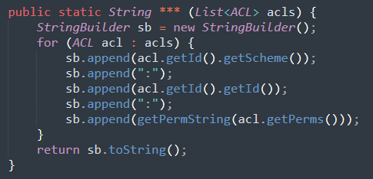

\*

|  |
| --- |
| aclToString |
| accessControlListToString |

Please kindly explain why the selected option should be preferred.

\*

|  |
| --- |
| □Use of widely recognized abbreviations that do not hinder the understanding of the source code |
| □Excessively lengthy method names significantly impact code readability |
| □Consistency with the naming conventions of identifiers within the method body |
| □Less common abbreviation influences the understanding of the source code |
| □Method name with full terms are not excessively long and full terms tend to be more readable |
| □Others \_\_\_\_\_\_\_\_\_\_\_\_\_\_\_\_\_ |

169. Please read through the following code snippet where the original method name is marked by "\*\*\*". If necessary, you can refer to the enclosing class of the method at [this link](https://r.wjx.com/redirect.aspx?url=https%3A%2F%2Fgithub.com%2Fjiangyanjie%2FsurveyData%2Fblob%2Fmain%2FSecondRound%2F169%2F169.java&activity=267595662" \t "_blank). Among the names provided below, please indicate your preference for the method name.

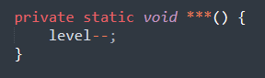

\*

|  |
| --- |
| decrLevel |
| decreaseLevel |

Please kindly explain why the selected option should be preferred.

\*

|  |
| --- |
| □Use of widely recognized abbreviations that do not hinder the understanding of the source code |
| □Excessively lengthy method names significantly impact code readability |
| □Consistency with the naming conventions of identifiers within the method body |
| □Less common abbreviation influences the understanding of the source code |
| □Method name with full terms are not excessively long and full terms tend to be more readable |
| □Others \_\_\_\_\_\_\_\_\_\_\_\_\_\_\_\_\_ |

170. Please read through the following code snippet where the original method name is marked by "\*\*\*". If necessary, you can refer to the enclosing class of the method at [this link](https://r.wjx.com/redirect.aspx?url=https%3A%2F%2Fgithub.com%2Fjiangyanjie%2FsurveyData%2Fblob%2Fmain%2FSecondRound%2F170%2F170.java&activity=267595662" \t "_blank). Among the names provided below, please indicate your preference for the method name.

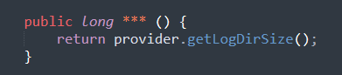

\*

|  |
| --- |
| getLogDirSize |
| getLogDirectorySize |

Please kindly explain why the selected option should be preferred.

\*

|  |
| --- |
| □Use of widely recognized abbreviations that do not hinder the understanding of the source code |
| □Excessively lengthy method names significantly impact code readability |
| □Consistency with the naming conventions of identifiers within the method body |
| □Less common abbreviation influences the understanding of the source code |
| □Method name with full terms are not excessively long and full terms tend to be more readable |
| □Others \_\_\_\_\_\_\_\_\_\_\_\_\_\_\_\_\_ |

171. Please read through the following code snippet where the original method name is marked by "\*\*\*". If necessary, you can refer to the enclosing class of the method at[this link](https://r.wjx.com/redirect.aspx?url=https%3A%2F%2Fgithub.com%2Fjiangyanjie%2FsurveyData%2Fblob%2Fmain%2FSecondRound%2F171%2F171.java&activity=267595662" \t "_blank). Among the names provided below, please indicate your preference for the method name.

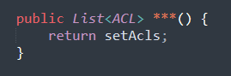

\*

|  |
| --- |
| getSetAcls |
| getSetAccessControlLists |

Please kindly explain why the selected option should be preferred.

\*

|  |
| --- |
| □Use of widely recognized abbreviations that do not hinder the understanding of the source code |
| □Excessively lengthy method names significantly impact code readability |
| □Consistency with the naming conventions of identifiers within the method body |
| □Less common abbreviation influences the understanding of the source code |
| □Method name with full terms are not excessively long and full terms tend to be more readable |
| □Others \_\_\_\_\_\_\_\_\_\_\_\_\_\_\_\_\_ |

172. Please read through the following code snippet where the original method name is marked by "\*\*\*". If necessary, you can refer to the enclosing class of the method at [this link](https://r.wjx.com/redirect.aspx?url=https%3A%2F%2Fgithub.com%2Fjiangyanjie%2FsurveyData%2Fblob%2Fmain%2FSecondRound%2F172%2F172.java&activity=267595662" \t "_blank). Among the names provided below, please indicate your preference for the method name.

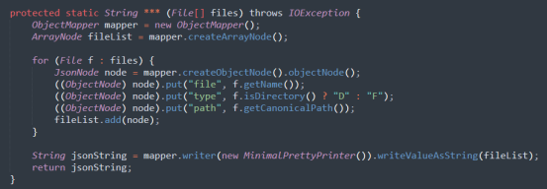

\*

|  |
| --- |
| generateJSON |
| generateJavaScriptObjectNotation |

Please kindly explain why the selected option should be preferred.

\*

|  |
| --- |
| □Use of widely recognized abbreviations that do not hinder the understanding of the source code |
| □Excessively lengthy method names significantly impact code readability |
| □Consistency with the naming conventions of identifiers within the method body |
| □Less common abbreviation influences the understanding of the source code |
| □Method name with full terms are not excessively long and full terms tend to be more readable |
| □Others \_\_\_\_\_\_\_\_\_\_\_\_\_\_\_\_\_ |

173. Please read through the following code snippet where the original method name is marked by "\*\*\*". If necessary, you can refer to the enclosing class of the method at [this link](https://r.wjx.com/redirect.aspx?url=https%3A%2F%2Fgithub.com%2Fjiangyanjie%2FsurveyData%2Fblob%2Fmain%2FSecondRound%2F173%2F173.java&activity=267595662" \t "_blank). Among the names provided below, please indicate your preference for the method name.

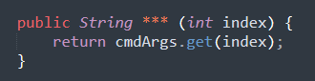

\*

|  |
| --- |
| getCmdArgument |
| getCommandArgument |

Please kindly explain why the selected option should be preferred.

\*

|  |
| --- |
| □Use of widely recognized abbreviations that do not hinder the understanding of the source code |
| □Excessively lengthy method names significantly impact code readability |
| □Consistency with the naming conventions of identifiers within the method body |
| □Less common abbreviation influences the understanding of the source code |
| □Method name with full terms are not excessively long and full terms tend to be more readable |
| □Others \_\_\_\_\_\_\_\_\_\_\_\_\_\_\_\_\_ |

174. Please read through the following code snippet where the original method name is marked by "\*\*\*". If necessary, you can refer to the enclosing class of the method at [this link](https://r.wjx.com/redirect.aspx?url=https%3A%2F%2Fgithub.com%2Fjiangyanjie%2FsurveyData%2Fblob%2Fmain%2FSecondRound%2F174%2F174.java&activity=267595662" \t "_blank). Among the names provided below, please indicate your preference for the method name.

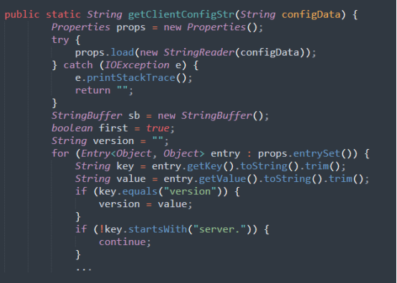

\*

|  |
| --- |
| getClientConfigStr |
| getClientConfigurationString |

Please kindly explain why the selected option should be preferred.

\*

|  |
| --- |
| □Use of widely recognized abbreviations that do not hinder the understanding of the source code |
| □Excessively lengthy method names significantly impact code readability |
| □Consistency with the naming conventions of identifiers within the method body |
| □Less common abbreviation influences the understanding of the source code |
| □Method name with full terms are not excessively long and full terms tend to be more readable |
| □Others \_\_\_\_\_\_\_\_\_\_\_\_\_\_\_\_\_ |

175. Please read through the following code snippet where the original method name is marked by "\*\*\*". If necessary, you can refer to the enclosing class of the method at [this link](https://r.wjx.com/redirect.aspx?url=https%3A%2F%2Fgithub.com%2Fjiangyanjie%2FsurveyData%2Fblob%2Fmain%2FSecondRound%2F175%2F175.java&activity=267595662" \t "_blank). Among the names provided below, please indicate your preference for the method name.

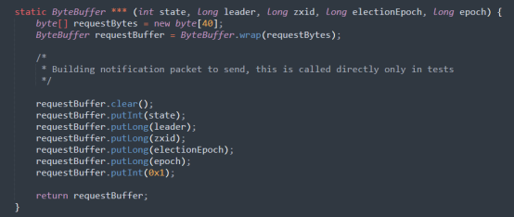

\*

|  |
| --- |
| buildMsg |
| buildMessage |

Please kindly explain why the selected option should be preferred.

\*

|  |
| --- |
| □Use of widely recognized abbreviations that do not hinder the understanding of the source code |
| □Excessively lengthy method names significantly impact code readability |
| □Consistency with the naming conventions of identifiers within the method body |
| □Less common abbreviation influences the understanding of the source code |
| □Method name with full terms are not excessively long and full terms tend to be more readable |
| □Others \_\_\_\_\_\_\_\_\_\_\_\_\_\_\_\_\_ |

176. Please read through the following code snippet where the original method name is marked by "\*\*\*". If necessary, you can refer to the enclosing class of the method at [this link](https://r.wjx.com/redirect.aspx?url=https%3A%2F%2Fgithub.com%2Fjiangyanjie%2FsurveyData%2Fblob%2Fmain%2FSecondRound%2F176%2F176.java&activity=267595662" \t "_blank). Among the names provided below, please indicate your preference for the method name.

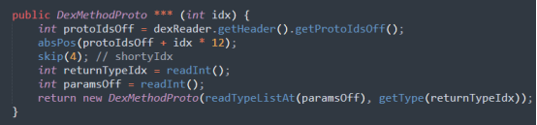

\*

|  |
| --- |
| getMethodProto |
| getMethodPrototype |

Please kindly explain why the selected option should be preferred.

\*

|  |
| --- |
| □Use of widely recognized abbreviations that do not hinder the understanding of the source code |
| □Excessively lengthy method names significantly impact code readability |
| □Consistency with the naming conventions of identifiers within the method body |
| □Less common abbreviation influences the understanding of the source code |
| □Method name with full terms are not excessively long and full terms tend to be more readable |
| □Others \_\_\_\_\_\_\_\_\_\_\_\_\_\_\_\_\_ |

177. Please read through the following code snippet where the original method name is marked by "\*\*\*". If necessary, you can refer to the enclosing class of the method at [this link](https://r.wjx.com/redirect.aspx?url=https%3A%2F%2Fgithub.com%2Fjiangyanjie%2FsurveyData%2Fblob%2Fmain%2FSecondRound%2F177%2F177.java&activity=267595662" \t "_blank). Among the names provided below, please indicate your preference for the method name.

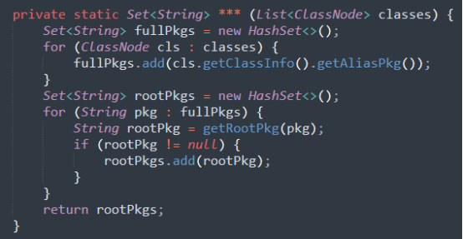

\*

|  |
| --- |
| collectRootPkgs |
| collectRootPackages |

Please kindly explain why the selected option should be preferred.

\*

|  |
| --- |
| □Use of widely recognized abbreviations that do not hinder the understanding of the source code |
| □Excessively lengthy method names significantly impact code readability |
| □Consistency with the naming conventions of identifiers within the method body |
| □Less common abbreviation influences the understanding of the source code |
| □Method name with full terms are not excessively long and full terms tend to be more readable |
| □Others \_\_\_\_\_\_\_\_\_\_\_\_\_\_\_\_\_ |

178. Please read through the following code snippet where the original method name is marked by "\*\*\*". If necessary, you can refer to the enclosing class of the method at [this link](https://r.wjx.com/redirect.aspx?url=https%3A%2F%2Fgithub.com%2Fjiangyanjie%2FsurveyData%2Fblob%2Fmain%2FSecondRound%2F178%2F178.java&activity=267595662" \t "_blank). Among the names provided below, please indicate your preference for the method name.

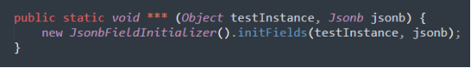

\*

|  |
| --- |
| initFields |
| initializeFields |

Please kindly explain why the selected option should be preferred.

\*

|  |
| --- |
| □Use of widely recognized abbreviations that do not hinder the understanding of the source code |
| □Excessively lengthy method names significantly impact code readability |
| □Consistency with the naming conventions of identifiers within the method body |
| □Less common abbreviation influences the understanding of the source code |
| □Method name with full terms are not excessively long and full terms tend to be more readable |
| □Others \_\_\_\_\_\_\_\_\_\_\_\_\_\_\_\_\_ |

179. Please read through the following code snippet where the original method name is marked by "\*\*\*". If necessary, you can refer to the enclosing class of the method at [this link](https://r.wjx.com/redirect.aspx?url=https%3A%2F%2Fgithub.com%2Fjiangyanjie%2FsurveyData%2Fblob%2Fmain%2FSecondRound%2F179%2F179.java&activity=267595662" \t "_blank). Among the names provided below, please indicate your preference for the method name.

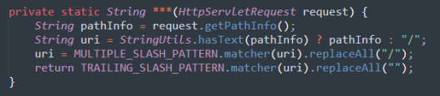

\*

|  |
| --- |
| getPathInfo |
| getPathInformation |

Please kindly explain why the selected option should be preferred.

\*

|  |
| --- |
| □Use of widely recognized abbreviations that do not hinder the understanding of the source code |
| □Excessively lengthy method names significantly impact code readability |
| □Consistency with the naming conventions of identifiers within the method body |
| □Less common abbreviation influences the understanding of the source code |
| □Method name with full terms are not excessively long and full terms tend to be more readable |
| □Others \_\_\_\_\_\_\_\_\_\_\_\_\_\_\_\_\_ |

180. Please read through the following code snippet where the original method name is marked by "\*\*\*". If necessary, you can refer to the enclosing class of the method at [this link](https://r.wjx.com/redirect.aspx?url=https%3A%2F%2Fgithub.com%2Fjiangyanjie%2FsurveyData%2Fblob%2Fmain%2FSecondRound%2F180%2F180.java&activity=267595662" \t "_blank). Among the names provided below, please indicate your preference for the method name.

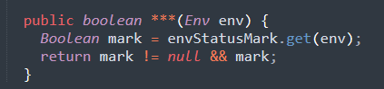

\*

|  |
| --- |
| isEnvActive |
| isEnvironmentActive |

Please kindly explain why the selected option should be preferred.

\*

|  |
| --- |
| □Use of widely recognized abbreviations that do not hinder the understanding of the source code |
| □Excessively lengthy method names significantly impact code readability |
| □Consistency with the naming conventions of identifiers within the method body |
| □Less common abbreviation influences the understanding of the source code |
| □Method name with full terms are not excessively long and full terms tend to be more readable |
| □Others \_\_\_\_\_\_\_\_\_\_\_\_\_\_\_\_\_ |

181. Please read through the following code snippet where the original method name is marked by "\*\*\*". If necessary, you can refer to the enclosing class of the method at [this link](https://r.wjx.com/redirect.aspx?url=https%3A%2F%2Fgithub.com%2Fjiangyanjie%2FsurveyData%2Fblob%2Fmain%2FSecondRound%2F181%2F181.java&activity=267595662" \t "_blank). Among the names provided below, please indicate your preference for the method name.

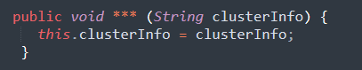

\*

|  |
| --- |
| setClusterInfo |
| setClusterInformation |

Please kindly explain why the selected option should be preferred.

\*

|  |
| --- |
| □Use of widely recognized abbreviations that do not hinder the understanding of the source code |
| □Excessively lengthy method names significantly impact code readability |
| □Consistency with the naming conventions of identifiers within the method body |
| □Less common abbreviation influences the understanding of the source code |
| □Method name with full terms are not excessively long and full terms tend to be more readable |
| □Others \_\_\_\_\_\_\_\_\_\_\_\_\_\_\_\_\_ |

182. Please read through the following code snippet where the original method name is marked by "\*\*\*". If necessary, you can refer to the enclosing class of the method at[this link](https://r.wjx.com/redirect.aspx?url=https%3A%2F%2Fgithub.com%2Fjiangyanjie%2FsurveyData%2Fblob%2Fmain%2FSecondRound%2F182%2F182.java&activity=267595662" \t "_blank). Among the names provided below, please indicate your preference for the method name.

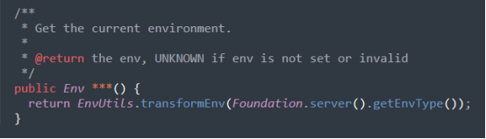

\*

|  |
| --- |
| getApolloEnv |
| getApolloEnvironment |

Please kindly explain why the selected option should be preferred.

\*

|  |
| --- |
| □Use of widely recognized abbreviations that do not hinder the understanding of the source code |
| □Excessively lengthy method names significantly impact code readability |
| □Consistency with the naming conventions of identifiers within the method body |
| □Less common abbreviation influences the understanding of the source code |
| □Method name with full terms are not excessively long and full terms tend to be more readable |
| □Others \_\_\_\_\_\_\_\_\_\_\_\_\_\_\_\_\_ |

183. Please read through the following code snippet where the original method name is marked by "\*\*\*". If necessary, you can refer to the enclosing class of the method at [this link](https://r.wjx.com/redirect.aspx?url=https%3A%2F%2Fgithub.com%2Fjiangyanjie%2FsurveyData%2Fblob%2Fmain%2FSecondRound%2F183%2F183.java&activity=267595662" \t "_blank). Among the names provided below, please indicate your preference for the method name.

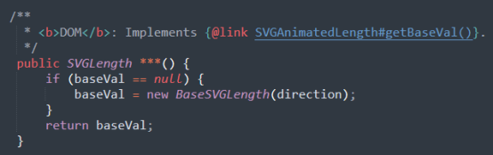

\*

|  |
| --- |
| getBaseVal |
| getBaseValue |

Please kindly explain why the selected option should be preferred.

\*

|  |
| --- |
| □Use of widely recognized abbreviations that do not hinder the understanding of the source code |
| □Excessively lengthy method names significantly impact code readability |
| □Consistency with the naming conventions of identifiers within the method body |
| □Less common abbreviation influences the understanding of the source code |
| □Method name with full terms are not excessively long and full terms tend to be more readable |
| □Others \_\_\_\_\_\_\_\_\_\_\_\_\_\_\_\_\_ |

184. Please read through the following code snippet where the original method name is marked by "\*\*\*". If necessary, you can refer to the enclosing class of the method at [this link](https://r.wjx.com/redirect.aspx?url=https%3A%2F%2Fgithub.com%2Fjiangyanjie%2FsurveyData%2Fblob%2Fmain%2FSecondRound%2F184%2F184.java&activity=267595662" \t "_blank). Among the names provided below, please indicate your preference for the method name.

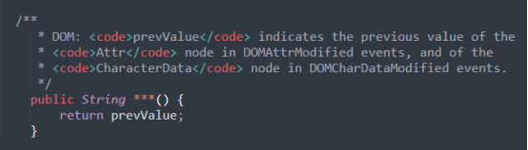

\*

|  |
| --- |
| getPrevValue |
| getPreviousValue |

Please kindly explain why the selected option should be preferred.

\*

|  |
| --- |
| □Use of widely recognized abbreviations that do not hinder the understanding of the source code |
| □Excessively lengthy method names significantly impact code readability |
| □Consistency with the naming conventions of identifiers within the method body |
| □Less common abbreviation influences the understanding of the source code |
| □Method name with full terms are not excessively long and full terms tend to be more readable |
| □Others \_\_\_\_\_\_\_\_\_\_\_\_\_\_\_\_\_ |

185. Please read through the following code snippet where the original method name is marked by "\*\*\*". If necessary, you can refer to the enclosing class of the method at [this link](https://r.wjx.com/redirect.aspx?url=https%3A%2F%2Fgithub.com%2Fjiangyanjie%2FsurveyData%2Fblob%2Fmain%2FSecondRound%2F185%2F185.java&activity=267595662" \t "_blank). Among the names provided below, please indicate your preference for the method name.

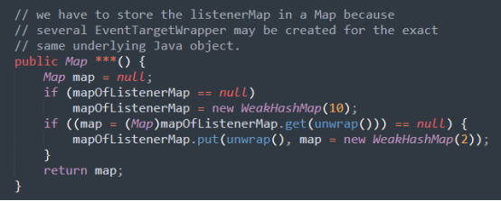

\*

|  |
| --- |
| initMap |
| initializeMap |

Please kindly explain why the selected option should be preferred.

\*

|  |
| --- |
| □Use of widely recognized abbreviations that do not hinder the understanding of the source code |
| □Excessively lengthy method names significantly impact code readability |
| □Consistency with the naming conventions of identifiers within the method body |
| □Less common abbreviation influences the understanding of the source code |
| □Method name with full terms are not excessively long and full terms tend to be more readable |
| □Others \_\_\_\_\_\_\_\_\_\_\_\_\_\_\_\_\_ |

186. Please read through the following code snippet where the original method name is marked by "\*\*\*". If necessary, you can refer to the enclosing class of the method at[this link](https://r.wjx.com/redirect.aspx?url=https%3A%2F%2Fgithub.com%2Fjiangyanjie%2FsurveyData%2Fblob%2Fmain%2FSecondRound%2F186%2F186.java&activity=267595662" \t "_blank). Among the names provided below, please indicate your preference for the method name.

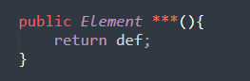

\*

|  |
| --- |
| getDef |
| getDefinition |

Please kindly explain why the selected option should be preferred.

\*

|  |
| --- |
| □Use of widely recognized abbreviations that do not hinder the understanding of the source code |
| □Excessively lengthy method names significantly impact code readability |
| □Consistency with the naming conventions of identifiers within the method body |
| □Less common abbreviation influences the understanding of the source code |
| □Method name with full terms are not excessively long and full terms tend to be more readable |
| □Others \_\_\_\_\_\_\_\_\_\_\_\_\_\_\_\_\_ |

187. Please read through the following code snippet where the original method name is marked by "\*\*\*". If necessary, you can refer to the enclosing class of the method at [this link](https://r.wjx.com/redirect.aspx?url=https%3A%2F%2Fgithub.com%2Fjiangyanjie%2FsurveyData%2Fblob%2Fmain%2FSecondRound%2F187%2F187.java&activity=267595662" \t "_blank). Among the names provided below, please indicate your preference for the method name.

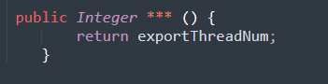

\*

|  |
| --- |
| getExportThreadNum |
| getExportThreadNumber |

Please kindly explain why the selected option should be preferred.

\*

|  |
| --- |
| □Use of widely recognized abbreviations that do not hinder the understanding of the source code |
| □Excessively lengthy method names significantly impact code readability |
| □Consistency with the naming conventions of identifiers within the method body |
| □Less common abbreviation influences the understanding of the source code |
| □Method name with full terms are not excessively long and full terms tend to be more readable |
| □Others \_\_\_\_\_\_\_\_\_\_\_\_\_\_\_\_\_ |

188. Please read through the following code snippet where the original method name is marked by "\*\*\*". If necessary, you can refer to the enclosing class of the method at [this link](https://r.wjx.com/redirect.aspx?url=https%3A%2F%2Fgithub.com%2Fjiangyanjie%2FsurveyData%2Fblob%2Fmain%2FSecondRound%2F188%2F188.java&activity=267595662" \t "_blank). Among the names provided below, please indicate your preference for the method name.

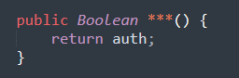

\*

|  |
| --- |
| getAuth |
| getAuthentication |

Please kindly explain why the selected option should be preferred.

\*

|  |
| --- |
| □Use of widely recognized abbreviations that do not hinder the understanding of the source code |
| □Excessively lengthy method names significantly impact code readability |
| □Consistency with the naming conventions of identifiers within the method body |
| □Less common abbreviation influences the understanding of the source code |
| □Method name with full terms are not excessively long and full terms tend to be more readable |
| □Others \_\_\_\_\_\_\_\_\_\_\_\_\_\_\_\_\_ |

189. Please read through the following code snippet where the original method name is marked by "\*\*\*". If necessary, you can refer to the enclosing class of the method at [this link](https://r.wjx.com/redirect.aspx?url=https%3A%2F%2Fgithub.com%2Fjiangyanjie%2FsurveyData%2Fblob%2Fmain%2FSecondRound%2F189%2F189.java&activity=267595662" \t "_blank). Among the names provided below, please indicate your preference for the method name.

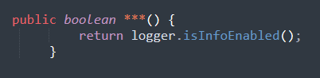

\*

|  |
| --- |
| isInfoEnabled |
| isInformatioonEnabled |

Please kindly explain why the selected option should be preferred.

\*

|  |
| --- |
| □Use of widely recognized abbreviations that do not hinder the understanding of the source code |
| □Excessively lengthy method names significantly impact code readability |
| □Consistency with the naming conventions of identifiers within the method body |
| □Less common abbreviation influences the understanding of the source code |
| □Method name with full terms are not excessively long and full terms tend to be more readable |
| □Others \_\_\_\_\_\_\_\_\_\_\_\_\_\_\_\_\_ |

190. Please read through the following code snippet where the original method name is marked by "\*\*\*". If necessary, you can refer to the enclosing class of the method at [this link](https://r.wjx.com/redirect.aspx?url=https%3A%2F%2Fgithub.com%2Fjiangyanjie%2FsurveyData%2Fblob%2Fmain%2FSecondRound%2F190%2F190.java&activity=267595662" \t "_blank). Among the names provided below, please indicate your preference for the method name.

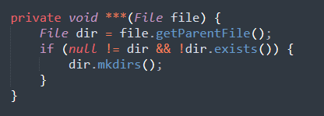

\*

|  |
| --- |
| createIfLogDirAbsent |
| createIfLogDirectoryAbsent |

Please kindly explain why the selected option should be preferred.

\*

|  |
| --- |
| □Use of widely recognized abbreviations that do not hinder the understanding of the source code |
| □Excessively lengthy method names significantly impact code readability |
| □Consistency with the naming conventions of identifiers within the method body |
| □Less common abbreviation influences the understanding of the source code |
| □Method name with full terms are not excessively long and full terms tend to be more readable |
| □Others \_\_\_\_\_\_\_\_\_\_\_\_\_\_\_\_\_ |

191. Please read through the following code snippet where the original method name is marked by "\*\*\*". If necessary, you can refer to the enclosing class of the method at [this link](https://r.wjx.com/redirect.aspx?url=https%3A%2F%2Fgithub.com%2Fjiangyanjie%2FsurveyData%2Fblob%2Fmain%2FSecondRound%2F191%2F191.java&activity=267595662" \t "_blank). Among the names provided below, please indicate your preference for the method name.

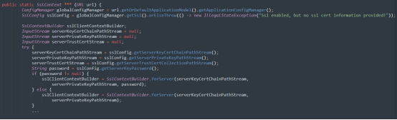

\*

|  |
| --- |
| buildServerSslContext |
| buildServerSecureSocketsLayerContext |

Please kindly explain why the selected option should be preferred.

\*

|  |
| --- |
| □Use of widely recognized abbreviations that do not hinder the understanding of the source code |
| □Excessively lengthy method names significantly impact code readability |
| □Consistency with the naming conventions of identifiers within the method body |
| □Less common abbreviation influences the understanding of the source code |
| □Method name with full terms are not excessively long and full terms tend to be more readable |
| □Others \_\_\_\_\_\_\_\_\_\_\_\_\_\_\_\_\_ |

192. Please read through the following code snippet where the original method name is marked by "\*\*\*". If necessary, you can refer to the enclosing class of the method at [this link](https://r.wjx.com/redirect.aspx?url=https%3A%2F%2Fgithub.com%2Fjiangyanjie%2FsurveyData%2Fblob%2Fmain%2FSecondRound%2F192%2F192.java&activity=267595662" \t "_blank). Among the names provided below, please indicate your preference for the method name.

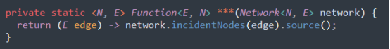

\*

|  |
| --- |
| sourceNodeFn |
| sourceNodeFunction |

Please kindly explain why the selected option should be preferred.

\*

|  |
| --- |
| □Use of widely recognized abbreviations that do not hinder the understanding of the source code |
| □Excessively lengthy method names significantly impact code readability |
| □Consistency with the naming conventions of identifiers within the method body |
| □Less common abbreviation influences the understanding of the source code |
| □Method name with full terms are not excessively long and full terms tend to be more readable |
| □Others \_\_\_\_\_\_\_\_\_\_\_\_\_\_\_\_\_ |

193. Please read through the following code snippet where the original method name is marked by "\*\*\*". If necessary, you can refer to the enclosing class of the method at [this link](https://r.wjx.com/redirect.aspx?url=https%3A%2F%2Fgithub.com%2Fjiangyanjie%2FsurveyData%2Fblob%2Fmain%2FSecondRound%2F193%2F193.java&activity=267595662" \t "_blank). Among the names provided below, please indicate your preference for the method name.

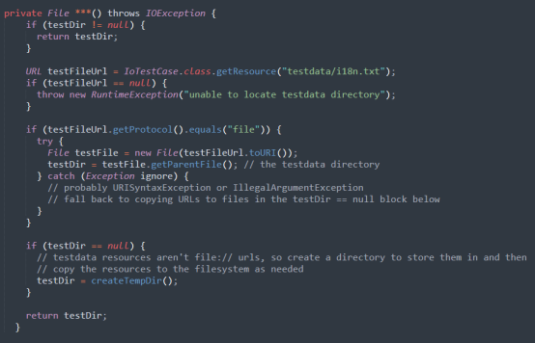

\*

|  |
| --- |
| getTestDir |
| getTestDirectory |

Please kindly explain why the selected option should be preferred.

\*

|  |
| --- |
| □Use of widely recognized abbreviations that do not hinder the understanding of the source code |
| □Excessively lengthy method names significantly impact code readability |
| □Consistency with the naming conventions of identifiers within the method body |
| □Less common abbreviation influences the understanding of the source code |
| □Method name with full terms are not excessively long and full terms tend to be more readable |
| □Others \_\_\_\_\_\_\_\_\_\_\_\_\_\_\_\_\_ |

194. Please read through the following code snippet where the original method name is marked by "\*\*\*". If necessary, you can refer to the enclosing class of the method at [this link](https://r.wjx.com/redirect.aspx?url=https%3A%2F%2Fgithub.com%2Fjiangyanjie%2FsurveyData%2Fblob%2Fmain%2FSecondRound%2F194%2F194.java&activity=267595662" \t "_blank). Among the names provided below, please indicate your preference for the method name.

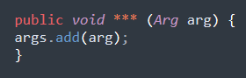

\*

|  |
| --- |
| addArg |
| addArgument |

Please kindly explain why the selected option should be preferred.

\*

|  |
| --- |
| □Use of widely recognized abbreviations that do not hinder the understanding of the source code |
| □Excessively lengthy method names significantly impact code readability |
| □Consistency with the naming conventions of identifiers within the method body |
| □Less common abbreviation influences the understanding of the source code |
| □Method name with full terms are not excessively long and full terms tend to be more readable |
| □Others \_\_\_\_\_\_\_\_\_\_\_\_\_\_\_\_\_ |

195. Please read through the following code snippet where the original method name is marked by "\*\*\*". If necessary, you can refer to the enclosing class of the method at[this link](https://r.wjx.com/redirect.aspx?url=https%3A%2F%2Fgithub.com%2Fjiangyanjie%2FsurveyData%2Fblob%2Fmain%2FSecondRound%2F195%2F195.java&activity=267595662" \t "_blank). Among the names provided below, please indicate your preference for the method name.

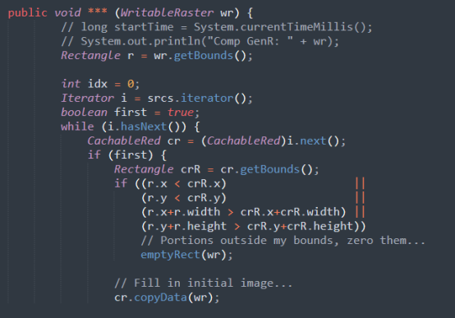

\*

|  |
| --- |
| genRect |
| generateRectangle |

Please kindly explain why the selected option should be preferred.

\*

|  |
| --- |
| □Use of widely recognized abbreviations that do not hinder the understanding of the source code |
| □Excessively lengthy method names significantly impact code readability |
| □Consistency with the naming conventions of identifiers within the method body |
| □Less common abbreviation influences the understanding of the source code |
| □Method name with full terms are not excessively long and full terms tend to be more readable |
| □Others \_\_\_\_\_\_\_\_\_\_\_\_\_\_\_\_\_ |

196. Please read through the following code snippet where the original method name is marked by "\*\*\*". If necessary, you can refer to the enclosing class of the method at [this link](https://r.wjx.com/redirect.aspx?url=https%3A%2F%2Fgithub.com%2Fjiangyanjie%2FsurveyData%2Fblob%2Fmain%2FSecondRound%2F196%2F196.java&activity=267595662" \t "_blank). Among the names provided below, please indicate your preference for the method name.

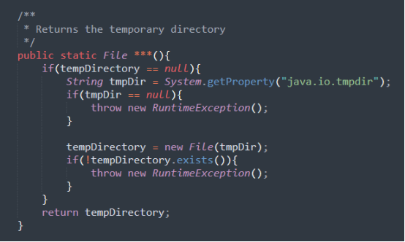

\*

|  |
| --- |
| getTempDirectory |
| getTemporaryDirectory |

Please kindly explain why the selected option should be preferred.

\*

|  |
| --- |
| □Use of widely recognized abbreviations that do not hinder the understanding of the source code |
| □Excessively lengthy method names significantly impact code readability |
| □Consistency with the naming conventions of identifiers within the method body |
| □Less common abbreviation influences the understanding of the source code |
| □Method name with full terms are not excessively long and full terms tend to be more readable |
| □Others \_\_\_\_\_\_\_\_\_\_\_\_\_\_\_\_\_ |

197. Please read through the following code snippet where the original method name is marked by "\*\*\*". If necessary, you can refer to the enclosing class of the method at [this link](https://r.wjx.com/redirect.aspx?url=https%3A%2F%2Fgithub.com%2Fjiangyanjie%2FsurveyData%2Fblob%2Fmain%2FSecondRound%2F197%2F197.java&activity=267595662" \t "_blank). Among the names provided below, please indicate your preference for the method name.

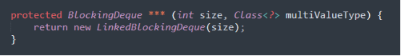

\*

|  |
| --- |
| createMultiValue |
| createMultipleValue |

Please kindly explain why the selected option should be preferred.

\*

|  |
| --- |
| □Use of widely recognized abbreviations that do not hinder the understanding of the source code |
| □Excessively lengthy method names significantly impact code readability |
| □Consistency with the naming conventions of identifiers within the method body |
| □Less common abbreviation influences the understanding of the source code |
| □Method name with full terms are not excessively long and full terms tend to be more readable |
| □Others \_\_\_\_\_\_\_\_\_\_\_\_\_\_\_\_\_ |

198. Please read through the following code snippet where the original method name is marked by "\*\*\*". If necessary, you can refer to the enclosing class of the method at [this link](https://r.wjx.com/redirect.aspx?url=https%3A%2F%2Fgithub.com%2Fjiangyanjie%2FsurveyData%2Fblob%2Fmain%2FSecondRound%2F198%2F198.java&activity=267595662" \t "_blank). Among the names provided below, please indicate your preference for the method name.

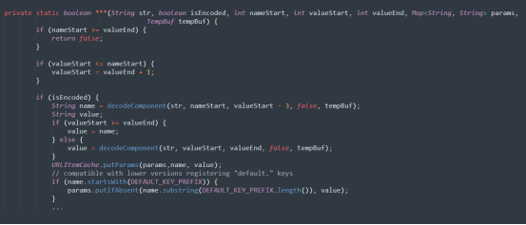

\*

|  |
| --- |
| addParam |
| addParameter |

Please kindly explain why the selected option should be preferred.

\*

|  |
| --- |
| □Use of widely recognized abbreviations that do not hinder the understanding of the source code |
| □Excessively lengthy method names significantly impact code readability |
| □Consistency with the naming conventions of identifiers within the method body |
| □Less common abbreviation influences the understanding of the source code |
| □Method name with full terms are not excessively long and full terms tend to be more readable |
| □Others \_\_\_\_\_\_\_\_\_\_\_\_\_\_\_\_\_ |

199. Please read through the following code snippet where the original method name is marked by "\*\*\*". If necessary, you can refer to the enclosing class of the method at [this link](https://r.wjx.com/redirect.aspx?url=https%3A%2F%2Fgithub.com%2Fjiangyanjie%2FsurveyData%2Fblob%2Fmain%2FSecondRound%2F199%2F199.java&activity=267595662" \t "_blank). Among the names provided below, please indicate your preference for the method name.

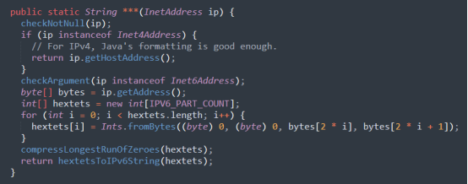

\*

|  |
| --- |
| toAddrString |
| toAddressString |

Please kindly explain why the selected option should be preferred.

\*

|  |
| --- |
| □Use of widely recognized abbreviations that do not hinder the understanding of the source code |
| □Excessively lengthy method names significantly impact code readability |
| □Consistency with the naming conventions of identifiers within the method body |
| □Less common abbreviation influences the understanding of the source code |
| □Method name with full terms are not excessively long and full terms tend to be more readable |
| □Others \_\_\_\_\_\_\_\_\_\_\_\_\_\_\_\_\_ |

200. Please read through the following code snippet where the original method name is marked by "\*\*\*". If necessary, you can refer to the enclosing class of the method at [this link](https://r.wjx.com/redirect.aspx?url=https%3A%2F%2Fgithub.com%2Fjiangyanjie%2FsurveyData%2Fblob%2Fmain%2FSecondRound%2F200%2F200.java&activity=267595662" \t "_blank). Among the names provided below, please indicate your preference for the method name.

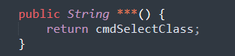

\*

|  |
| --- |
| getCmdSelectClass |
| getCommandSelectClass |

Please kindly explain why the selected option should be preferred.

\*

|  |
| --- |
| □Use of widely recognized abbreviations that do not hinder the understanding of the source code |
| □Excessively lengthy method names significantly impact code readability |
| □Consistency with the naming conventions of identifiers within the method body |
| □Less common abbreviation influences the understanding of the source code |
| □Method name with full terms are not excessively long and full terms tend to be more readable |
| □Others \_\_\_\_\_\_\_\_\_\_\_\_\_\_\_\_\_ |